**CONTENTS**

**AUTOMATION AND CONTROL OF TECHNOLOGICAL PROCESSES AND PRODUCTIONS**

**Krotova N.A., Pushkov R.L.**

Determination of geometric parameters and orientation of the workpiece inside the machine tool using computer-vision algorithms

**Nyi Nyi Htwe, Volkova G.D.**

Development of formal description for the typologies of statistical subject constraints in the conceptual modeling of applied problems

**Al Khoury A.**

Batch parameterization of CAN servo drives by using motion controller based on a single-board computer

**Filatov S.E.**

Development of method and algorithm for preparing the control program of machine for mounting printed circuit board with a wide range element base of domestic production.

**Issa A.**

Development of OPC UA server and conducting bench tests for remote monitoring of parameters of the CNC system core

**Drapak K.A., Krylov E.G., Kapitanov A. V.**

LNG terminal risk assessment analysis using a risk diagram

**Sukhanova N.V., Sheptunov S.A.**

The neural network models of equipment and technological processes in mechanical engineering and their application in automated control systems

**TECHNOLOGY AND EQUIPMENT OF MECHANICAL AND PHYSICAL-TECHNICAL PROCESSING**

**Mirzomakhmudov A.R., Isaev A.V.**

Milling cutters for machining parts in the railway industry

**Artamonov E.V., Grechishnikov V.A., Kireev V.V., Zyryanov V.A., Isaev A.V., Pivkin P.M.**

Implementation of group cutting scheme for prefabricated hob milling

**Mitrofanov A.P., Malkov S.N., Kozlachkov A.P., Zabrodin A.V.**

Investigation of the influence of modes and conditions for supplying the minimum quantity lubrication on the parameters of the grinding process of heat-resistant nickel alloy

**TECHNOLOGY OF MACHINE BUILDING**

**Nekrasov R.Yu., Tempel O.A., Starikov A.I.**

Determination of the optimal thickness of hard-to-cut material to restore the product's working capacity

**Davydov E.V., Fomin E.V.**

Application of topological optimization for marine engineering products

**TECHNOLOGIES AND MACHINES OF PROCESSING BY PRESSURE**

**Gusev D.S., Sosenushkin E.N.**

Simulation of hot volumetric stamping of a wrench forging on an impactor

**Liubimskiy S.V.**

Simulation of the combined technological process of severe plastic deformation

**ROBOTS, MECHATRONICS AND ROBOTIC SYSTEMS**

**Sivenkov M. I., Ivanov Y. V., Semenyaka A. G., Poduraev Y. V.**

Artificial neural networks architectures for human semantic segmentation investigation

**MANAGEMENT OF INDUSTRIAL ENTERPRISES, MATHEMATICAL AND INSTRUMENTAL METHODS OF ECONOMICS**

**Kovalev A.P.**

Methodical issues of using the functional approach to the functional-value analysis of machines and equipment

**Prosvirina M.E., Chervenkova S.G., Malina T.V., Andreev V.N., Kisel’ T.N.**

The selection of company key value drivers based on an A. Osterwalder business model

**Ryzhkova T.V.**

The essential qualities of the production function model in a complex form

**Tsuverkalova O.F.**

The heat supply industry digitalization role in achieving sustainable development goals

УДК62-50:004.057.8 N.A. Krotova, R.L. Pushkov

**Determination of geometric parameters and orientation of the workpiece inside the machine tool using computer-vision algorithms**

*The paper describes the research of modern algorithms for computer technical vision and proposes their application to determine the geometric parameters and orientation of the workpiece inside the working area of the machine tool. An algorithm for the use of computer technical vision based on a stereo pair of images of the working area was developed and tested to determine the measurement errors.*

**Keywords:** technical vision, computer vision, workpiece coordinate system, machine-tool coordinate system, determining of contour, image processing, stereovision, CNC, machine-tool.

**Introduction**

Before starting the workpiece processing on the machine, it is necessary to bind the workpiece installed in the working area to the coordinate system of the numerical control system. The binding methods are selected depending on the requirements for the geometry of the part, the accuracy of processing, as well as the technical capabilities of the equipment. The most accurate methods are the use of probes and automated measuring systems. However, such systems are quite expensive and are rarely installed on simple milling or turning machines.

On such machines, the binding is carried out using such methods as facing, turning along the outer diameter, rolling with an indicator. Such methods require the direct participation of the operator in the process of binding the workpiece to the CNC coordinate system, which limits the use of simple machines in automated lines and unmanned industries. The use of computer vision algorithms for determining the position of the workpiece in the working area of the machine can accelerate the automation of the process of binding the workpiece to the CNC coordinate system [1, 2].

Computer vision systems today are an effective and affordable tool for modernization of production, the use of which allows solving a wide range of industrial problems, and in comparison with traditional solutions, they often turn out to be easier, faster, and cheaper.

Technical vision systems in mechanical engineering can replace or supplement manual measurements, solving one or several classical problems at once [3]:

1) determining the position of an object;

2) measuring the dimensions of the object;

3) quality control;

4) marking recognition.

To determine the position and orientation of the workpiece, it is proposed to create a system that solves the first two tasks and to automate the determination of the workpiece zero points in the coordinate system of machines that are not equipped with automated measuring instruments.

Most of the existing technical vision systems that solve such problems either receive an image from a single camera and use the phenomenon of perspective transformations or are organized according to the stereoscopic vision scheme. It is found that the error in determining the distance to the object at observation distances of about 2 m is much smaller for the second type of system [4] (Fig. 1), besides, this measurement method does not require knowledge of the exact position of the camera system relative to the coordinate system of the machine and the dimensions of the object under study. In this case, the error in determining the contours of an object in the image plane linearly depends on the size of the area captured by the camera, per pixel of the image, and is inversely proportional to its resolution [5].

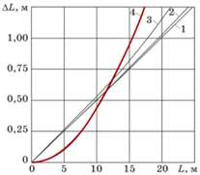

**Fig. 1.** Comparison of errors in the analysis of one image (curves 1, 2, 3) and two images (curve 4)

**Selection of the method for obtaining and processing the images of the working area**

Based on the analysis, it was decided to use a system of two high-resolution cameras. Calculations of the geometric parameters of the workpiece installed on the machine are made based on the analysis of stereo pairs of images of the working area of the machine obtained from a pair of co-directional cameras rigidly fixed relative to each other so that the distance *a* between the centers of their lenses is known. Such an installation makes it possible to simulate binocular vision, which does not require knowledge of the exact position of the installation itself relative to the zero of the machine, since its position can be calculated relative to special marks on the desktop of the machine being equipped with the installation, the coordinates of which are known in the coordinate system of the machine.

The installation demonstrating a possible variant of the arrangement of the elements of the technical vision system is shown in Fig. 2.

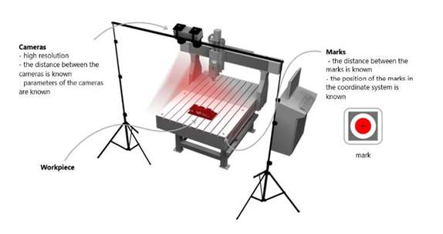

**Fig. 2.** The installation demonstrating the location of the elements of the technical vision system

To reduce the errors of changes, it is necessary to make some requirements for the hardware of the system. For cameras, this is the immobility of fixing relative to each other and relative to the machine in the time interval between obtaining the main and auxiliary stereo pairs, the minimum possible height of their placement above the table.

Since it is necessary to find an area with a workpiece on the input stereo pair, before placing it on the machine it is necessary to obtain an auxiliary stereo pair of images of an empty table. After placing the workpiece, the main stereo pair of images is obtained. If the natural lighting in the room is not constant or the shadows of moving parts of other equipment fall into the frame, it is necessary to use additional illumination.

It is assumed that the marks in the frame will be located in different quarters of the image so that each is close to the corresponding corner of the image (Fig. 3).

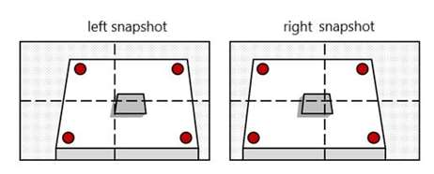

**Fig. 3.** The expected location of the marks on the images of stereo pairs

To minimize possible measurement errors, the cameras should be fixed so that the angle between their visual axes and the normal of the machine table tends to zero. (position B in Fig. 4a).In this case, the perspective distortion of the stereo pair images will be minimal, which will reduce the error introduced into the measurement during the perspective image correction.

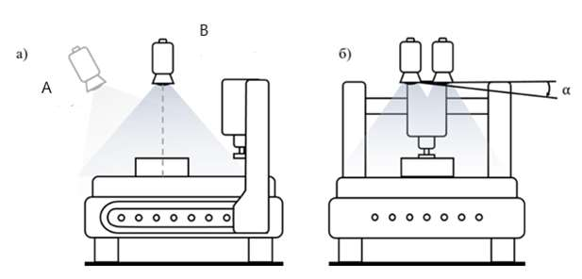

**Fig. 4.** The intended location of the cameras above the machine table

The best way to install the cameras is to fix the system on a horizontal rod mounted on two tripods (Fig. 2). With this installation option, it is necessary to make sure that the cameras do not tilt, as a result of which one camera will be higher than the other (Fig. 4b).

**Development of an algorithm for determining the position and orientation of the workpiece**

The algorithm for determining the position and orientation of the workpiece (Fig. 5) is based on finding the contours of the workpiece in the images from the cameras and calculating their displacements.

At the stage of preprocessing, based on the differences of the corresponding images of the main stereo pair with the auxiliary one, the areas that have changed in the images after the installation of the workpiece are determined. The marks located on the table are detected and the pictures are aligned to them to correct perspective distortion. The coordinates of the zero point of the machine in pixels for both images of the main stereo pair and the coefficients of the correspondence of pixels to millimeters for the level of the surface of the machine table are determined.

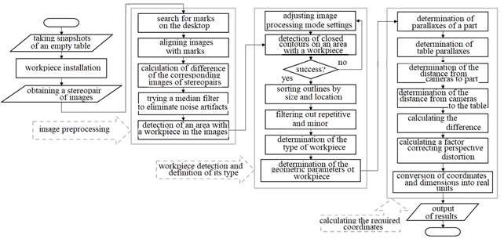

**Fig. 5.** Algorithm for determining the position and orientation of the workpiece

As a result of pre-processing, only the areas of aligned images of fragments of the table with the workpiece are obtained. This allows us to simplify the calculations at the next stage and speed up its implementation.

At the second stage, the search for the contours of objects is carried out, while only the areas with the workpiece images of the main stereo pair are processed. Outlines of rectangles and circles are detected, and unnecessary ones are filtered out. The result of this operation depends on the contrast and brightness of the original images. If it is impossible to detect the contours, the image parameters are corrected, and the operation is repeated. After filtering, the type of workpiece is determined, and a set of its contours is transferred to the next stage. At the moment, the algorithm recognizes only the simplest workpieces - rectangular and cylindrical, but in the future, it is possible to expand its functionality.

At the third stage, the distances from the cameras to the table and the surface of the workpiece are determined. The calculations are based on the marks found at the first stage on the desktop and a set of contours and matching coefficients found at the second stage.

The distance is determined as follows: we know the distance *a* between the cameras, the resolution of the images obtained from the X × Y cameras and their vertical and horizontal viewing angles A and B, and we need to calculate the distance d (Fig. 6).

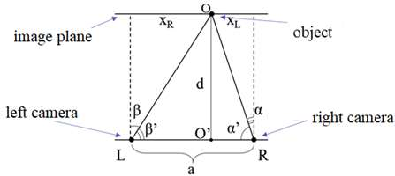

**Fig. 6.** Scheme for determining the distance to the object to which the point O belongs

Point O on the scheme is the center of the object under study. The known distance *a* is related to the angles and the distance d by relation (1).

|  |  |  |
| --- | --- | --- |
|  | $$a=\frac{d}{tg(β^{'})}+\frac{d}{tg(α^{'})}.$$ | (1) |

Angles α and β are calculated using relations (2) and (3):

|  |  |  |
| --- | --- | --- |
|  | $$\frac{X}{2}⋅\frac{1}{x}=tg\left(A\right) ⇒ x=\frac{X}{2tg\left(A\right)};$$ | (2) |
|  | $$α=atan\left(\frac{x_{R}}{x}\right); β=atan\left(\frac{x_{L}}{x}\right).$$ | (3) |

Subtracting them from 90 °, we obtain α’and β’, substitute them in relation (1) and express the required distance d (4):

|  |  |  |
| --- | --- | --- |
|  | $$d=\frac{a}{\frac{1}{tg(90°-α)}+\frac{1}{tg(90°-β)}}$$ | (4) |

Using the found distances from the cameras to the table and from the cameras to the workpiece, are corrected the distortions shown in Fig. 7. Coefficients of pixel-to-millimeter correspondence for the level of the table surface are adjusted by multiplying by the ratio of the height of the cameras above the table to the height of the camera above the workpiece since the size seen in the picture refers to the real size in the same proportion.

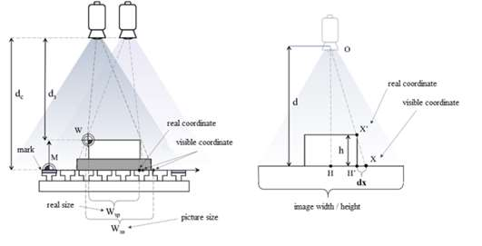

**Fig. 7.** The main distortions

When shooting, the contour of the workpiece is projected onto the image plane, and its "stretching" occurs. Fig. 7 shows that the displacement dx is proportional to the displacement of the point X relative to the visual axis of the camera and its value can be found by the formula (5).

|  |  |  |
| --- | --- | --- |
|  | $$dx =(X-H)\frac{h}{d}$$ | (5) |

After all the key points of the contours from the "left" and "right" images have been processed, the results are averaged and displayed on the screen and can then be transmitted to the machine's CNC system.

**Algorithm testing**

To test the algorithm, a test application was developed in C ++ using the OpenCV library [6].

Testing was carried out on images of a three-dimensional model of a milling table with marks applied to it. The resolution of the input images is 5120 × 2880 pixels. The marks form a rectangle with a long side of 900 mm and a short side of 600 mm.

The images of rectangular and cylindrical workpieces were worked out with various methods of installing cameras above the machine table. An example of the result obtained for a cylindrical workpiece is shown in Fig. 8.



**Fig.8** Example of module output data

The error of the calculated dimensions has a range of values of 0.2-0.6 mm. The speed of the algorithm (from the beginning of the analysis of the input images to the receipt of the results) is from 4 to 10 seconds.

**Conclusion**

The obtained test results allow us to conclude that the developed algorithm for determining the position and orientation of the workpiece based on the technical vision system makes it possible to obtain results that are comparable in accuracy with the methods of facing or external turning, with a significant increase in the speed of obtaining the resulting parameters and almost complete exclusion of the operator from the process. This makes it possible to increase the level of production automation.

**References**

1.**Нежметдинов Р.А., Пушков Р.Л., Евстафиева С.В., Мартинова Л.И.** Построение специализированной системы ЧПУ для многокоординатных токарно-фрезерных обрабатывающих центров: статья // Автоматизация в промышленности, №6, 2014. с.25-28.

2.**Мартинов Г.М., Пушков Р.Л., Евстафиева С.В.** Основы построения однокомпьютерной системы ЧПУ с программно реализованным ядром и открытой модульной архитектурой: статья // [Вестник МГТУ "Станкин"](http://www.stankin.ru/vestnik-magazin/magazin-december-2008.pdf" \t "_blank). 2008. №4. C. 82–93.

3.**SICK IVP** Machine Vision Introduction [Электронный ресурс] // 2006.– Режимдоступа: https://www.academia.edu/38693358/Machine\_Vision\_Introduction2\_2\_web.

4.**Красильников Н.Н.** Механизмы и погрешности восприятия 3d-пространства зрительной системой: статья // Информационно-управляющие системы. 2014. №6. с. 13–19.

5.**KEYENCE** DimensionMeasurement [Электронный ресурс]. – Режим доступа: https://www.keyence.com/ss/products/vision/visionbasics/use/inspection03.

6.**OpenCV** Официальный сайт [Электронный ресурс]. – Режим доступа: https://opencv.org

***Krotova Nataliya Alexeyevna*** – student of group ADB-17-06 of MSUT «STANKIN»

*natalilia1900@gmail.com*

***Pushkov Roman L’vovich*** – candidate Sc. of Engineering, assistant professor of the sub-department of «Numeric Control Systems» of MSUT «STANKIN»

*[pushkov@ncsystems.ru](mailto:pushkov@ncsystems.ru)*

УДК 004.4.22:658.512:621(075) Nyi Nyi Htwe, G.D. Volkova

**Development of formal description for the typologies of statistical subject constraints in the conceptual modeling of applied problems**

*This article presents a formal description of the conceptual model of the* 1st *kind at the object and specific levels for the subject problem, a description of the typology of statistical constraints of the* 1st*kind, representing documented technical knowledge.*

**Keywords:** a conceptual model of the 1st kind of object problem, statistical constraints of the 1st kind, typology of constraints of the 1st kind.

**Introduction**

The preservation of the intellectual potential of industrial enterprises is currently an urgent problem. The intellectual resource of any organization includes the experience and knowledge of its specialists; funds of regulations and standards stored both in documentary and electronic form. To transfer the accumulated information and knowledge from the memory of specialists and documents, it is necessary to carry out their formal modeling. The methodology that provides such a transfer based on formal knowledge modeling (or conceptual modeling) is the methodology of the automation of intellectual work [1,2,5,6], developed at the Department of Information Technologies and Automated Systems of MSUT "STANKIN".

The formal description of the model of technical knowledge in the form of a conceptual representation of subject problems within the framework of the methodology of automation of intellectual labor allows us not only to model knowledge in various methods (research, design, technological, managerial, etc.) but also to additionally process and classify technical knowledge.

**Characteristics of the process of forming conceptual models of subject problems**

Conceptual modeling is understood as the process of objectifying (revealing) the system of knowledge of the subject area for a specific subject problem and fixing the results obtained in a specific form [1,2,5,6].

The process of conceptual modeling includes the following basic procedures [2]: - formation of a generalized model (for a set of object problems); - formation of a model of the current object problem; - analysis of the model of the current problem; - analytical processing of the model of the current problem; - documenting the model of the current problem; - synthesis model of the current problem with a generalized (initial) model; - analytical processing of the generalized model of problems; - documenting the model of the current set of problems.

The input information for this process is the results of the previous stage, namely, the initial model representation of the problem, including - diagrams and specifications of the system of objective actions for a set of objective problems; - diagrams and specifications of the system of objective actions of the objective problem (for each problem); - classification of information for complex as a whole and each problem; - specification of parameters (for each problem); - specifications of elementary actions and data streams (for each problem); - matrix diagram of relationships between actions and parameters (for each problem).

Conceptual modeling of subject problems is performed by a specialist in knowledge engineering. At the stage of forming conceptual models (generalized and current) of subject problems, the formation of a conceptual model of the 1st kind and a conceptual model of the 2nd kind is carried out sequentially. The formation of a conceptual model of the 1st kind includes the formation of a system of subject dependencies of the 1st kind, the main conceptual structure, the formation of a conceptual model as a whole. The basis for the formation of a conceptual model of the 1st kind of a subject problem is a formal description of the conceptual representation of the subject problem (at the object level).

At the stage of analyzing conceptual models, the structures and models are checked for completeness and coherence, the correctness of their descriptions, the presence of contradictions in them, etc. are analyzed, according to the results of the analysis, recommendations are developed for correcting the model. In the absence of errors, this version of the model is final and subject to further refinement.

**The formal description of the conceptual representation of subject problems**

For the n-th objective problem, the formal description of the conceptual representation has the form [3]:

|  |  |  |
| --- | --- | --- |
|  | $$KP\left(n\right)=<KP2\left(n\right),\overline{KP3\left(n\right)},R_{23}^{KP}\left(n\right)>,$$ | (1) |

where $KP2\left(n\right)$ is the object level model for the n-th object problem,

$\overline{KP3\left(n\right)}=\left\{KP3(nm)\right\}$ is a set of models of a specific level.

In this case, the model of each level of abstraction includes two submodels of the corresponding i-th level - the 1st ($KPi.1-z$) and the 2nd ($KPi.2-z$) kind, where *i=2*, *z=n*, and *i=3*, *z=n.* The refined structure of the representation taking into account submodels is shown in Figure 1.

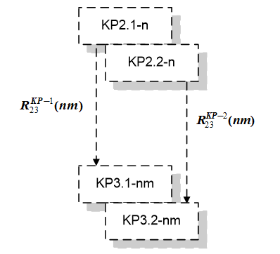

**Fig. 1.** The refined structure of the conceptual representation of the subject problem, taking into account submodels

To distinguish structural elements at any level of abstraction, categories and constraints acquire definitions and are named in Table 1.

*Table 1.* **Elements of conceptual relations**

|  |  |  |
| --- | --- | --- |
| Level | Elements of static structures | Elements of dynamic structures |
| Object | -subject categories (SC)  - SC diagrams | - subject dependencies of the 1st kind  -subject dependencies of the 2nd kind |
| Specific | - instances of subject categories (ISC)  - ISC diagrams | - instances of subject dependencies of the 1st kind  - instances of subject dependencies of the 2nd kind |

The basis for modeling domain knowledge is the conceptual model of the object level, so we will consider it in more detail.

**Refinement of the formal description of the conceptual model of the** 1st **kind of the object level**

The conceptual model of the object level of the 1st kind for the n-th subject problem is a combination of a set of subject categories (SC), a set of statistical (structural) relations, and a set of dynamic relations on subject categories[3,4]:

|  |  |  |
| --- | --- | --- |
|  | $KP2.1\left(n\right)= <M2\left(n\right), T2\left(n\right),H2\left(n\right),\overline{F2}\left(n\right),R_{2}^{KP-1}\left(n\right)>$*,* | (2) |

where each of the sets can be represented:

|  |  |  |
| --- | --- | --- |
|  | $$M2\left(n\right)≡A\left(n\right)=\left\{a_{km}\right\},$$ | (3) |

The set of subject categories for the n-th subject problem is divided into many subsets:

|  |  |  |
| --- | --- | --- |
|  | $$A\left(n\right)=\bigcup_{i}{A_{i}}\left(n\right),A_{i}\left(n\right)∩ A_{j}\left(n\right)=∅,A_{i}(n)⊂A(n),A_{i}(n)= \{a_{ik}\}$$ | (4) |

where $T2\left(n\right)$ is a set of binary relations and $H2\left(n\right)$ is a set of ternary relations on object categories, $\overline{F2}\left(n\right)$ are dynamic relations, $R_{2}^{KP-1}(n)$ is a link between static and dynamic components.

|  |  |  |
| --- | --- | --- |
|  | $$T2(n)⊂ A(n)×A(n).$$ | (5) |

For a better perception and understanding of the developed theory, a graphical interpretation of all semantic constructions was proposed.

Binary relations on categories of any level reflect, in their essence, the "pedigree" of attributes (or, more precisely, subject categories of the "Attribute" class) and their meanings. And ternary relationships reflect levels of semantic complexity or "scale."

|  |  |  |
| --- | --- | --- |
|  | $$H2(n)⊂ A(n) ×A(n)×A(n).$$ | (6) |

Dynamic relations include a system of subject dependencies of the 1st kind:

|  |  |  |
| --- | --- | --- |
|  | $\overline{F2}(n)=( \overline{V2}\left(n\right),\overline{ FV2}(n)$), | (7) |

where $\overline{V2}(n)$ is the set of subject dependencies of the 1st kind and $\overline{FV2}(n)$ is the set of binary relations between subject dependencies of the 1st kind.

|  |  |  |
| --- | --- | --- |
|  | $$\overline{V2}\left(n\right)≡ \overline{W}\left(n\right),\overline{ W}\left(n\right)=\bigcup_{s}{\overline{W_{s}}}\left(n\right),\overline{W_{s}}\left(n\right)=\left\{\overline{w_{sp}}\right\}.$$ | (8) |

The set of subject dependencies of the 1st kind is divided into subsets of different levels of decomposition.

|  |  |  |
| --- | --- | --- |
|  | $\overline{FV2}(n)⊂\overline{ W}(n)×\overline{ W}(n)$, | (9) |

Any dependence of the 1st kind is always a variant of a certain type. Since the type of dependence is always fixed on a certain set of categories, the subject dependence of the 1st kind, as a variant, is fixed on a subset of this set of categories:

|  |  |  |
| --- | --- | --- |
|  | $$\overline{w_{sp}}=\overline{w_{sp}}\left(i , t,u_{sp}\right).$$ | (10) |
|  | $$\overline{w_{sp}}\left(i,t,u_{sp}\right)={(a_{j1},…,a_{jq})}_{u_{sp}}\&Q_{it}^{sp}\left(n\right),$$ | (11) |

where $Q_{it}^{sp}\left(n\right)$ reflects the ratio of structural and contextual subject categories, the $u_{sp}$ index marks a subset of the set $A_{j}\left(n\right)$ of subject categories, which characterizes $sp$- constraint or subject dependence for the selected subject problem.

**Refinement of the formal description of the conceptual model of the 1st kind of a specific level**

Conceptual model of the 1st kind is a combination of a set of instances of subject categories (ISC), a set of statistical (structural) relations, and a set of dynamic relations [3,4]:

|  |  |  |
| --- | --- | --- |
|  | $KP3.1\left(nm\right)= <M3\left(nm\right), T3\left(nm\right),H3\left(nm\right),\overline{F3}\left(nm\right),R_{3}^{KP-1}(nm)$*>,* | (12) |

where each of the sets can be represented as follows:

|  |  |  |
| --- | --- | --- |
|  | $$M3\left(nm\right)≡B\left(nm\right)$$ | (13) |
|  | $$B\left(nm\right)=\bigcup_{i,j}{B_{ij}}\left(nm\right),B_{ij}\left(nm\right)∩B_{km}\left(nm\right)=∅,$$ | (14) |
|  | $$B_{ij}(nm)⊂B(nm),B_{ij}(nm)= \{b_{r}^{ij}\}$$ | (15) |

where $T3\left(nm\right)$ is a set of binary relations and $H3\left(nm\right)$ is a set of ternary relations between SC instances, $\overline{F3}\left(nm\right)$ are dynamic relations, $R_{3}^{KP-1}(nm)$ is a link between static and dynamic components.

|  |  |  |
| --- | --- | --- |
|  | $$T3(nm)⊂B(nm)×B(nm).$$ | (16) |
|  | $$H3(nm)⊂ B(nm) ×B(nm)×B(nm).$$ | (17) |

Dynamic relation is a system of subject dependencies of the first kind $\overline{F3}(nm)$:

|  |  |  |
| --- | --- | --- |
|  | $\overline{F3}(nm)=( \overline{V3}\left(nm\right),\overline{FV3}(nm)$), | (18) |

where $\overline{V3}(nm)$ is a set of instances of subject dependencies of the 1st kind (ISD -1) and $\overline{FV3}(nm)$ is a set of binary relations between ISD -1.

|  |  |  |
| --- | --- | --- |
|  | $$\overline{V3}\left(nm\right)≡\overline{P}\left(nm\right)$$ $$\overline{P}\left(nm\right)=\bigcup_{i,p}{\overline{P_{ip}}}\left(nm\right),\overline{P_{ip}}\left(nm\right)∩\overline{P_{rt}}\left(nm\right)=⌀,$$ $\overline{P_{rt}}\left(nm\right)⊂\overline{P}\left(nm\right),\overline{P_{rt}}\left(nm\right)=\{p_{s}^{rt}\}$. | (19) |
|  | $\overline{FV3}(nm)⊂\overline{P}(nm)×\overline{P}(nm)$. | (20) |

In this case, each instance of a subject dependency can be correlated with an instance of the dependency type. Since an instance of a dependency type is always fixed on a certain set of instances of subject categories, an instance of a subject dependency of the 1st kind is, as a variant, fixed on a subset of this set of categories:

|  |  |  |
| --- | --- | --- |
|  | $$\overline{p_{r}^{sp}}=\overline{p_{r}^{sp}}\left(i,t,s,u_{spr}\right).$$ | (21) |
|  | $$\overline{p_{r}^{sp}}\left(i,t,s,u_{spr}\right)={\left(b_{x}^{j1},…,b_{z}^{jq}\right)}_{u_{spr}}\&H_{its}^{spr}\left(nm\right),$$ | (22) |

where $H_{its}^{spr}\left(nm\right)$ is a condition reflecting the ratio of structural and contextual instances of subject categories for the selected subject problem.

**Refinement of the formal description of the relationship of conceptual models of the 1st kind of the object and specific levels**

Relationships describing the interconnections of conceptual models of different levels of abstraction for representing subject problems $R_{23}^{KP}$ can be represented as follows:

|  |  |  |
| --- | --- | --- |
|  |  | (23) |

The relationship of the models can be represented component-by-component:

|  |  |  |
| --- | --- | --- |
|  | $$KP2.1\left(n\right)→KP3.1\left(nm\right):$$ $$A\left(n\right)→B\left(nm\right);$$ | (24) |
|  | $$TH2\left(n\right)→TH3\left(nm\right):$$ $$T2\left(n\right)→T3\left(nm\right),$$ $$H2\left(n\right)→H3\left(nm\right),$$ | (25) |
|  | $$\overline{F2}\left(n\right)→\overline{F3}\left(nm\right):\overline{W}\left(n\right)→\overline{P}\left(nm\right), \overline{FV2}\left(n\right)→\overline{FV3}\left(nm\right),$$ | (26) |

Or, in other words, this relationship of conceptual models can be represented in the form of Table 2.

|  |  |  |
| --- | --- | --- |
|  | $$R_{23}^{KP}\left(nm\right)=\left\{R_{23}^{KP-1}\left(nm\right),R_{23}^{KP-2}\left(nm\right)\right\}.$$ | (27) |

*Table 2.* **Relationships of models of different levels of abstraction**

|  |  |  |  |  |  |
| --- | --- | --- | --- | --- | --- |
| $$R_{23}^{KP}\left(nm\right)$$ | $$B\left(nm\right)$$ | $$Т3\left(nm\right)$$ | $$Н3\left(nm\right)$$ | $$\overline{P}\left(nm\right)$$ | $$\overline{FV3}\left(nm\right)$$ |
| $$A\left(n\right)$$ | $$R_{23}^{KP-1}\left(nm\right)$$ | 0 | 0 | 0 | 0 |
| $$Т2\left(n\right)$$ | 0 | $$R_{23}^{KP-1}\left(nm\right)$$ | 0 | 0 | 0 |
| $$Н2\left(n\right)$$ | 0 | 0 | $$R_{23}^{KP-1}\left(nm\right)$$ | 0 | 0 |
| $$\overline{W}\left(n\right)$$ | 0 | 0 | 0 | $$R_{23}^{KP-2}\left(nm\right)$$ | 0 |
| $$\overline{FV2}\left(n\right)$$ | 0 | 0 | 0 | 0 | $$R_{23}^{KP-2}\left(nm\right)$$ |

Thus, the refinement of the models has been carried out for each component of the model: elements, static relations (binary and ternary), dynamic relations (dependencies of the 1st kind and their relationships).

**Features of identifying statistical subject constraints and their description**

The system of subject dependencies of the 1st kind represents many constraints on the basic conceptual structure. Each simple SD-1 can be analytical, statistical, and empirical according to the degree of formalization.

Moreover, any SD-1 can be associated with a certain type of dependencies, i.e. it is possible to define for it a “closing” vertex or SC of a certain class in the main conceptual structure. Any type of dependence has a two-position code, in which the 1st position characterizes the level of semantic complexity, and the 2nd position defines the "closure" to one or different contextual subject categories of a given level of semantic complexity.

All subject categories (SC) are divided into seven classes: Cycle, Process, Problem, Component, Object, Attribute, Value. These classes also form a strict hierarchy for levels of semantic complexity: contextual subject categories define classes of semantic complexity (1- corresponds to the Cycle class; 3- corresponds to the Problem class; 5- corresponds to the Object class) [4].

Based on the above, it is possible to determine a set of rules for determining the types of subject dependencies of the 1st kind:

- Type 5.1: constraint on the interconnection of the SCs of the "Attribute" class within one SC of the "Object" class;

- Type 5.2: constraint on the interconnection of the SCs of the "Attribute" class associated with different but homogeneous SCs of the "Object" class, that is, belonging to one SC of the "Component" class;

- Type 3.1: constraint on the interconnection of SC of the "Attribute" class associated with different and dissimilar SCs of the "Object" class, belonging to different SCs of the "Component" class, but within one SC of the "Problem" class;

- Type 3.2: constraint on the interconnection of SCs of the "Attribute" class associated with different and dissimilar SCs of the "Object" class, belonging to different SCs of the "Component" class of different but homogeneous SCs of the "Problem" class, i.e. within one SC of the "Process" class;

- Type 1.1: constraint on the relationship of SCs of the "Attribute" class associated with different and heterogeneous SCs of the "Object" class, belonging to different SCs of the "Component" class of different SCs of the "Problem" class, included in different SCs of the "Process" class within one SC of the "Cycle" class;

Thus, any SD-1 "closes" on one SC of a certain class by their hierarchy.

A conceptual model of the 1st kind of any level of abstraction for the n-th subject problem, taking into account the performed stratification process, is represented by a set of model fragments in the form:

|  |  |  |
| --- | --- | --- |
|  | $KPi.1\left(z\right)=<{KPi}_{v}.1\left(z\right),\overline{{KPi}_{c}.1}\left(z\right)>$, | (28) |

where $z=n$ describes the conceptual model of the n-th object problem of the object level $(i=2),z=nm$ is the conceptual model of the m-th implementation of the n-th object problem of a specific level ($i=3$);

〖 ${KPi}_{v}.1\left(z\right)$ is a fragment of the conceptual model for design information; $\overline{{KPi}_{c}.1}\left(z\right)$ is a set of fragments of the conceptual model for constant information.

|  |  |  |
| --- | --- | --- |
|  | $\overline{{KPi}_{c}.1}\left(z\right)={\{KPi}_{c}^{w}.1\left(z\right)$} | (29) |

where ${KPi}_{c}^{w}.1\left(z\right)$ is a fragment of the conceptual model for constant information of any level of abstraction; the index $w$ identifies a statistical subject dependence of the 1st kind or its instance, defining a given fragment of the conceptual model.

**The formal description of the statistical subject constraints of the 1st kind of the object level**

All subject dependencies by the degree of formalization can be classified into analytical (*an*), statistical (*st*), empirical (*em*). Formally, this can be represented [4]:

|  |  |  |
| --- | --- | --- |
|  | $$\overline{W\left(n\right)}=\overline{W^{an}}(n)∪\overline{W^{st}}(n)∪\overline{W^{em}}(n)$$ | (30) |

Since the typology of dependencies is determined by the level of semantic complexity, subject dependencies must determine their type, taking into account the level of complexity.

Statistical subject dependencies of the 1st kind, respectively, can be classified according to types and content (according to general arguments).

A fragment of the conceptual model of the 1st kind for constant information for the selected statistical subject dependence of the 1st kind at the object level can be represented as follows:

|  |  |  |
| --- | --- | --- |
|  | $${KP2}_{c}^{sp}.1\left(n\right)=<A_{sp}\left(n\right),{T2}_{sp}\left(n\right),{\overline{w}}_{sp},R_{2}^{KP-\overline{w_{sp}}}>$$ | (31) |

where $A_{sp}\left(n\right)$ is a set of subject categories that characterize SD the 1st kind; ${T2}_{sp}\left(n\right)$ is set of binary relations on object categories that characterize the $sp$-th SD of the 1st kind; ${\overline{w}}_{sp}$**-** - statistical subject dependence of the 1st kind, $R_{2}^{KP-\overline{w_{sp}}}$- linking of SD-1 and the main conceptual structure.

Abstract spaces can be used for the geometric interpretation of constraints of the 1st kind. Thus, the space itself is defined by a contextual category, its axes are determined by structural categories, and the metrics of these axes are determined by monadic categories. Figure 2 shows a geometric interpretation of the subject dependence of the 1st and 2nd types.

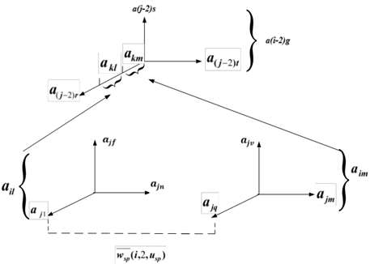

**Fig. 2.** Geometric interpretation of the subject dependence of the 1st kind of the 2nd type, where $a_{il},a_{im}$ define abstract spaces, $a_{j1},…,a_{jq},a_{jm}, a_{\left(j-2\right)r},a_{\left(j-2\right)t}$ define the axes of spaces of different levels of semantic complexity, $a_{kl},a_{km}$- define fragments of scales on the axis

**The formal description of statistical subject constraints of the 1st kind of a specific level**

All subject dependences according to the degree of formalization can be classified into analytical (*an*), statistical (*st*), empirical (*em*). Formally, this can be represented:

|  |  |  |
| --- | --- | --- |
|  | $$\overline{P\left(n\right)}=\overline{P^{an}}(n)∪\overline{P^{st}}(n)∪\overline{P^{em}}(n)$$ | (32) |

Instances of statistical subject dependencies of the 1st kind, respectively, can be classified by types and by content (by common arguments and by their values).

Since the typology of dependencies is determined by the level of semantic complexity, it is necessary to determine their type to systematize instances of statistical subject dependencies, taking into account the level of complexity.

A fragment of a conceptual model for constant information for a selected statistical instance of a subject dependence of the 1st kind at a specific level can be represented as follows:

|  |  |  |
| --- | --- | --- |
|  | $${KP3}_{c}^{spl}.1\left(nm\right)=<B_{sp}\left(nm\right),{T3}_{spl}\left(nm\right),\overline{p_{l}^{sp}},R_{3}^{KP-\overline{p_{l}^{sp}}}>$$ | (33) |

where $B_{sp}\left(nm\right)$ is a set of instances of subject categories that characterize the *spl*th ISD of the 1st kind; ${T3}_{spl}\left(nm\right)$ is a set of binary relations on the ISC, characterizing the *spl*th ISD of the 1st kind; $\overline{p_{l}^{sp}}$- statistical instance of subject dependence of the 1st kind, $R_{3}^{KP-\overline{p_{l}^{sp}}}$– linking of ISD-1 and the main conceptual structure at a specific level.

|  |  |  |
| --- | --- | --- |
|  | ${KP2}_{c}^{sp}.1\left(n\right)=\{{KP3}_{c}^{spl}.1\left(nm\right)$} | (34) |

Linking is a fragment of a conceptual model for constant information for a selected statistical subject dependence of the 1st kind and a selected statistical instance of a subject dependence of the 1st kind.

For the geometric interpretation of constraints of the 1st kind, the following concepts can be used: abstract space, axes of abstract space, metrics, or scales of axes of abstract space. It is assumed that the axes have "heterogeneous" metrics and any axis can have a set of “non-uniform" scales. Then the abstract space itself will be determined by a contextual subject category, its axes are determined by structural subject categories, and the metrics of these axes are determined by a set of monadic categories.

At a specific level, a monadic subject category instance defines a point on an axis fragment (or a structural subject category instance). The collection of points on the axes defines a point in abstract space (or a contextual instance of a subject category). Figure 3 shows a geometric interpretation of instances of subject dependencies of the 1st year of the 3rd type.

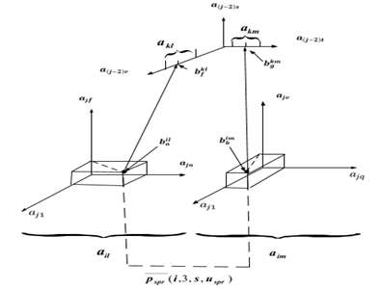

**Fig. 3.** Geometric interpretation of instances of subject dependence of the 1st kind of the 3rd type, where $b_{g}^{km}$ is a point in the $a_{km}$ fragment of the $a_{(j-2)r}$ axis, $b_{f}^{kl}$ is a point in the $a_{kl}$ fragment of the $a_{(j-2)t}$ axis, $b_{a}^{il}$ is a point in space $a_{il}$, $b_{b}^{im}$ is a point in space $a_{im}$

Statistical SD-1 and instances of statistical SD-1 are a fragment of the conceptual model of the object-level objective problem, in which one SD-1 is associated with a fragment of the main conceptual structure. Based on this, a formal description of the procedure for stratifying the conceptual model of the subject problem for variable and constant information was carried out.

**Conclusions**

The refinement of the formal description of conceptual representations makes it possible to take into account and systematize all the variety of constraints applied in subject problems, following the typology of constraints on a single conceptual structure.

This is the basis for their subsequent methodological identification and description when developing a methodology for allocating fragments of a conceptual model for permanent information for subject problems.

**References**

1. **Волкова Г. Д.** Методология автоматизации интеллектуального труда. - М.: Янус-К, 2013. - 104 с.
2. **Волкова Г. Д.** Концептуальное моделирование проектных задач: учеб. Пособие – М.: ФГБОУ ВО «МГТУ «СТАНКИН», 2016. -117 с.:цл.
3. **НьиНьиХтве, Волкова Г. Д., Тюрбеева Т.Б.**Формальное описание классификации и обработки концептуальной модели объектного уровня для предметной задачи// В сборнике: Цифровая экономика: технологии, управление, человеческий капитал. Материалы III всероссийской научно-практической конференции. 2020. С. 73-78.
4. **Волкова Г. Д., НьиНьиХтве**Формальное описание процедуры обработки концептуальной модели//Материалы XIII всероссийской конференции с международным участием «Машиностроение: традиции и инновации (МТИ – 2020)». Сборник докладов. – М.: ФГБОУ ВО «МГТУ «СТАНКИН», 2020. – 444 с. 298-305.
5. **Волкова Г.Д.** Философские аспекты моделирования конструкторско-технологических знаний при создании систем автоматизации проектирования в машиностроении // Вестник МГТУ Станкин. – 2012. – № 1 (19). – С. 141-144.
6. **Тюрбеева Т.Б., Волкова Г.Д., Семячкова Е.Г., Винарская Г.А**. Исследование методов классификации и представления знаний в научно-технических публикациях и технической документации // Вестник МГТУ Станкин. – 2018. – № 4 (47). – С. 168-171.

***Volkova Galina Dmitrievna***– d. Sc. in Engineering, Professorsub‑department «Information technologies and computing systems» of MSUT «STANKIN»

*[cog-par@yandex.ru](mailto:cog-par@yandex.ru)*

***NyiNyiHtwe*** -postgraduate student of sub-department «Information technologies and computing systems» of MSUT «STANKIN»

*[sawnyinyi90@yandex.ru](mailto:sawnyinyi90@yandex.ru)*

УДК 004.057.4:62-526А.

A.Al Khoury

**Batch parameterization of CAN servo drives by using motion controller based on a single-board computer**

*When upgrading a high-performance CNC, the development of a mechanism for autonomous parameterization of servo drives is an important step. Advanced CNC systems must support multi-protocol control and provide the ability to configure different equipment. Modern servo drives have built-in configuration tools that are designed for devices from the same manufacturer and cannot be used in a heterogeneous environment.*

*This article describes an approach to developing and using a motion controller to control and configure CAN equipment from different manufacturers based on a single board computer. Program solution for parameterization of different CAN servo drives is demonstrated, the results of the autonomous parameterization are also analyzed.*

**Keywords:** automation, parameterization, CAN servo drives, motion controller, ARM microcomputer, CAN industrial protocol.

**Introduction**

Various technological tools are used to configure and parameterize the servo drives.

One of the ways of parameterization is the use of the manufacturer's tools. For example, "Motomaster for step CAN servo drives", "MintWorkBench for ABB CAN servo drives", "SuperDrive for WEG servo drives", etc., with the help of which the machine commissioning engineer can select and configure the required parameters of the servo drive operation.

When using the manufacturer's toolkits, the engineer is obliged to connect the servos to a personal computer via the USB interface and install the appropriate software, which increases the cost of the final product, since there will be no configuration tool without a personal computer. In addition, this solution has other disadvantages - the factory setup tools are not open solutions, which does not allow the user to add new functionality, such as automatic setup methods, diagnostics of parameters, and receiving feedback from the CNC system to determine the parameters of servo drives.

**Main part**

As an example, let us illustrate the CAN servo motion controller, previously implemented in previous works [1], used to perform the control task. In this implementation, the computing platform of the motion controller was an ARM microcomputer Raspberry PI3 with the Linux operating system. The core of the CNC system controls servo drives via the industrial CAN protocol, the interaction between the motion controller and the core of the CNC system is carried out using local TCP/IP [2,3]. The MCP2515 module is a stand-alone CAN bus controller that provides connectivity to CAN servo drives.

To configure servo drives, in addition to the motion controller, we needed a PC with the Motomaster tool.

The previously described classic way of performing servo control and tuning is shown in Fig. 1.

**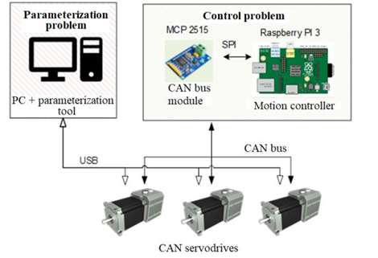**

**Fig. 1.** The classic way to perform control and configuration of servos

Since all servos work in the system and have different loads, this solution has some disadvantages: each drive is configured separately, and the CNC system [4] does not have a complete picture of the operation of the servos, and it is also constantly necessary to re-configure individual drives iteratively.

As a rule, servo drives, in addition to the standard factory setting tool, also support another method of parameterization - the use of a direct industrial fieldbus protocol used for control, which provides customization flexibility and reduces the cost of the final product, since this solution excludes the use of an additional PC.

For the simultaneous execution of tasks of control and adjustment of servo drives using the same industrial protocol, it is necessary to expand the functionality of the motion controller, which was implemented earlier.

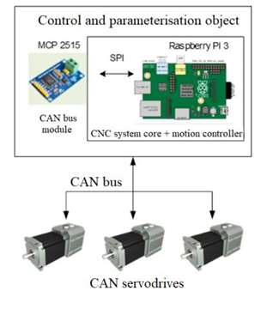

**Fig. 2.** Using the motion controller to control and parameterize servo drives

Additional advantages of using an industrial protocol to solve the parameterization problem are the use of a single protocol for configuration and control; all servos will be connected directly to the motion controller via a single line, which provides flexibility for installation, maintenance, and expansion of the system with new components.

In addition, the CNC system receives feedback information not only for control but also on the status of the operating parameters of the servo drives via one communication line.

The motion controller, as a controlled device, receives information in the form of frames of a certain format via the real-time CAN protocol.

The motion controller as a parameterization device sets the value of a specific parameter of any connected servo drive using the technological CAN protocol (the technological protocol is intended for configuring the drive and analyzing its operation), the frame format for this protocol is shown in Fig.3, with the help of this protocol, you can access any parameters both for writing and for reading.

**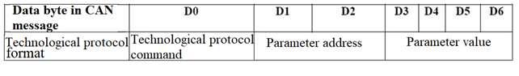**

**Fig. 3.** The format of the frame of the CAN technological protocol

To perform the task of controlling and parameterizing servo drives, the CNC core [5] initiates the exchange of information with the motion controller and controls the change of communication phases. The main 3 phases are initialization, parameterization, cyclic exchange, as shown in Fig. 4.

At each communication phase, different sets of commands are available, which are perceived by the motion controller. In the parameterization phase, the CAN technology protocol is used, where the procedures for reading and writing the parameters of the servo drive are reproduced in the form of "Request-Response" packets, where the core sends a request [6,7], and the drive responds within a certain period.

**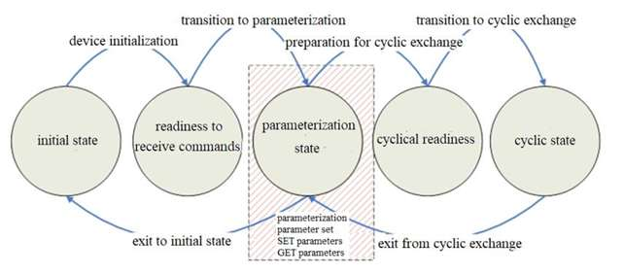**

**Fig. 4.** The phases of the motion controller operation and the principle of "communication state machine"

In the parameterization phase, the entire list of parameters of drives and input/output devices will also be set. Depending on the preset values that are stored in the CNC core [8] or entered by the system engineer, high precision of the part processing is ensured. Thus, the motion controller will receive or set the correct set of parameters of the servos via the technical CAN protocol.

In the core of the CNC system, some classes have been developed that allow sending a file with a whole set of servo parameters to the motion controller, for this, we should create an appropriate file, place it in the executable directory, and specify the file name in the machine parameters [9]. The content of the parameterization configuration file depends on the drive type, as shown in Fig. 5.

**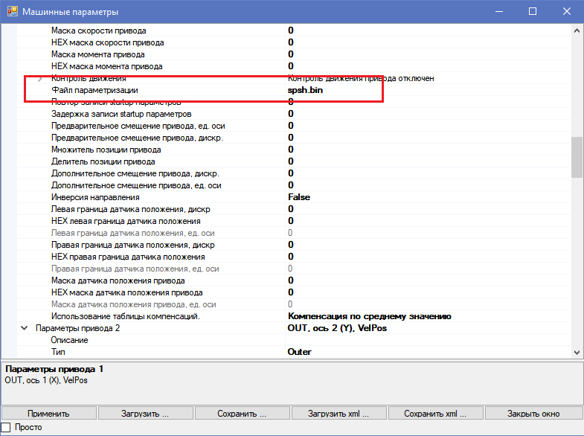**

**Fig. 5.** Sending a file with a whole set of servo parameters from the CNC core to the motion controller

Thus, according to the technological CAN protocol, each of the drives receives a corresponding set of parameters, then the parameter values are decrypted by the CAN frame identifier.

To change a specific parameter of a servo drive, an online editor of servo drive parameters was implemented, which allows you to change any value and test the accuracy of the movement of the drive when machining a part. The online editor of the servo drive parameters is shown in Fig. 6, it is integrated into the user interface of the control system.

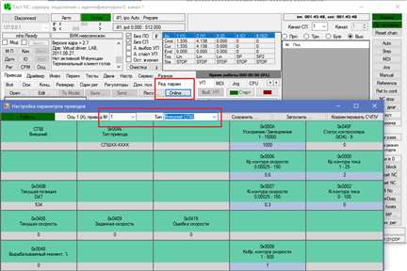

**Fig. 6**. Online-editor of the step servo drive parameters

There are several models of CAN servo drives on the domestic market - these are synchronous servos and step servos. The synchronous servo, in contrast to the step servo drive, has higher output power, a wider speed range, and high smoothness at low engine speeds. But step servo drive is cheaper for desktop machines. Our approach extends to both models since our motion controller uses the industrial CAN protocol, and the addresses of the parameters of both drive models and their allowable ranges of values have been added to the software solution. In addition, in the structure of the configuration file for parameterization, it is necessary to indicate the used servo drive model - synchronous or step servo drive.

To test the implemented system, a parameterization configuration file was created, with the help of which the parameter used for the step type drive "Acceleration/Deceleration" will be automatically set to the value 1000 when parameterizing. The text file is shown in Fig. 7.



**Fig. 7**. An example of the configuration file for the parameterization of the step servo drive

To compare this approach with the classical parameterization method, the cores of the CNC system and the motion controller were launched on the hardware base of the Raspberry Pi microcomputer, and an additional PC with the Motomaster tool was needed for the classical method.

Table 1 shows the key points of comparison:

*Table 1*. **Key points of comparison**

|  |  |  |  |  |
| --- | --- | --- | --- | --- |
| Parameterization  method | Cost | Parameterization of several drives simultaneously | Parameterization time for 3 drives | Used interfaces |
| Classic | 15,000 rubles  (PC + Raspberry) | no | 7 min. (including USB switching) | - USB for parameterization  - CAN for control |
| Our solution | 4000 rubles  (Raspberry only) | yes | 2 min. | - CAN for parameterization and control |

**Conclusions**

In this work, an autonomous mechanism for batch parameterization of servo drives was developed using a motion controller based on a RaspberryPi 3 single-board computer, which allowed performing drive parameterization procedures directly from the control system via the industrial CAN protocol and reducing the cost of an additional PC with a factory setup tool. Also, the corresponding software elements were implemented in the CNC system, allowing sending parameter sets to the drive via the motion controller and editing the values of any parameter through an Online editor. This solution gives the CNC system the ability to perform some additional tasks.

These include online readjustment of drives and self-diagnostics. During online readjustment, the CNC system, based on the load of the servo drives, can adjust its own control loop regulators. In self-diagnostics, the CNC system during machine operation receives feedback on the status of the servo drive parameters, analyzes the compliance of the operating parameters, and issues warning messages to the operator about the need to reconfigure the parameters.

**References**

1. **Georgi M.Martinov, AkramAlKhoury, Ahed Issa.** An approach of developing low-cost ARM-based CNC systems by controlling CAN drives// MATEC Web Conf., 2018, Volume 224. P.122-127.

2. **Мартинов Г.М., Аль Хури Акрам, Исса Ахед** Удаленное управление сервоприводами CAN и мониторинг их работы на основе микрокомпьютеров ARM и с использованием протокола OPC UA // Автоматизация в промышленности, №10. 2019. с.9-12.

3. **Никишечкин П.А., Аль Хури А., Исса А., Червоннова Н.Ю.** Использование протокола OPC UA для мониторинга работы технологического оборудования, управляемого с помощью программно-реализованного контроллера // Автоматизация в промышленности, №5. 2020. с.37-40.

4. **Мартинова Л.И., Мартинов Г.М.** Организация межмодульного взаимодействия в распределенных системах ЧПУ. Модели и алгоритмы реализации // Мехатроника, автоматизация, управление. 2010. № 11. С. 50-55.

5. **Martinov G., Nikishechkin P., Al Khoury A., and Issa A.** Control and remote monitoring of the vertical machining center by using the OPC UA protocol // IOP Conf. Series: Materials Science and Engineering V. 919, 032030. P.1-8.

6. **Мартинов Г.М., Нежметдинов Р.А., Никишечкин П.А.** Разработка средств визуализации и отладки управляющих программ для электроавтоматики, интегрированных в систему ЧПУ//Вестник МГТУ «Станкин». 2012. № 4 (23). С. 134-138.

7. **Мартинов Г.М., Козак Н.В.** Декомпозиция и синтез программных компонентов электроавтоматики//Приборы и системы. Управление, контроль, диагностика. 2006. № 12. С. 4-11.

8. **Мартинов Г.М., Козак Н.В., Нежметдинов Р.А., Григорьев А.С., Обухов А.И., Мартинова Л.И.** Метод декомпозиции и синтеза специализированных систем ЧПУ//Автоматизация в промышленности. 2013. № 5. С. 08-14.

9. **Мартинов Г.М., Обухов А.И., Пушков P.Л.** Принцип построения универсального интерпретатора языка программирования высокого уровня для систем ЧПУ//Мехатроника, автоматизация, управление. 2010. № 6. С. 42-50.

***Al Khoury Akram*** –lecturer at the department of computer-architecture control systems, MSUT«STANKIN»

*akramalkhoury@gmail.com*

УДК 621.735.016.2 S.E. Filatov

**Development of method and algorithm for preparing the control program of machine for mounting printed circuit board with a wide range element base of domestic production.**

*The work presents the problem of difficult preparation of the control program of the modern high-tech equipment for mounting electronic products with a wide range element base of domestic production. The analysis of structure electronic uploading for preparation of the control program and operation of hardware of the machine with computer-controlled equipment (CNC) for surface mounting is made. The method and algorithm of software-implemented tool for preparing electronic uploading for preparation the control program of the machine have been developed.*

**Keywords:** automation, computer-controlled equipment, CNC, control program, printed circuit board (PCB), surface mounting devices (SMD).

**Introduction**

At the stage of experimental work on the automated production cell, it was revealed that the vast majority of technological equipment performing automated surface mounting of the planar-type element base has the software [1] adjusted for the installation of the imported element base.

This problem concerns almost all electronic engineering enterprises engaged in the implementation of government orders, which are regulated by generally accepted industry production standards. Based on this, the layout of electronic equipment is made only by the domestic element base to maintain competitiveness in the electronic engineering market. At the same time, production cells engaged in the production of electronic products on a commercial basis can set their conditions for the execution of the order [2]. Enterprises that use the technology of surface mounting of printed circuit boards set the requirements for the design of electronic products for the production facilities that the enterprise has. As a rule, enterprises that produce electronic equipment set the design of products with 90% of the imported element base due to the problem associated with the peculiarities of the operation of technological equipment [3].

**Analysis of the process of creating a control program for a CNC machine**

In practice, during the preparation of production, due to the indicated drawback, it is necessary to carry out the laborious process of creating the control program of the machine tool manually. If we consider the process of creating a control program on a CNC machine, it is divided into the following stages:

1. preparation of electronic unloading from the board design environment;

2. reconciliation and editing of the parameters of electronic unloading with design documentation;

3. preparation of the installation file by the built-in software of the machine that performs the automated installation.

When generating an electronic upload file, it is necessary to determine in which systems (environments) the printed circuit board was designed. In this study, the design and construction of electronic products are governed by the use of AltiumDesigner and P-CAD programs [4]. In the presented automatic design systems (CAD), the process of generating an electronic download for automatic looks like this.

**Generating electronic uploads in AltiumDesigner**

In AltiumDesigner, a constructed model of a printed circuit assembly containing a topological drawing of a printed circuit board with the extension ".pcb" must be opened using the appropriate software. With the built-in CAD software, the "Pick and Place Setup" dialog box is opened sequentially in the tabs (File → Assembly Outputs → Generates pick and place files), the necessary parameters are set in it, which will later be generated in the form of text data for electronic unloading for the CNC installer (Fig.1).



**Fig. 1**. The order of opening tabs for generating the upload file

In this dialog box, the unit of measurement for the coordinates of the element base is indicated (in practice, the metric system is always used), then the file in the form of a text table (Fig. 2) is generated automatically in the root folder of the project. This file is required to implement the installation of components on a printed circuit board on an automatic installer.

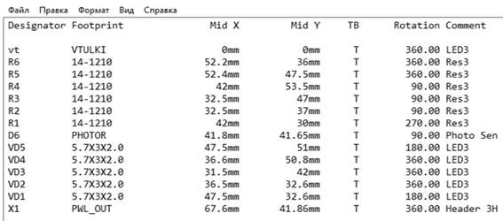

**Fig. 2.** View of the text file of the electronic upload

**Formation of electronic upload in P-CAD**

The procedure for creating an upload from this software is identical to the previous one, except that in this program it is necessary to specify what data to enter in the electronic upload (all project data is generated in AltiumDesigner).

To create an electronic upload after designing a printed circuit assembly, using the tabs "File" and "Reports" in the dialog box that appears (Fig. 3), select the attributes required to generate an electronic upload. Further, to configure the generated file, you need to select additional settings (coordinate value, nominal value, standard size of the electronic component, etc.).

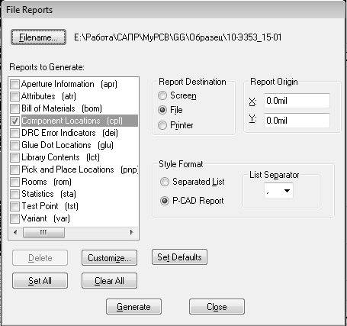

**Fig. 3.** View of the "File Reports" dialog box

Then the file in the form of a text table (Fig. 4), as in the previous case, is formed automatically in the root folder of the project. This file is necessary to implement the installation of components on a printed circuit board on an automatic installer.

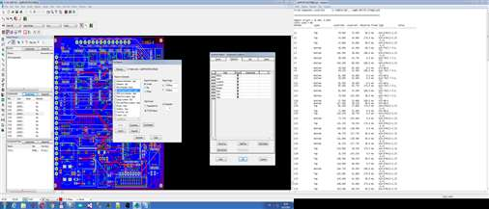

**Fig. 4**. View of the text file of the electronic upload

**Description of the structure of electronic unload from CAD**

To represent the structure of the electronic unloading for an automatic installer with a CNC system, we define the value of each attribute:

• Mid X, Mid Y as well as LocationX, LocationY - coordinates relative to the center point of the component; this parameter is required for precise positioning of the element base on the contact pad;

• Layer - the side of the component (bottom or top); since most electronic products are mounted on both sides by design, this parameter allows you to sort them by location on the board;

• Designator - component identifier on the printed circuit board; as a rule, the identifier, in addition to the model, is duplicated on the printed circuit board in the form of silk-screen printing for checking during the start-up launch for the correspondence of the location of the component relative to its seat;

• Rotation - the angle by which the component is rotated on the model; since chip components are supplied in a vertical position in the tape, this parameter is required when the component is automatically rotated by a given angle;

• Type and Footprint - component size; this parameter is the key to the productivity of the installer, since thanks to it, the electronic unloading is linked to the library of components of the installer, after which the automat performs manipulations on the installation of this component, linking through the library all the attributes and options related to the specifics of its installation.

**Problem statement**

A significant disadvantage of automatic installers, due to which the productivity of the machine tool drops sharply at the stage of technological preparation of production, as mentioned earlier, is a large volume of domestic hardware components used in electronic products [5].

When developing a method for solving this problem, the option of replenishing the built-in library with domestic cases was considered, but in the process of mastering the machine software that adds a new component to the library, a problem arose associated with the need to enter a large number of element base parameters:

• selection of the type of centering of the component in the setting head of the machine (laser, machine vision, automatic mechanics, etc.);

• input of component dimensions (height, width, length);

• location of the key or polarity symbol of the component;

• selection of a nozzle for gripping a component;

• setting the vacuum level in the nozzle;

• creating a graphical image of a component using the built-in software utility;

• binding the feeder to the component and choosing its type;

• advanced settings for gripping a component from a feeder;

• setting parameters for each type of component centering;

• adjusting the speed of movement of the manipulator with the component in the head.

In general, if we imagine the process of replenishing the built-in library with the nomenclature of all domestic elements used in electronic products of computer control systems, then, according to preliminary calculations, this process may take several years. Also, an increase in the labor intensity of the process of replenishing the library is due to a number of the following factors: re-equipment of electronic products and technological equipment, development, and implementation of new electronic products, updating outdated elements base, etc. Based on the above, it was decided to simulate a software tool that adapts electronic unloading for automatic installers [6].

**Development of a model and method of forming electronic unloading for CNC machines**

When studying the standard sizes of the domestic element base, it was found that it corresponds to almost all known import designations of standard sizes. The difference lies in the material from which the microcircuits and size coding are made. For example, the domestic standard size of integrated microcircuits 4308.16-1 fully corresponds to the standard sizes of the imported SO16 coding (Fig. 5), based on which it can be concluded that the element codes of domestic production and the element codes of imported production are interchangeable. In other words, the means for adapting electronic unloading, a sub-automatic installer of the element base, must replace the code of the domestic standard size of the case with an imported designation of the standard size. With this, it is possible to adapt electronic products with a wide range of domestic element bases for installation on modern equipment that carries out automated surface mounting of electronic equipment [7].

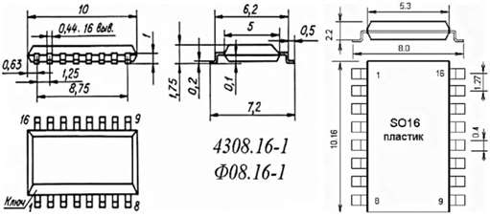

**Fig. 5.** Comparison of standard sizes of cases of domestic and foreign production

Based on the type of electronic unloading presented earlier, it can be concluded that the replacement of the code values will be made in the columns "Type" and "Footprint" since they contain the code of the standard size of the element base. Due to this, the process of replacing the codes of the standard sizes of the element base can be represented in the form of an algorithm (Fig. 6).

Based on the given model of the algorithm for the formation of electronic unloading, adapting domestic cases for imported ones, it is possible to perform a software implementation of such a converter to significantly increase the performance indicator at the stage of technological preparation of production and assembly processes in general.

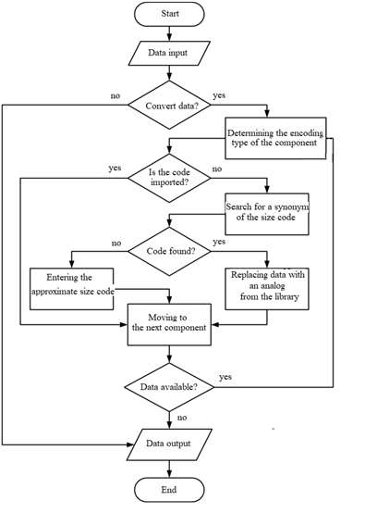

**Fig. 6**. Algorithm of work of the electronic unloading converter

Modeling and development of this method is a conceptual solution to the problem of preparing a control program for automatic CNC installers for all enterprises that use surface mount technology for electronic products.

**Research results and their discussion**

Based on the results of the work carried out on modeling the automation tool for technological preparation of production, which converts electronic unloading for an automatic element installer, an experimental model of the program was designed based on the developed converter algorithm [8].

The software model developed based on the algorithm, by creating an integrated data library, is completed with codes of domestic elements that are closest to their imported counterparts, for subsequent automatic replacement of the code synonym.

If the synonym of the code of the body of the domestic element base is not found, then the code of the synonym is entered manually, after which a new code (precedent) is entered into the library to implement the replacement of this body of the element in the future.

When testing the starting version of the designed model of the electronic unloading conversion software, it turned out to convert the initial form of electronic unloading from the CAD for the design of electronic products into the final form adapted to the built-in software of the CNC machine, using the pre-installed library of element base cases used on printed circuit assemblies (Fig.7).

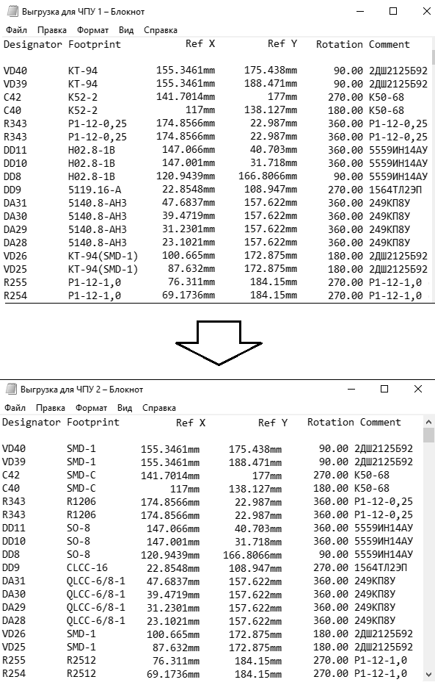

**Fig. 7**. View of electronic upload before and after conversion

Based on the results of the test work of the model of the automatic converter of electronic unloading (in comparison with the manual method of its preparation), it was concluded that the time for compiling the control program of the CNC machine was significantly reduced. Since the manual preparation of electronic unloading required a time-consuming operation to study the product specification and the composition of the element base to determine the code of the component body, using the developed converter model, the operation of processing design documentation for labor intensity is minimized, and since electronic unloading is generated from the source project file, checking the drawing for inconsistencies is not required.

**Conclusion**

Based on the above observation, we can conclude about the positive effect of the developed model of the electronic unloading converter, thanks to which, at the stage of preparing the control program of the CNC machine, there is no need to perform a labor-intensive and responsible operation for pre-processing design documentation, which greatly reduces the time of implementation of technological preparation for the production of electronic products.

According to the results of the test work, in addition to simplifying the technological preparation associated with the development of a control program for a CNC machine, there is a significant reduction in the labor intensity of the production of electronic products. Moreover, with an increase in the complexity of the design of the printed circuit assembly, the time spent on preparing the electronic unloading decreases, and there is no need for operations related to the processing of design documentation. This effect is caused by the fact that with a manual type of assembly of a printed circuit assembly, the installer should constantly refer to the design documentation for the correct installation of the element base, just as in automated assembly the operator of the CNC machine based on the design data of the printed circuit assembly composes a control program, creating an element base that is constantly changing from time constructively due to the high rates of development of domestic electronics.

**References**

1. **Пелипенко А.Б., Яблочников Е.И.** Современные тенденции в развитии CAD/CAM-технологий: ориентация на процессы. // САПР и Графика, № 9, 2001, с. 82-85.
2. Технология радиоэлектронных устройств и автоматизация производства. Курсовое проектирование: Учебное пособие / Ануфриев Л.П., Бондарик В.М., Ланин В.Л., Хмыль А.А. - Мн.: Бестпринт, 2001. – 144 с.
3. **Филатов С.Е.** Особенности применения автоматизированного оборудования на производстве электронных изделий в машиностроении. Технология машиностроения. 2020. № 1. С. 53-59.
4. **Энгельке У.Д.** Как интегрировать САПР и АСТПП: Управление и технология. /Пер. с англ.; Под ред. Д.А. Корягина.-М: Машиностроение, 1990 - 320 с.
5. **Филатов С.Е.**Внедрение и освоение автоматизированных технологий на производстве современных наукоемких РЛС. Гагаринские чтения - 2018 Сборник тезисов докладов XLIV Международной молодёжной научной конференции. 2018. С. 215-216.
6. **Мартинов Г.М., Нежметдинов Р.А., Никишечкин П.А.**Разработка средств визуализации и отладки управляющих программ для электроавтоматики, интегрированных в систему ЧПУ. Вестник МГТУ Станкин. 2012. № 4 (23). С. 134-138.
7. **Евстафиева С.В., Лукьянов А.В., Мартинова Л.И., Пушков Р.Л.** Разработка аппаратных компонентов системы ЧПУ с использованием современных САПР. Автоматизация в промышленности, №9, 2014. c.35-39.
8. **Мартинова Л.И., Никич А.Н.** Модели и инструментальные средства сбора и обработки информации о работе технологического оборудования в цифровых производствах. Вестник МГТУ «Станкин». – 2019. – № 3 (50). – С. 103-107.

***Filatov Sergey Evgenievich*** – teacher-researcher, the head office of «JSC «SPO ALMAZ»

*lab421polus@mail.ru*

УДК 004:681.2.087

Issa A.

**Development of OPC UA server and conducting bench tests for remote monitoring of parameters of the CNC system core**

*The OPC UA protocol is widely used for data collection of technological production equipment and monitoring its operation.*

*This work describes a way of connecting the CNC system to the OPC UA server for performing remote monitoring of parameters and then conduct bench tests to evaluate the performance of the OPC UA servers.*

**Keywords**: Automation, monitoring, OPC UA server, CNC, testing.

**Introduction**

Industry 4.0 and the Industrial Internet of Things (IIoT) provide a powerful industrial digitization solution for remote monitoring and control of process equipment. This solution supports several types of technological equipment, for example, CNC machines, PLCs, controllers, network switches, data collectors, etc. It also supports many standard communication protocols (OPC UA, MT Connect, Modbus, PROFINET, MQTT, etc.) for connecting process equipment, making it suitable for various applications and projects of process automation.

OPC UA is widely used as a key communication and data modeling technology for the Industry 4.0 initiative. It works with many software platforms, is fully scalable, and, due to its flexibility, is widely used in several manufacturing industries.

Since there are many OPC UA protocol libraries in different programming languages and with many types of licenses, an important step after the implementation of an OPC UA server-based on various libraries is to conduct bench tests to evaluate the performance of OPC UA servers, the data exchange rate of each node for reading and writing.

**Main part**

There are many communication interfaces, profiles, and mechanisms for integrating CNC machines into the production network, including standardized solutions for specific manufacturers.

A large number of different standards and the lack of consistency in standardization lead to significant difficulties when creating new OPC UA networks. OPC UA is a standard for cross-industry communication between different participants.

Although OPC UA is currently used in the field of CNC machine tools, there are no universal and consistent information models. The main goal of OPC UA is to create standard companions for CNC systems [1,2].

Figure 1 shows an OPC UA information model for remote monitoring of the parameters of the CNC system core. Conventionally, the components operating in real-time are distinguished in the architecture of the technological equipment control system: the core of the control system (the core of the CNC system) and the components operating in machine time: the terminal of the control system (the terminal of the CNC system) and the OPC UA server.

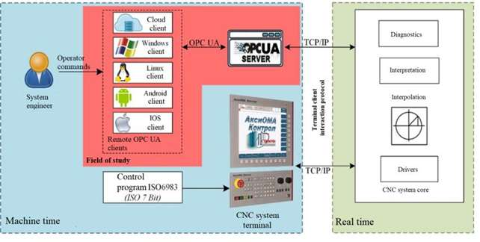

**Fig. 1.** Information OPC UA model for remote monitoring of the parameters of CNC system core

The OPC UA server runs on a personal computer, generates parameters specific to the CNC system, and communicates with the core via a TCP/IP socket. Using this protocol, the server receives a list of readable parameters of the CNC system core. Remote monitoring of the parameters of the core of the CNC system is carried out by cloud clients and ready-made clients available in the OPC UA market, as well as by clients developed by OPC UA.

Any client connected to the OPC UA server has access to the list of parameters of the CNC system core to monitor and read their values. Thus, a system engineer, using the OPC UA client, can remotely monitor the parameters of the CNC system core.

The OPC UA information model is implemented in the OPC UA server and reflects the logical structure of a CNC machine [3]. A proposed information model corresponds to the hierarchy of the internal structure of objects of the CNC system, which makes it possible to have complete and structured information about the machine tool and the machining process, as well as to build full-featured operator interfaces like OPC UA clients. Restrictions of the AxiOMA Control platform are imposed on the information model for the CNC system, for example, the maximum permissible number of channels, the number of axes, etc. These restrictions are implemented in software and can be extended if necessary.

The OPC UA server provides remote monitoring of the parameters of the core of the AxiOMA Control CNC system, which solves real-time problems.

The OPC UA server also establishes a relationship between the parameter of the CNC system core and OPC UA clients. The tasks of the architectural model of the OPC UA server for customer service of the CNC system [4,5] include:

- Detection of CNC systems specified by a text format list and automatic connection to those that are working at the time of launch. Interaction between the CNC system client and the CNC system core is carried out using an open protocol.

- Automatic creation of C ++ objects corresponding to the main objects of the core of the connected CNC systems (the core as a whole, channels, axes, etc.).

- Automatic creation and subsequent updating of OPC UA data of elements corresponding to objects and their data of connected CNC systems.

In particular, OPC UA elements of the "CNCType" type are characterized by such data about the state of the CNC system core, such as the connection status, the total operating time of the machine, the processor load, etc. OPC UA elements of the "ChannelType" type are characterized by such data as working mode, channel state, name of the current control program, etc. For elements of the "AxisType" type - the axis type, current, set and end coordinates, etc. A simplified hierarchy of OPC UA server elements is shown in Figure 2.

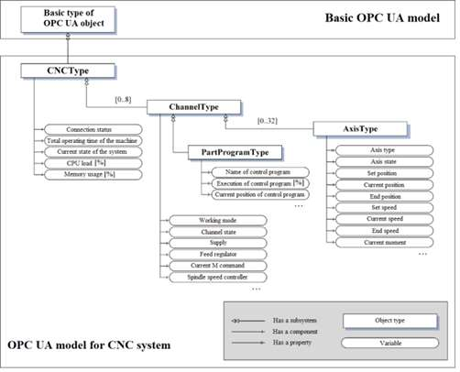

**Fig. 2**. Architectural model of the OPC UA server for remote monitoring of the parameters of the core of the CNC system

As a result, the OPC UA server has data on the state of the core of the CNC system [6] and on control objects (spindle, drives controlling machine axes, etc.) and transmits this data to all OPC UA clients operating based on various operating systems, providing complete remote monitoring of machine data.

The main code of the OPC UA server does not depend on the hardware and software platform. This is the most common way to build multiplatform software modules.

All available data received from the CNC system [7] are similarly defined in the information model of the OPC UA server. After establishing communication between the OPC UA server and the CNC system, the clients connected to the OPC UA server gain access to the data of the CNC system such as the connected channels, the state of the connection with the OPC UA server, and the total operating time of the system. The Channel node displays general information about the channel and the working axes in it. In the Axis node, information about the current state of the axis is viewed. Figure 3 shows the viewing of nodes and access to data from the OPC UA server of the CNC system. These nodes provide the ability to remotely monitor the parameters of the CNC system core.

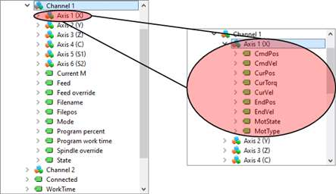

**Fig. 3.** Viewing nodes and accessing data from the OPC UA server of the CNC system

The OPC UA CNC server [8,9] was implemented using two different libraries:

- OPC UA SDK C ++: A closed source solution suite developed by Unified Automation GmbH in C ++ and has rich developer documentation detailing how to create a basic OPC UA application. But it is not completely free.

- OPC UA Open62541: Open source and completely free project under the Mozilla Public License v2.0 (MPLv2). This library implements the OPC UA specification and is developed in the C \ C ++ and C # languages. Has well-described documentation with instructions for building and creating an OPC UA application.

UAExpert OPC UA client can be used to measure the efficiency of an OPC UA server. This client can be configured to call OPC UA services (read, write, create and delete items) a certain number of times or to call services as often as possible at a specified time interval. UAExpert OPC UA client can also specify the number of nodes to be used for OPC UA service calls. For each test case, a cumulative value is provided that displays the average time of all tested OPC UA services tested for each number of nodes.

Using this client, the efficiency of the OPC UA SDK C++ and OPC UA Open62541 libraries was compared. The comparison is performed using a different number of nodes (10,50, 100, 250, 500, and 1000) and by repeating the comparison 100 times for each number of nodes. The test results are presented in Tables 1 and 2, as well as in Figures 4 and 5.

*Table 1*. **Average time of tested OPC UA services of the OPC UA Open62541 library using the UAExpert OPC UA client**

|  |  |  |  |  |  |  |  |
| --- | --- | --- | --- | --- | --- | --- | --- |
|  | | Average time of tested OPC UA services for each number of nodes (ms) | | | | | |
| 10 nodes | 50 nodes | 100 nodes | 250 nodes | 500 nodes | 1000 nodes |
| OPC UA Service | Read | 0.4739 | 1.1989 | 2.5491 | 5,7597 | 14,2555 | 37,9581 |
| Write | 1,4998 | 6,2471 | 12,0716 | 29,0203 | 63,3387 | 126,6281 |
| Create | 0,7412 | 2,6965 | 5,2722 | 12,8442 | 29,2738 | 71,4381 |
| Delete | 0,2251 | 0,3481 | 0,6618 | 1,2856 | 2,6373 | 16,9371 |

The average time of all tested OPC UA services for each number of nodes using the OPC UA Open62541 library is also shown in Figure 4.

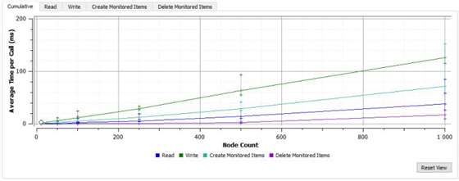

**Fig. 4**. Average time of all tested OPC UA services for each number of nodes using the OPC UA Open62541 library

*Table 2.* **Average time of tested OPC UA services of OPC UA SDK C ++ library using UAExpert OPC UA client**

|  |  |  |  |  |  |  |  |
| --- | --- | --- | --- | --- | --- | --- | --- |
|  | | Average time of tested OPC UA services for each number of nodes (ms) | | | | | |
| 10 nodes | 50 nodes | 100 nodes | 250 nodes | 500 nodes | 1000 nodes |
| OPC UA Service | Read | 2.0291 | 7.0718 | 11.6071 | 26.2831 | 50.4835 | 92.7631 |
| Write | 1.3382 | 6.1828 | 11.3316 | 25.6181 | 52.5566 | 91.7058 |
| Create | 2.1801 | 8.7217 | 15.3221 | 35.0561 | 70.4501 | 130.089 |
| Delete | 0.4564 | 0.9609 | 1.5543 | 3.3545 | 7.2471 | 19.3253 |

The average time of all tested OPC UA services for each number of nodes using the OPC UA SDK C ++ library is shown in Figure 5.

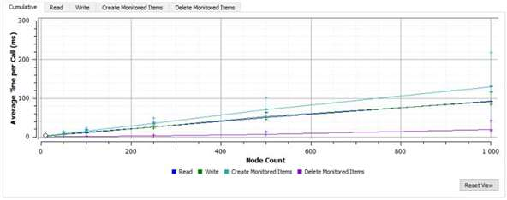

**Fig. 5**. Average time of all tested OPC UA services for each number of nodes using the OPC UA SDK C ++ library

Comparison of the data presented in tables 1 and 2 shows that the OPC UA Open62541 library is faster than the OPC UA SDK C ++ library for OPC UA services for reading, creating, and deleting items, but the OPC UA SDK C ++ library is faster than the OPC UA Open62541 library for OPC UA writing services elements.

**Conclusions**

In this work, bench testing was carried out. We also compared the efficiency of the OPC UA SDK C++ and OPC UA Open62541 libraries using the UAExpert OPC UA client. It turned out that the OPC UA Open62541 library is faster than the OPC UA SDK C++ library for OPC UA services for reading, creating, and deleting elements, but the OPC UA SDK C++ library is faster than the OPC UA Open62541 library for OPC UA services for writing elements.

The current implementation of the project is a way to connect the CNC system to the OPC UA server for remote monitoring of the parameters of the core of the CNC system.

**References**

1. **Никишечкин П.А., Аль Хури А., Исса А., Червоннова Н.Ю.** Использование протокола OPC UA для мониторинга работы технологического оборудования, управляемого с помощью программно-реализованного контроллера // Автоматизация в промышленности, №5. 2020. с.37-40.

2. **Georgi M.Martinov, Akram Al Khoury, Ahed Issa**. An approach of developing low-cost ARM-based CNC systems by controlling CAN drives // MATEC Web Conf., 2018, Volume 224. P.122-127.

3. **Мартинов Г.М., Нежметдинов Р.А**. Кроссплатформенный программно-реализованный логический контроллер управления электроавтоматикой станков с ЧПУ // Автоматизация и современные технологии. 2013. № 1. С. 015-023.

4. **Мартинов Г.М., Мартинова Л.И**. анализ систем ЧПУ, представленных на международной выставке "Металлообработка-технофорум-2009", их новизна и особенности // Автоматизация в промышленности. 2009. № 12. С. 59-65.

5. **Мартинов Г.М., Нежметдинов Р.А.** Модульный подход к построению специализированной системы ЧПУ для обрабатывающих центров наклонной компоновки // СТИН. 2014. № 11. С. 28-33.

6. **Martinov G., Nikishechkin P., Al Khoury A., and Issa A.** Control and remote monitoring of the vertical machining center by using the OPC UA protocol // IOP Conf. Series: Materials Science and Engineering V. 919, 032030. P .1-8.

7. **Мартинова Л.И., Мартинов Г.М.** Организация межмодульного взаимодействия в распределенных системах ЧПУ. Модели и алгоритмы реализации // Мехатроника, автоматизация, управление. 2010. № 11. С. 50-55.

8. **Мартинов Г.М., Нежметдинов Р.А., Никишечкин П.А.** Разработка средств визуализации и отладки управляющих программ для электроавтоматики, интегрированных в систему ЧПУ // Вестник МГТУ Станкин. 2012. № 4 (23). С. 134-138.

9. **Мартинов Г.М., Козак Н.В.** Декомпозиция и синтез программных компонентов электроавтоматики // Приборы и системы. Управление, контроль, диагностика. 2006. № 12. С. 4-11.

***Issa Ahed*** – Ph.D. student at the Department of Computer-Architecture Control Systems, MSUT «STANKIN».

*ahed144@gmail.com*

УДК 681.5:622.276

Drapak K.A., Krylov E.G., Kapitanov A. V.

**LNG terminal risk assessment analysis using a risk diagram**

*The features of the operation of gas processing plants with an increased risk are considered, a methodology for analyzing and controlling the risks of an LNG terminal using the LOPA method is presented. The assessment of the probability of failures on demand, taking into account the provision of safety integrity for high-tech automated systems, is described. A risk diagram has been drawn based on the likelihood of an incident and damage to the plant or equipment.*

**Keywords**: LNG terminal, LOPA analysis, reliability, safety, risk, risk diagram.

The operation of the regasification terminals of liquefied natural gas (LNG terminals) of the Rosneft LNG complex has revealed the need to study and reduce the environmental risks that arise during the operation of the equipment in the harsh climatic conditions of Russia (frost, hot climate, high humidity, heavy winds).

The LNG terminal is a special regasification complex consisting of a berth, a discharge jetty, storage tanks, an evaporation system, evaporation gas treatment plants from tanks, a metering unit, and technological blocks. The technological equipment of the LNG terminal is shown in Fig. 1 and includes: stands for loading gas onto LNG and NG tankers (1, 3); floating isothermal tanks for storing ПлХГ gas (2); compressors and recondensers of flash gas; LNG evaporators or regasifiers, low-pressure submersible pumps of tanks (4). LNG production plants are also shown in Fig. 1 and are indicated by numbers: the NG dehydration unit (5); the NG liquefaction unit (6); the rectification unit (7); the LNG regasification unit with a pumping station (8).

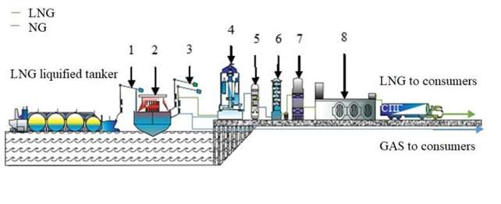

**Fig. 1.** Technological scheme of the LNG terminal equipment

The design of LNG terminals in terms of general requirements is carried out by GOST R 54257, GOST R 54382, GOST 5P4483. During the construction and operation of the LNG terminal, a quantitative risk assessment is necessary, which will allow taking into account the adjacent or responsible port facilities and civilian areas, as well as the geographical conditions of port territories and resort areas to reduce the likelihood of accidents and man-made disasters. Table 1 presents an analysis of accidents on Russian gas pipelines.

The main factors and reasons contributing to the occurrence of emergency ruptures of gas pipelines are an increase in the initial (pre-operational) damage during operation (defective construction and installation works, factory defective pipes), undetected during testing and commissioning; the formation of corrosion damage (atmospheric and soil corrosion; stress corrosion); mechanical defects of pipes by construction (earthmoving) equipment; low-quality performance (or absence) of diagnostic and repair work.

To reduce the risk of occurrence and development of emergencies and to ensure that the gas transportation system of the Russian Federation is in working condition, some measures should be taken to prevent and reduce the accident rate of main gas pipelines [1].

*Table 1.* **Analysis of accidents on Russian gas pipelines**

|  |  |  |
| --- | --- | --- |
| 1. Analysis of accidents on Russian gas pipelines | | |
| Date, place | Causes | Consequences |
| August 23, 2018  Sakhalin-2 LNG plant of Gazprom PJSC | Malfunction in the operation of one of the two LNG gas compressors. | Reduction of gas production. |
| January 22, 2019  Gas tankers Maestro (IMO 8810700) and Candy (IMO 9005479), Kerch Strait, Black Sea. | Violations of safety regulations during the transshipment of LNG from one vessel to another. | A fire on a gas tanker and pollution of the sea area. |
| November 23, 2019  The water area of the port of Odessa, the Black Sea. | Climatic conditions (storm). | Pollution of the sea area and the territory of the city beach. |
| June 12, 2020  LLC "Gazprom liquefied gas", Kazan | Violations of safety standards. | Ignition of a stationary container of finished products with a volume of 200 m3. |
| July 13, 2020  Section of the Okha – Komsomolsk-on-Amur oil pipeline of RN-Sakhalinmorneftegaz LLC of Rosneft PJSC | Corrosion of the metal of the oil pipeline. | Contamination of the territory with oil products. |
| December 3, 2020  Igrim-Serov-Nizhny Tagil main gas pipeline, Novolyalinsky city district, Sverdlovsk region. | Depressurization of the gas pipeline. | A fire on a gas pipeline. |
| February 26, 2021  Yubileynoye gas field, Novy Urengoy, Yamalo-Nenets autonomous district | Violations of safety regulations. | Fire in the gas treatment building, decrease in gas production, pollution of the territory. |

To solve this problem, it is proposed to use the LOPA analysis, in which the possible consequences are calculated up to the order of magnitude of severity, which is much simpler than mathematical modeling, but at the same time allows you to compare the risks of different scenarios.

The LOPA analysis can be performed immediately after the HAZOP hazard analysis, or concurrently with it, or after re-confirmation of the results of these analyzes [2]. The general process for performing LOPA analysis is shown in Fig. 2.

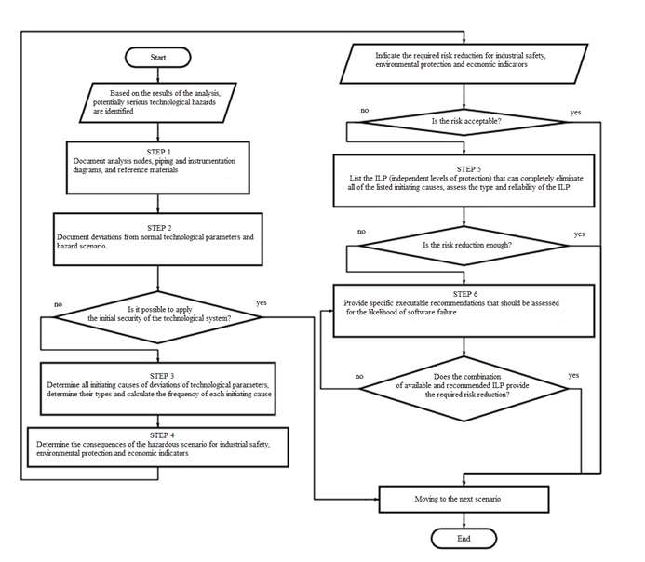

**Fig. 2.** Block diagram of the "LOPA Analysis" process

The steps of performing the LOPA analysis.

The first step. Registration of all reference documents, including hazard analysis documentation, safety valve design documents and inspection reports, protection level design documents, etc.

The second step. Entering data on the deviation of the technological process and the dangerous scenario considered by the analytical group into the documentation.

The third step. Determination of all initiating reasons for a given deviation of the technological process and determination of the frequency of each initiating reason.

The fourth step. Determining the consequences of a dangerous scenario.

The fifth step. Enumeration of independent levels of protection that can eliminate all the initiating causes. They must meet the requirements for independence, specificity, trustworthiness, and verifiability.

The sixth step. Submission of specific documentation to reduce the risk.

The risk assessment matrix provides a qualitative analysis of the risk level of an undesirable event during the performance of this type of work at the automation facility. When forming a list of significant hazards and risks in the field of labor protection, industrial safety, and environmental protection (LP, IS, and EP), the significant risks are those whose assessment result is 8-25 (Fig. 3).

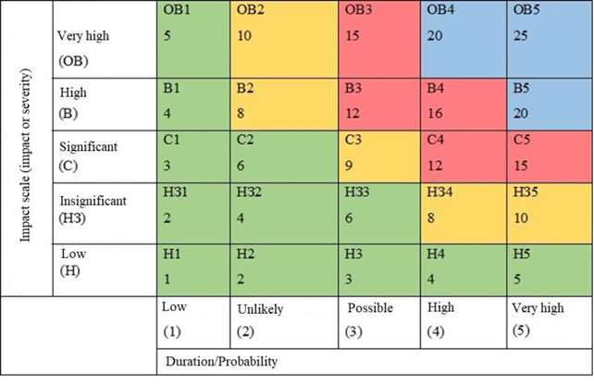

**Fig. 3.** Matrix of the value of risks in the area (LP, IS, and EP)

By multiplying the impact scale, which ranges from 1 to 5, and the probability of risk occurrence from 1 to 5, an assessment of the risk level is obtained, which can take a value from 1 to 25. The risk assessment algorithm is shown in Fig. 4. The key to the risk matrix is presented in Table 2.

*Table 2*. **Key to the risk matrix**

|  |  |
| --- | --- |
| 2. Key to the risk matrix | |
| ОВ | Extremely high risk (catastrophic) |
| В | High risk |
| С | Significant risk |
| НЗ | Insignificant risk |
| Н | Low risk |

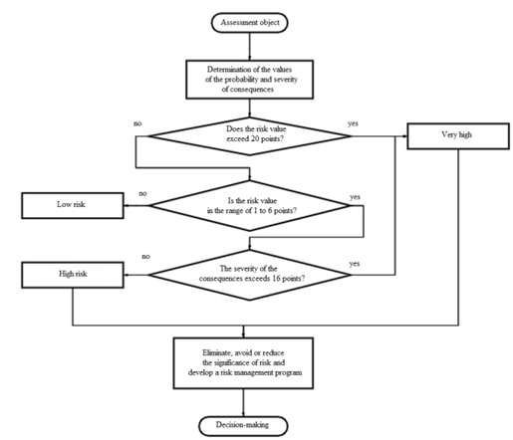

**Fig. 4.** Risk assessment algorithm

The risk assessment methodology is as follows. The risk diagram is based on the probability of an incident and the damage caused to the enterprise or equipment. A table of possible incidents is compiled, after which the risks are identified and their qualitative assessment is carried out. Further, the risks are divided into categories depending on their importance and the damage caused. The data is presented using a diagram, where you can see which of the risks is the most significant.

The risk identification analysis of LNG terminal equipment revealed 24 risks (Fig. 5).

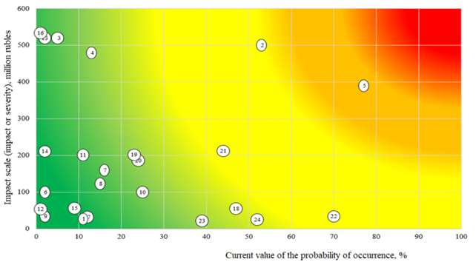

**Fig. 5**. Diagram of risks during operation of gas equipment

These risks are classified into the following categories: strategic, technological, technical, personal, political, legal, economic, and force majeure situations (environmental). There were 6 risks in the high-risk zone, the quantitative assessment of which took the value from 8 to 16 points:

- physical wear of the equipment;

- mechanical damage to the components of technical devices;

- impossibility of achieving the planned level of gas production;

- actuation of safety devices;

- manifestation of a latent defect of an equipment element;

- deviation from the norm of the technological process.

The described methodology for assessing the risk of LNG terminal equipment using a risk diagram provides a qualitative and basic quantitative analysis of the level of occurrence of an undesirable event during production operations and can be used to increase the reliability and safety of complex automated systems at the steps of their design and operation.

**References**

1. Долгосрочная программа развития производства сжиженного природного газа в РФ. Утв. распоряжением Правительства РФ от 16 марта 2021 г. № 640-р [Электронный ресурс]. –Режим доступа: http://government.ru/docs/41790/.

2. **Драпак К. А., Кадыгрова Т. С., Крылов Е. Г., Капитанов А. В.** Оценка уровня надежности защиты регазификационного терминала // Известия ВолгГТУ. Сер. Прогрессивные технологии в машиностроении. 2021. № 3 (250). C. 54-56.

3. Long-term program for the development of liquefied natural gas production in the Russian Federation. Approved by order of the Government of the Russian Federation of March 16, 2021, № 640-р [Electronic version]. – Available at: http://government.ru/docs/41790/.

4. **K. A. Drapak, T. C. Kadygrova, E. G. Krylov, A. V. Kapitanov.** Assessment of the regasification terminal's protection reliability level. *Izvestiya VolgSTU. Ser. Progressive technologies in mechanical engineering*, 2021, vol. 3 (250), pp. 54-56.

***Drapak Kristina Alekseevna*** – student of the Faculty of Automated Systems, Transport and Weapons FSBEI HE "VolgSTU"

Тел.: +7(844) 224-84-32

*app@vstu.ru*

***Krylov Evgeniy Gennadievich*** – сandidate Sc. of Engineering, associate professor of the sub-department of «Automation of Production Processes» of FSBEI HE "VolgSTU"

Тел.: +7(844) 224-84-32

*app@vstu.ru*

***Kapitanov Alexey Vyacheslavovich*** – doctor Sc. of Engineering, head of the sub-department of «Automated information processing and control systems» of MSUT «STANKIN»

Тел.: +7(499) 973-21-45

*av.kapitanov@stankin.ru*

УДК 004.052.3

Sukhanova N.V., Sheptunov S.A.

**The neural network models of equipment and technological processes in mechanical engineering and their application in automated control systems**

*The purpose of the study is to reduce the cost of the development and operation of automated control systems. Research methods - modeling, artificial neural networks. The obtained results - new neural network models of equipment and technological processes in mechanical engineering are proposed. Models are implemented based on switching neural networks. The switching structure of neural networks allows you to modify, complement and complicate models at all stages of the life cycle.*

**Keywords:** automated control systems (ACS), neural network models of equipment and technological processes, switching structure, artificial neural networks.

**1. Relevance**

At the present stage, "the time between obtaining new knowledge and creating technologies, products, and services, and their entry into the market has been significantly reduced"[1]. Using models instead of real objects allows us to reduce the time of the automated control system innovation cycle. It is proposed to use models based on artificial neural networks (ANN). The use of ANN with a traditional structure is limited due to the complexity of their hardware and software implementation. An increase in the number of neurons in an ANN with a traditional structure leads to an increase in the number of their mutual connections and an increase in the time spent on training. A change in the structure of the ANN or the training sample for a traditional neural network requires its re-synthesis and subsequent training. New neural network models of equipment and technological processes in mechanical engineering based on switchboard neural networks are proposed [2,3], see Fig. 1.

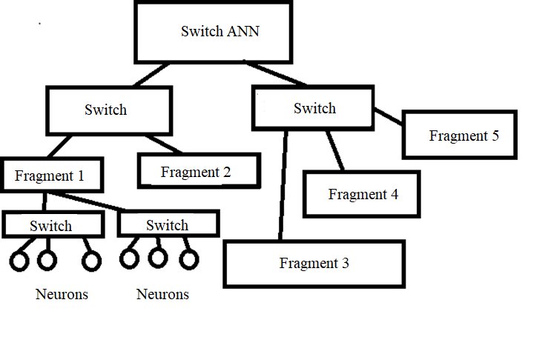

**Fig. 1**. Switch ANN

The switch structure allows you to combine the trained fragments of neural networks with each other, see Fig. 1. The change and complication of the neural network model occur by adding additional switches and newly trained fragments to the already trained neural network. The switch neural network allows you to make changes to the developed model, change its functions and properties. The switch structure of neural networks eliminates the need for repeated synthesis and training of the entire neural network, which reduces the training time, the cost of implementing the model and should give a great economic effect.

**2. Development of a neural network model of ACS equipment**

It is proposed to use a modular computing system (CS) with a switch structure to develop a neural network model of equipment. In the computing system [4], modules of the same or different types can be used, depending on the functions of the simulated equipment:

1. Peripheral modules are designed to exchange data with the external environment, technological processes, equipment, and other models.

2. Intelligent modules contain fragments of a trained switching ANN.

3. Algorithmic modules implement a program based on an algorithm for processing input data and generating output data.

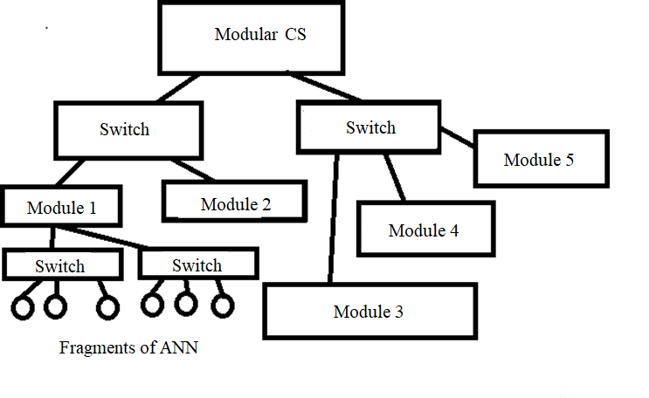

**Fig. 2.** Modular computing system with a switch structure

The modules of the computing system are combined and form layers [5], see Fig. 3.

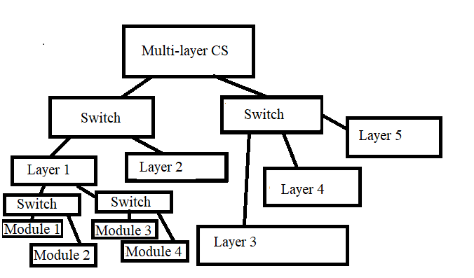

**Fig. 3**. Multi-layer modular computing system with a switch structure

At different stages of the life cycle, the functions of equipment can expand and become more complex, which requires corresponding changes in the neural network model.

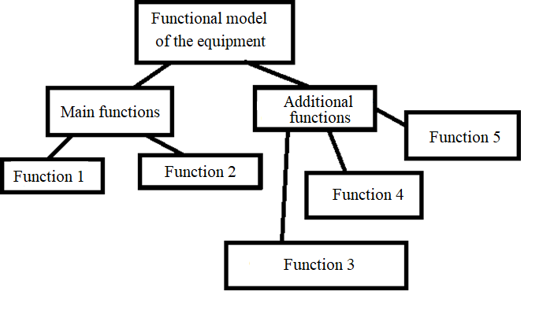

**Fig. 4.** Functional model of the equipment

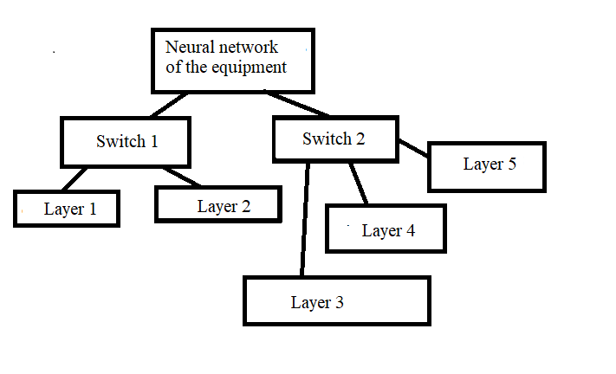

**Fig. 5.** Neural network model of the equipment

The neural network model of the equipment is created by the method of sequential synthesis, when there are basic and additional functions of the equipment, see Figure 4.5. The main functions of the equipment are implemented in an existing neural network model. Additional hardware functions are implemented in new layers that are connected through switches.

**3. Development of a neural network model of the technological process**

A neural network model of technological processes based on a modular computing system is proposed in this paper. The technological process is represented by a network model of operations that are performed serially or in parallel in time. Transitions from one operation to another occur at random times, see Figure 6,7.

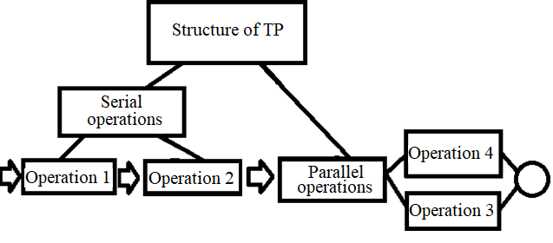

**Fig.6**. Structure of operations in TP

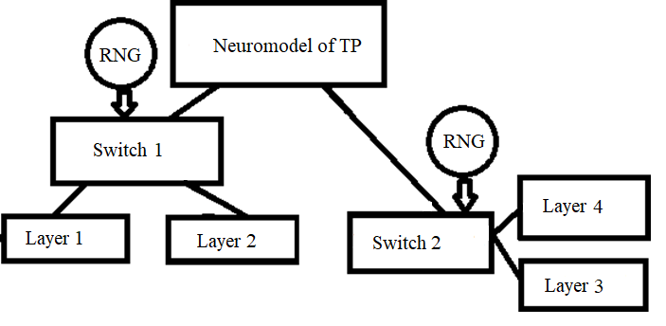

**Fig. 7**. Neural network model of the technological process

The transition time is modeled based on a statistical law, which is given by the probability distribution function. The modular computing system is supplemented with random number generators that set the execution time of each operation. The random number generator is connected to the control input of the switch. When a signal is received from a random number generator (RNG), the switch switches the inputs and outputs. Mutual connections of switches implement serial and parallel execution of technological process operations. At different stages of the life cycle, changes can be made to the technological process that relates to the execution of operations, their sequence, or the statistical law of the distribution of the time of execution of each operation. The switch structure of the neural network model of the TP allows connecting additional and disconnecting redundant modules and layers in the following cases [ 8-9]:

- neural network models of various equipment and technological process are implemented on the same hardware and software complex of the computer system,

- at different stages of the life cycle of the automated control system, the functions of the equipment and technological process change, respectively, it is necessary to connect additional or disable redundant modules of the computer system,

- neural network model allows you to implement and compare the effectiveness of different variants of the automated control system structure.

**Conclusions**

Neural network models of equipment and TP based on neural networks with a switch structure are proposed. Through additional switches, new fragments of the neural network are connected, which expand and change the functionality of the model at different stages of the life cycle. The use of neural network models allows you to simulate the operation of various equipment and TP on one hardware and software complex and reduce the period of the innovation cycle from requirements development to product release.

**References**

1.О Стратегии научно-технологического развития Российской Федерации. Указ Президента Российской Федерации [Электронный ресурс] Режим доступа URL= http://docs.cntd.ru/document/420384257.

2.Патент на полезную модель 66831 Российская Федерация МПК 7 G06G7/66 Нейронная сеть [Текст] / Кабак И.С. , Суханова Н. В.: заявитель и патентообладатель Кабак И.С. , Суханова Н. В. № 2007111998/22 заявл. 02.04.2007, опубл. 27.09.2007, Бюл №27,-2с., ил.

3.Патент на полезную модель 72084 Российская Федерация МПК 7 G06G7/60, G06G7/62, G06G7/66 Доменная нейронная сеть [Текст] / Кабак И.С. , Суханова Н. В.: заявитель и патентообладатель Кабак И.С. , Суханова Н. В. №2007144359/22 заявл. 03.12.2007, опубл. 27.03.2008, Бюл. №9,-2с., ил.

4.Патент на полезную модель 75247 Российская Федерация МПК 7 G06F15/16 Модульная вычислительная система [Текст] / Кабак И.С. , Суханова Н.В.: заявитель и патентообладатель Кабак И.С. , Суханова Н. В.-№ 2008106859; заявл.26.02.2008; опубл. 27.07.2008, Бюл. № 21- 2 с.: ил.

5.Патент на изобретение 2398281 Российская Федерация МПК 7 G06N 3/06 Многослойная модульная вычислительная система [Текст]/ Соломенцев Ю. М., Шептунов С.А., Кабак И.С., Суханова Н.В.: заявитель и патентообладатель Федеральное государственное бюджетное учреждение науки Институт конструкторско-технологической информатики Российской академии наук (ИКТИ РАН).-№ 2008143737; заявл. 07.11.2008; опубл. 27.08.2010, Бюл. № 24- 8с.: ил.

6.**Суханова Н.В.** Обеспечение отказоустойчивости аппаратных средств автоматизированных систем управления[Текст]/Н.В. Суханова.- Вестник МГТУ СТАНКИН, 2017, №2 (41) -с. 79-83.

7.**Суханова Н.В.** Применение коммутаторной структуры при обеспечении отказоустойчивости аппаратных средств вычислительных систем[Текст]/Н.В. Суханова.-.Вестник МГТУ СТАНКИН.- 2017.- №3(42) -с.105-110.

8**.Суханова Н.В** Разработка требований к аппаратно-программному комплексу интеллектуальных систем управления в машиностроении[Текст]// Н.В/Суханова.- Наукоемкие технологии в машиностроении.- 2018. -№ 12 (90).- С. 38-44.

9.**Суханова Н.В.** Совершенствование структуры интеллектуальных автоматизированных систем управления на базе технологий стратегического, конкурентного и ситуационного управления[Текст]/Н.В. Суханова.-.Наукоемкие технологии в машиностроении. -2019. -№ 5 (95).- С. 42-48.

***Sukhanova Natalya V. .-***candidate Sc. of Engineering, associate professor, lecture of the sub-department of “Computer control systems” of MSUT “STANKIN”,

*[n\_v\_sukhanova@mail.ru](mailto:n_v_sukhanova@mail.ru)*

***Sheptunov Sergey A.*** – Ph.D., director of Institute for Design and Technological Informatics RAS (IDTI RAS)

*ship@ikti.ru*

# **УДК 621.9.025.7**

Mirzomakhmudov A.R., Isaev A.V.

**Milling cutters for machining parts in the railway industry**

*The paper is devoted to the calculation method (algorithm), design of structural elements, creation of a parameterized model, and calculation of the cutting modes of a milling cutter with changeable polyhedral inserts.*

**Keywords**: milling cutters with polyhedral inserts, form milling cutters, design of cutting tools, modes of a cutter with polyhedral inserts.

Prefabricated shaped milling cutters are widely used in various industries, for example, in the railway industry. The problem of processing hardened shaped parts with a straight guide (pointers of switches, side barrel-shaped profiles, railheads, etc.) or processing of a hardened shaped part of the body of rotation (wheelset tires) [4,8]. When designing prefabricated shaped milling cutters, a comprehensive study of such issues as the choice of the shape of carbide replaceable polyhedral plates depending on the profile of the part, their location on the profile, errors that occur during processing, the influence of profile parameters on performance, etc. is required.

Thus, the design, development, and evaluation of the operational characteristics of the structures of prefabricated milling cutters with replaceable polyhedral plates (RPP) for processing the above parts is an urgent task.

When designing prefabricated milling cutters with RPP, the initial data are the processed material and the profile of the tire (rim) of wheelsets or the profile of the railhead [3]. A schematic block diagram of a CAD system of a prefabricated shaped cutter with an RPP has been developed (Fig. 1).

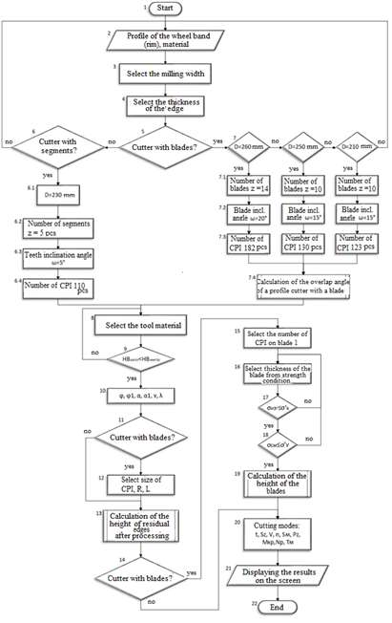

**Fig. 1.** The developed basic block diagram of the CAD of the prefabricated shaped milling cutter

The design of prefabricated shaped milling cutters with replaceable polyhedral plates should be considered as a system of separate, functionally interconnected structural elements, clearly represented in the form of an oriented graph [1]. The graph model of the design of a prefabricated shaped milling cutter with replaceable polyhedral plates allows you to analyze the constituent elements of the design of a prefabricated shaped milling cutter, build a logical scheme of the found technical solution and evaluate its effectiveness (Fig. 2). Also, the considered model is open and can be modified by specific technical requirements without changing the initial structure.

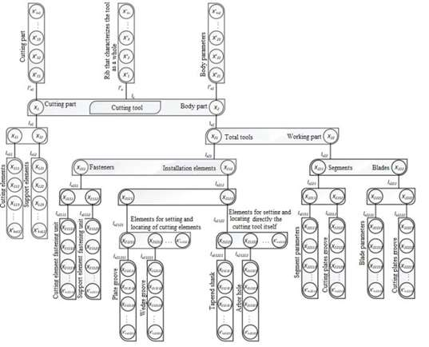

**Fig. 2.** Graph model of the construction of a prefabricated shaped milling cutter

The error in the processing of any part, namely, the set of precision parameters that affect the processing of a prefabricated milling cutter with an RPP, can also be represented in the form of an oriented graph (Fig. 3). The proposed model allows you to visually determine all the components of the processing error of a part, identify and classify the parameters that affect the processing accuracy. The graph model does not include errors from thermal, electrochemical, and dynamic processes (except for the action of the cutting force). The total processing error in this model is decomposed into its parts: errors of the machine (device), fixture, tool, part. This allows you to identify the relationship between the components of the error and select those edges of the graph, with the elements attached to them, which have the greatest impact on the total error. Thus, it becomes possible to control the quality of processing.

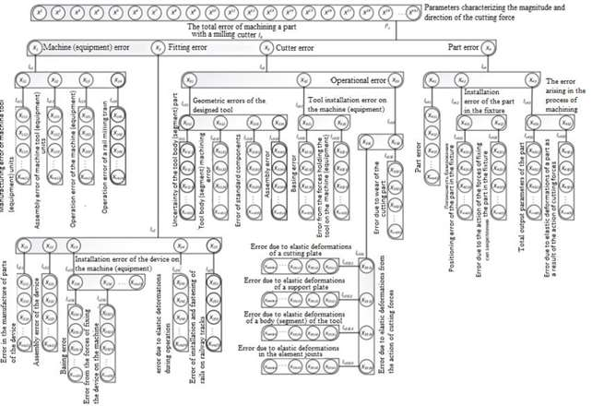

**Fig. 3.** Graph of processing errors when milling with prefabricated shaped cutters

Based on the obtained data on the design features of the milling cutters, the formation of the processing error, methods for calculating the design parameters of the milling cutters for processing the railhead, and wheelset bandages will be obtained [2].

After analyzing the designs of prefabricated shaped milling cutters with round plates for processing wheelsets, the design of a shaped milling cutter with a diameter of D = 250 mm with 10 blades was selected for further research.

The roughness of the wheelset rim surface when machining with prefabricated shaped cutters depends, first of all, on the angle of overlapping of the shaped cutter with a blade, i.e. on how close the envelope surface is to a given profile of the wheel's working surface. The height of residual irregularities after machining wheelsets in concave and convex areas should be minimal. This is achieved with the optimal mutual arrangement of the round plates (Fig. 4). In this case, the design of the blades allows us to place on each blade 13 round plates with a diameter of d = 12 mm, the center distance of which is P = 14 mm (Fig. 5).

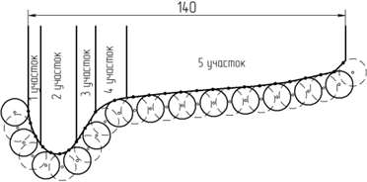

**Fig. 4.** Wheel profile divided into 5 sections

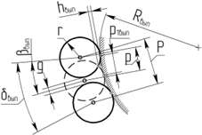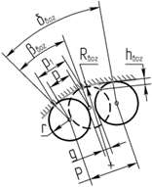 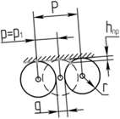

|  |  |  |
| --- | --- | --- |
| а) | b) | с) |

**Fig. 5.** The layout of the RPP on the convex (a), concave (b), and straight (c) surface of the workpiece

The height of the residual irregularities hвып1,2 after processing the part for convex surfaces is calculated by the formula (1) [1]:

|  |  |  |
| --- | --- | --- |
|  | $$h_{вып1,2}=\frac{r∙sin\left[180-\left[\frac{β_{вып1,2}}{2}+\left[180-arcsin\left[\frac{\left(R_{вып1,2}+r\right)∙sin\left(\frac{β_{вып1,2}}{2}\right)}{r}\right]\right]\right]\right]}{sin\left(\frac{β_{вып1,2}}{2}\right)}-R_{вып1,2};$$ | (1) |

residual irregularities hвог after processing the part for concave surfaces is calculated by the formula (2) [1]:

|  |  |  |
| --- | --- | --- |
|  | $$h_{вог}=R_{вог}-\frac{r∙sin\left[\frac{β_{вог}}{2}+arcsin\left[\frac{\left(R_{вог}-r\right)∙sin\left(\frac{β_{вог}}{2}\right)}{r}\right]\right]}{sin\left(\frac{β_{вог}}{2}\right)}$$ | (2) |

The height of the residual irregularities hпр after machining the part for straight surfaces is calculated by the formula (3) [1]:

|  |  |  |
| --- | --- | --- |
|  | $$h_{пр}=r-\sqrt{r^{2}-\frac{{\left(2∙r+g\right)}^{2}}{{4∙z}^{2}}}.$$ | (3) |

In formulas (1) - (3) Rвог/вып is the radius of the processed concave or convex profile, mm; P is the distance between the centers of the plates, mm; p is the distance between the centers of the plates located on adjacent teeth, mm; p1 is the distance between the main base points, mm; g is the distance between the plates located on one tooth, mm; δвог/вып - angular step between the centers of the plates on one tooth, º; βвог/вып is the angular step between the centers of the plates located on adjacent teeth, measured in the axial plane of the cutter, º; h - the height of residual irregularities after processing, mm.

The results of calculating the heights of residual irregularities for the corresponding sections of the processed profile are given in table. 1.

*Table 1.* **The heights of residual irregularities in different parts of the processed profile**

|  |  |  |  |  |
| --- | --- | --- | --- | --- |
| Section № | 1 | 2 | 3 and 5 | 4 |
| Radius of the processed convex or concave profile R, mm | 45 | 12.5 | − | 15 |
| Distance between the centers of the plates P, mm | 14 | | | |
| Distance between plates g, mm | 2.409 | | | |
| Distance between the centers of the plates located on adjacent teeth p, mm | 1.4 | | | |
| Distance between main base points p1, mm | 1.239 | 0.97 | 1.4 | 2.67 |
| Angular pitch between the centers of the plates located on adjacent teeth, measured in the axial plane of the cutter β, ° | 1.578 | 4.447 | − | 10.212 |
| Angular pitch between the centers of the plates on one tooth δ, ° | 15.778 | 44.467 | − | 102.212 |
| Height of residual irregularities after machining h, mm | 0.036 | 0.029 | 0.043 | 0.083 |

The results of calculations of cutting modes for milling cutters with round plates and milling cutters with the tangential mounting of plates are shown in Tables 2 and 3. All formulas and coefficients used for calculating cutting modes were selected by the recommendations of the manual of a mechanical engineer [7].

*Table 2.* **The results of calculating the cutting modes of cutters with the radial attachment of round inserts**

|  |  |  |  |  |  |  |
| --- | --- | --- | --- | --- | --- | --- |
| Cutting depth t, mm | 1 | 2 | 3 | 4 | 5 | 6 |
| Feed per tooth Sz, mm/tooth | 0.12 | | | | | |
| Cutting speed V, m/min | 310 | 240 | 205 | 183 | 168 | 157 |
| Rotational frequency n for Ø250 mm, rpm | 395 | 305 | 260 | 233 | 214 | 200 |
| Minute feed SM, mm/min | 474 | 366 | 312 | 280 | 257 | 240 |
| Cutting force Pz, N | 63.5 | 116.6 | 166.6 | 215 | 261 | 307 |
| Torque Mкр, N\*m | 79.4 | 145.7 | 208.3 | 268.7 | 326.2 | 383.7 |
| Cutting power N, kW | 0.322 | 0.457 | 0.558 | 0.643 | 0.716 | 0.788 |
| Machine time T0 for processing wheelset tires, min | 8.76 | 11.36 | 13.33 | 14.85 | 16.2 | 17.3 |

*Table 3.* **The results of calculating the cutting modes of cutters with the tangential attachment of plates**

|  |  |  |  |  |  |  |
| --- | --- | --- | --- | --- | --- | --- |
| Cutting depth t, mm | 1 | 2 | 3 | 4 | 5 | 6 |
| Feed per tooth Sz, mm/tooth | 0.12 | | | | | |
| Cutting speed V, m/min | 295 | 227 | 195 | 174 | 160 | 149 |
| Rotational frequency n for Ø230 mm, rpm | 408 | 314 | 270 | 241 | 222 | 207 |
| Minute feed SM, mm/min | 735 | 565 | 485 | 434 | 399 | 372 |
| Cutting force Pz, N | 100 | 184 | 262.8 | 338.5 | 412 | 483.7 |
| Torque Mкр, N\*m | 115 | 212 | 302.3 | 389.3 | 473.8 | 556.3 |
| Cutting power N, kW | 0.482 | 0.682 | 0.835 | 0.964 | 1.08 | 1.18 |
| Machine time T0 for processing wheelset tires, min | 5.38 | 7.33 | 8.55 | 9.54 | 10.4 | 11.12 |

According to the obtained calculation results, it can be observed that a milling cutter with the tangential mounting of cutting plates, in comparison with the radial mounting of round plates, has a higher spindle rotation frequency n, minute feed SM, cutting force Pz, and the cutting speed V of the cutter and machine time T0 is less at the same cutting depth t and feed per tooth Sz. Based on this, we can say that the use of the design of a prefabricated shaped milling cutter with the tangential mounting of cutting plates increases the processing performance of wheelset bandages by almost 36% compared to existing designs of prefabricated shaped milling cutters with the radial mounting of round plates [6].

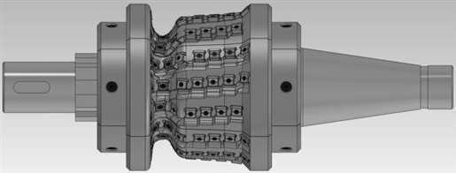

**Fig. 6.** 3D model of a prefabricated shaped milling cutter with RPP for processing the profile of wheelsets

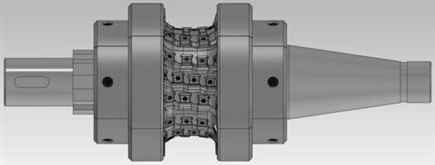

**Fig. 7.** 3D model of a prefabricated shaped milling cutter with RPP for processing the profile of the railhead

Based on the analysis of existing designs of prefabricated shaped milling cutters with replaceable polyhedral plates [5], new designs of prefabricated shaped milling cutters with replaceable polyhedral plates for processing the profile of wheelsets (Fig. 6) of railway trains and railheads (Fig. 7) were developed. Patents for inventions No. 2746202 and No. 2746204 of 09.06.2020 were also obtained for the developed new designs of prefabricated shaped milling cutters with replaceable polyhedral plates for processing the profile of wheelsets of railway trains and railheads.

**References**

1. **Гречишников В. А., Исаев А. В.** Проектирование сборных фасонных фрез со сменными многогранными пластинами, расположенными вдоль винтовой стружечной канавки – М.: ФГБОУ ВО МГТУ «СТАНКИН», 2014. – 158 с.: ил.

2. **Гречишников В.А., Чулин И.В.,** Сборные фасонные фрезы со сменными режущими элементами, расположенными в осевой плоскости – М.: ФГБОУ ВПО МГТУ «СТАНКИН», 2014. – 121 с.: ил.

3. **Исаев А.В.** Проектирование сборных фасонных фрез с круглыми сменными многогранными пластинами, расположенными на винтовой поверхности – Вестник МГТУ «СТАНКИН». 2011. № 1. С. 61–66.

4. **Кожевников Д.В., Гречишников В.А., Кирсанов С.В., Кокарев В.И., Схиртладзе А.Г.,** Режущий инструмент: Учебник для вузов/Под редакцией С.В. Кирсанова. М.: Машиностроение, 2004. 512 с.: ил.

5. **Коротков И.А., Схиртладзе А.Г., Борискин В.П.** Фрезерный инструмент: учебное пособие. – Старый Оскол: ООО «ТНТ», 2006. – 248 с.

6. Пат. 198166 Российская Федерация, МПК B 23 C 5/02. Сменная тангенциальная многогранная режущая пластина / Исаев А.В., Мирзомахмудов А.Р., Романов В.А.; заявитель и патентообладатель ФГБОУ ВО «МГТУ «СТАНКИН». – №2020100802; заявл. 14.01.20 г; опубл. 22.06.20 г., Бюл. № 18 (IV ч.). – 1 с.: ил.

7. Справочник технолога-машиностроителя. В 2-х т. С74 Т. 2/Под ред. А.Г. Косиловой и Р.К. Мещерикова. – 4-е изд., перераб. и доп. – М.: Машиностроение, 1985. 496 с., ил.

8. Фрезерный инструмент: учебное пособие / В.В. Морозов, Ф86 Владим. гос. ун-т им. А. Г. и Н. Г. Столетовых. – Владимир : Изд-во ВлГУ, 2014. – 214 с.

***Mirzomakhmudov Azimzhon Rustamovich*** – student of sub-department “Cutting Tools and Form-Generation Technologies” of MSUT “STANKIN”.

Tel.: +7(977) 809-36-34.

*mirzoazim97@mail.ru*

***Isaev Alexander Vyacheslavovich*** – Candidate of Engineering Sciences, Associate professor of sub-department “Cutting Tools and Form-Generation Technologies” of MSUT “STANKIN”.

Tel.: +7(499) 972-94-56.

*avisz@yandex.ru*

УДК 621.9.025.7

Artamonov E.V., Grechishnikov V.A., Kireev V.V., Zyryanov V.A., Isaev A.V., Pivkin P.M.

**Implementation of group cutting scheme for prefabricated hob milling**

*Currently, when processing gears, arises the problem of the operability of standard hob cutter when processing gears of large modules. In the current conditions of sanctions, import substitution and the launch of the state program for the development of domestic metal cutting tool designs by tool companies, the creation of hob cutters equipped with changeable cutting inserts can be considered a promising and effective solution.*

**Keywords:** prefabricated hob cutter, hard alloy, group cutting scheme, gear

The article considers the possibility of creating prefabricated hob cutters with replaceable cutting carbide plates for roughing large-module gears. The effectiveness of the use of prefabricated tool structures with cutting elements made of tool hard alloy has been repeatedly confirmed by leading Russian researchers [1-8]. Gears have entered our daily life everywhere, their range of applications is very wide. For the Tyumen region, which is the leading oil and gas-bearing and oil-producing region of Russia, the need for processing gears is very high, since they are used in all technological installations.

There are many methods of processing gears, but let's focus on the method of rolling using hob cutters. Tool companies in the Russian Federation today do not offer designs of prefabricated hob cutters for processing large-module gears. The design of such tools must withstand high non-stationary loads and stresses that occur during processing, providing the required performance, high productivity, and economic efficiency during gear milling.

The creation of a prefabricated design of a hob cutter must begin with the location of replaceable cutting carbide elements in the initial contour of the tool rail (ICR). As an example, consider the ICR for gears with a module m=14.

|  |
| --- |
| контур.jpg |
| **Fig.1.** ICR for m=14 |

By GOST 13755-81, we perform mathematical calculations and construction of the initial contour of the tool rail in the Compass-3D software (Fig. 1). Next, we proceed to the placement of replaceable cutting carbide plates (RCCP) in the ICR. As mentioned above, the process of gear milling is complex and places high demands on the tool.

Based on this, in the design of the tool, it is necessary to use an RCCP of such a form that facilitates operation at high non-stationary loads without destruction. After the information search, attention was drawn to the work [9], which describes the classification of RCCP in the areas of functional efficiency, i.e., increasing the strength and accuracy of positioning (Fig. 2). The author speaks of the need to use cutting elements with the maximum apex angle ε.

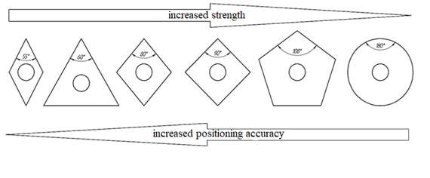

**Fig. 2.** Classification of forms of RCCP

Therefore, as an example, let's take a pentahedral plate and place it in the ICR (Fig. 3).

|  |
| --- |
|  |

**Fig. 3**. Scheme of the pentahedral RCCP in the ICR

Similarly, we will place a round RCCP with maximum strength (Fig. 4).

|  |
| --- |
|  |
| **Fig. 4.** Scheme of the position of round RCCP in the ICR |

However, these schemes of the location of the RCCP on the instrumental rail have their drawbacks. After processing with a tool with a similar position of cutting elements in the tool body, further processing will be required with large values of the cut layer and a machining allowance. If we talk about a round plate with an angle ε = 180o, then it is rather difficult to fix it in the tool body. Therefore, the way out of this situation is to use cutters with a new, more perfect cutting scheme.

In search of solutions [10-15] for the creation of a fundamentally new tool and the choice of the optimal method for fixing cutting carbide plates, modifying the tool, and reducing loads in the process of tooth cutting, the results of the research were studied in [16]. It puts forward the idea of the tangential arrangement of the cutting elements in the tool body.

In works [17-18], a combined scheme of the RCCP in the tool body was proposed. This positioning scheme of cutting elements in the body of a gear-cutting tool is called group. The group scheme is realized by sequentially cutting off the machining allowance for the gear blank with the main - elliptical, radially located, and lateral, tangentially located plates. Due to this, the chips are divided into simpler elements by sequentially cutting off the machining allowance (Fig. 5).

|  |
| --- |
|  |
|  |

**Fig. 5.** Group scheme of RCCPs that fit into ICR

In [19-20], studies were carried out to determine the cross-sectional areas of the cut layer and the boundary conditions for loading the cutting elements. This made it possible to determine the main stresses that occur during the machining process using the ANSYS software.

|  |  |
| --- | --- |
|  |  |
| Tooth of a standard hob cutter | Elliptical element of a prefabricated milling cutter |

**Fig. 6.** Pictures of the distribution of the main stresses for the tooth of a standard hob cutter and an elliptical cutting element of a prefabricated tool

The analysis of the obtained isolines of the distribution of the main stresses showed that the value of the maximum tensile stresses at the base of the tooth of a standard hob cutter reaches 1355 MPa, which is 2.6 times more than with a replaceable elliptical cutting element installed in the design of a prefabricated hob cutter with a group positioning of cutting elements (Fig. 6).

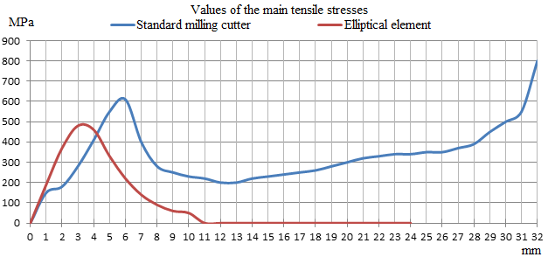**Fig. 7.** Dependences of the distribution of the main stresses on the front surface of the tooth of a standard hob cutter and an elliptical cutting element of a combined hob cutter at m=14

The highest values of tensile stresses σ1 are observed at the base of the tooth along the front surface of a standard hob cutter, which correlates well with the stress distribution in a cantilevered pinched beam. As for the values of tensile stresses in the contact zone and behind the contact zone, their values range from 610 to 800 MPa along the front surface of the tooth from 0 to 30 mm. For an elliptical element of a combined hob mill, the maximum tensile stresses reach their maximum of 500 MPa outside the contact zone at a distance of 2 to 5 mm from the apex (Fig. 7).

This nature of the stress distribution is explained by the fact that due to the implementation of the group cutting scheme, there is a sequential cutting of the allowance for processing the groove of the wheel tooth by separate cutting elements located both radially and tangentially [21]. Also, the use of an elliptical plate with an increased apex angle ε compared to the tooth of a standard hob cutter allows you to reduce the values of dangerous stresses σ1 by 2-2.5 times and, consequently, increase the strength of the cutting plate. Thus, the processing of gears in the implementation of a group cutting scheme by using prefabricated hob cutters with replaceable cutting carbide plates in comparison with the work of a standard high-speed steel hob cutter can significantly reduce the tensile stresses on the front surface, increase the cutting speed and, accordingly, increase the efficiency and productivity of processing.

**References**

1. **Гречишников, В. А.** Инструментальное обеспечение интегрированных машиностроительных производств // В. А. Гречишников, С. Н. Григорьев, А. Р. Маслов, А. Г. Схиртладзе. - Старый оскол: ООО «Тонкие наукоемкие технологии», 2018. – 348 с. – Текст : непосредственный.
2. **Семенченко, И. И.** Проектирование металлорежущих инструментов / И. И. Семенченко, В. М. Матюшин, Г. Н. Сахаров – Москва : Машиностроение. 1963. 952 с. – Текст : непосредственный.
3. **Борискин, О. И.** Эвольвентная червячная фреза с твердосплавными рейками / О. И. Борискин, Н. Г. Стаханов, А. В. Якушенков – Текст : непосредственный // [Отечественный и зарубежный опыт обеспечения качества в машиностроении](https://www.elibrary.ru/item.asp?id=41285835) : всероссийская научно-техническая конференция. – Тула, 2019. – С. 116-118. – Текст : непосредственный.
4. **Чулин, И. В.** Повышение стойкости сборных твердосплавных фрез для обработки железнодорожных остряков : 05.02.07 : автореф дис. … канд. техн. наук. / И. В. Чулин. – Москва, 2011. – 24 с. – Текст : непосредственный.
5. **Исаев, А. В.** Разработка сборных фрез со сменными многогранными твердосплавными пластинами, расположенными на винтовой поверхности, для обработки заготовок с фасонным профилем : 05.02.07 : автореф дис. … канд. техн. наук. / А. В. Исаев. – Москва, 2012. – 24 с. – Текст : непосредственный.
6. **Гречишников, В. А.** Метод формирования профиля образующей исходной инструментальной поверхности сборных фасонных фрез с режущими пластинами, расположенными вдоль винтовой линии / В. А. Гречишников, А. В. Исаев, В. Б. Романов. – Текст : непосредственный //Вестник МГТУ Станкин. – 2015. - №1. – С. 8-12.
7. **Чевычелов, С. А.** Повышение эффективности проектирования гиперболических фрез компьютерным моделированием процесса репрофилирования рельсов : 05.02.07 : автореф дис. … канд. техн. наук. / С. А. Чевычелов. – Орел, 2005. – 23 с. – Текст : непосредственный.
8. **Ничков, А. Г.** Основы комплексного исследования процесса зубофрезерования и оптимизации его конструктивных и технологических параметров в простых и комбинированных схемах нарезания зубчатых колес червячными фрезами : 05.03.01 : дис. … докт. техн. наук. / А. Г. Ничков ; - Тула, 1991. – 566 с. – Текст : непосредственный.
9. **Артамонов, Е. В.** Прочность и работоспособность сменных твердосплавных пластин сборных режущих инструментов / Е. В. Артамонов. – Тюмень : ТюмГНГУ. 2003. 192 с. – Текст : непосредственный.
10. **Смирнов Н. Н.,** Зубофрезерование многозаходными червячными фрезами с различными схемами резания : 05.03.01 : автореф дис. … канд. техн. наук. / Н. Н. Смирнов ; Волгоград, 1982. – 20 с. – Текст : непосредственный.
11. **Медведицков, С. Н.** Высокопроизводительное зубонарезание фрезами / С. Н. Медведицков. – Москва : Машиностроение. 1981. 106 с. – Текст : непосредственный.
12. **Voschinobu T.** Stress analysis in cutting edge Fundamental study of Cutting edge chipping / T. Voschinobu, I. Naoga, V. Kuniharu. - Text: electronic // I. Jap. Soc. Precis. Eng. – 1973. - № 10. – Р. 1055-1061.
13. **Bouzakis K.** Manufacturing of cylindrical gears by generating cutting processes / K. Bouzakis, E. Lili, N. Michailidis, O. Friderikos. - Text: electronic // A critical synthesis of analysis methods. CIRP Annals - Manufacturing Technology. – 2008. - № 2. – Р. 676-696.
14. **Bouzakis K.** Gear hobbing cutting process simulation and tool wear prediction models / K. Bouzakis, S. Kombogiannis, A. Antoniadis, N. Vidakis. - Text: electronic // Journal of Manufacturing Science and Engineering. – 2002. - № 1. - Р. 42-51.
15. **Fontaine M.** Analytical simulation of milling: Influence of tool design on cutting forces / M. Fontaine, A. Devillez, D. Dudzinski. - Text : electronic // 12th IFToMM World Congress. - 2007. Besançon (France).
16. **Артамонов, Е. В.** Механика разрушения и прочность сменных режущих пластин из твердых сплавов / Е. В. Артамонов, Т. Е. Помигалова, А. М. Тверяков, М. Х. Утешев. – Тюмень : ТюмГНГУ. 2013. 148 с. – Текст : непосредственный.
17. **Artamonov, E. V.** An interlocking side mill with retrofittable carbide blades for processing of coarse-pitch tooth wheels / E. V. Artamonov, V. V. Kireev. V. A. Zyryanov. - Text: electronic // MATEC Web of Conferences. - 2018. - № 224. – Р. 1–5.
18. **Artamonov, E. V.** Layout of cutting blades in an assembly basic rack of a counterpart rack for hob gears / E. V. Artamonov, V. V. Kireev. V. A. Zyryanov. - Text: electronic // IOP Conference Series: Materials Science and Engineering. – 2019. - № 709. – Р. 1-6.
19. **Артамонов Е.В.** Повышение эффективности зубофрезерования путем создания сборных фрез со сменными режущими твердосплавными пластинами / Е.В. Артамонов, В.В. Киреев, В.А. Зырянов // Известия Юго-Западного государственного университета – 2020. 24(1). – С. 35-51.
20. **Artamonov E.V.** Application of the group scheme of cutting when processing coarse-grain cogwheels / E.V. Artamonov, V.V. Kireev. V.A. Zyryanov // IOP Conference Series: Materials Science and Engineering, 2020, - pp. 1-5
21. Пат. 2720011 Российская Федерация, МПК B23F21/16. Сборная червячная фреза с групповой схемой резания : заявл. 21.05.2019 : опубл. 23.04.2020 / Артамонов Е. В., Киреев В. В., Зы­рянов В. А. ; патентообладатель Федеральное государственное бюджетное учре­ждение высшего образования «Тюменский индустриальный университет» (ТИУ). – Текст : непосредственный

***Evgeny Vladimirovich Artamonov*** Doctor of Engineering, professor, head of the department "Machines and tools" of Industrial University of Tyumen, [evgart2014@mail.ru](mailto:evgart2014@mail.ru)

***Vladimir Andreevich Grechishnikov*** — Doctor of Engineering, professor, head of the sub-department «Tool engineering and forming technologies» of MSUT «STANKIN», *ittf\_stankin@gmail.com*

***Vitaly Vladimirovich Kireev*** Candidate of Technical Sciences, associate professor, department "Machines and tools" of Industrial University of Tyumen, kireevvv@tyuiu.ru

***Vitaly Andreevich Zyryanov*** assistant department "Machines and tools" of Industrial University of Tyumen, *zyrjanovva@tyuiu.ru*

***Alexander Vyacheslavovich Isaev*** — Candidate of Technical Sciences, associate professor of the sub-department «Tool engineering and forming technologies» of MSUT «STANKIN», *[avisz@yandex.ru](mailto:avisz@yandex.ru)*

***Petr Mihailovich Pivkin*** - Candidate of Technical Sciences, associate professor of the sub-department «Tool engineering and forming technologies» of MSUT «STANKIN», *pmpivkin@gmail.com*

*УДК 621.9.011:669.15-194.56:539.25´32´536*

Mitrofanov A.P., Malkov S.N., Kozlachkov A.P., Zabrodin A.V.

**Investigation of the influence of modes and conditions for supplying the minimum quantity lubrication on the parameters of the grinding process of heat-resistant nickel alloy**

*The implementation of two technology options has been investigated: the basic one with the use of minimum quantity lubrication (MQL) and with additional air cooling (CAMQL). The influence of the dosing modes of the lubricant medium and the amount of cooling air flow supplied to the cutting zone on the parameters of the grinding process of the heat-resistant nickel alloy has been evaluated. It was found that the use of CAMQL provides a decrease in cutting force, the temperature of the processed surface and helps to clean the working surface of an abrasive tool*.

**Keywords**: minimum quantity lubrication, cooled air, grinding, cutting force, and temperature.

**Introduction**

Recently, the scientific direction of researching the technology of supplying the quantity lubrication (MQL) at metalworking operations has been widely developed [1, 2], since the traditional use of cutting fluids (coolants) has several significant disadvantages. These include the negative impact on the environment, the need for disposal, high health risks for workers, and the decomposition of microorganisms in tanks [3]. The grinding process is one of the most difficult machining processes. Here, each abrasive grain performs a single cutting action, but in the aggregate, the presence of many cutting edges leads to a significant increase in energy, which is converted into thermal energy, thereby significantly increasing the temperature of the surface layer. Accordingly, in the process of abrasive machining, the use of MQL in its usual form is not always effective in comparison with cooling the lubrication fluid.

Several steps have been taken in the scientific community to improve grinding efficiency when using MQL technology. The authors of works [4, 5] achieved a positive effect by using additional cooling of the cutting zone with cryogenic media (liquid nitrogen, CO2). The complexity of the design of the supply and storage of cryogenic media creates problems for the further development of this direction. In works [6, 7] it is proposed to cool the contact interaction zone using a vortex tube (based on the vortex effect). This method is quite simple to implement, but its effectiveness without the use of lubricants is not so high. In works [8–10], it is proposed to use the technology of supplying a minimum amount of lubricant in a cooling air flow (CAMQL - cold air with minimum quantity lubrication).

Because a vortex tube is used in the CAMQL technology and the degree of cooling depends on the ratio of the proportion of cold and hot air, the question arises of choosing the most effective settings for the tube operation. An important factor is the amount of lubricant supplied to the cutting zone, which affects the processes of contact interaction. Thus, the purpose of this work is to study the influence of the dosing modes of the lubricating medium (vegetable oil) and the amount of cooling air flow supplied to the cutting zone during the implementation of the CAMQL technology on the performance of the grinding process of the heat-resistant nickel alloy.

**Materials and research methods**

For experimental studies, a CHEVALIER surface grinding machine, model Smart-B1224III, was used. Characteristics of the abrasive tool - 24AF90J10V5. Grinding mode: wheel speed *v* = 30 m/s; table feed speed *vs* = 6 m/min; feed to depth *t* - 0.01 mm/stroke. The size of the allowance removed in one experiment is 0.5 mm, the number of parallel experiments – 3. Based on the analysis of the available works on the application of the MQL and CAMQL feed technology in the grinding process [8, 9], the following modes of dosing of the lubricating medium were selected: 20, 30, and 50 ml/h. An AIRRUSCE 250-V135 compressor was used to supply air to the air cooling system. Soybean vegetable oil was used as a lubricating medium [10] because it has a minimal negative impact on the environment [2], which corresponds to the concept of environmentally friendly grinding.

The device for supplying the minimum amount of lubricant in cooled air (CAMQL) is realized by synthesizing the MQL installation (model Spraymat700 manufactured by Steidle Germany) and a vortex tube (Fig. 1). When adjusting the MQL supply system, it is possible to vary the air flow rate for transporting the lubricant medium. Using a rotameter, the volumetric flow was adjusted to 2 and 4 m3/h.

In the process of grinding using the CAMQL technology, the value of the cooling air flow was taken equal to 8, 12, and 16 m3/h at the corresponding temperature of –10, –5, 0 ° C. The choice of the flow rate is based on the research results presented in [8, 9]. Using the capabilities of 3D printing, a nozzle for the implementation of CAMQL technology was manufactured, in which the MQL delivery nozzle is located in the center of the tip with a circular cross-section. The angle of inclination between the nozzle and the workpiece is 15º.

The heat-resistant alloy KHN45MVTYUBR (EP718), which is an analog of one of the most popular nickel alloy Inconel 718 in the world, was used as the processed material. For experimental studies, samples with a size of 75×35×7 mm were prepared, which were heat-treated according to standard technology, as a result of which their hardness was 37 HRC.

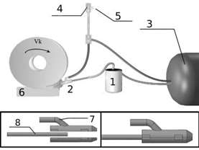

**Fig. 1.** Scheme of the experimental installation: 1 – Spraymat700 lubrication supply system; 2-nozzle; 3-compressor; 4-vortex tube; 5-hot air outlet; 6-workpiece; 7- cold air supply; 8 – lubricant supply tube

The components of the cutting force (*Pz*, *Py*) were measured using a six-component Amti MC36-1000 force measuring complex, an analog-to-digital converter L-CARD E14-140 and a laptop with special Powergraph software.

The working surface of the wheel was photographed after the experiment using a USB digital microscope at 100x magnification.

To measure the temperature in the contact interaction zone, a semi-artificial cut-off thermocouple was used. The main thermoelectrode is a constantan alloy wire. The second thermoelectrode of the thermocouple is the workpiece itself (sample). The signal was recorded using an amplifier, L-CARD E14-140 ADC, and LGraph software. The recorded temperature is the surface temperature of the workpiece after contact with the abrasive wheel.

**Research results and their discussion**

The evaluation of the components of the cutting force showed that a change in the dosage mode of the lubricating medium has a significant effect on the results obtained. Thus, a significant decrease in the radial component *P*y is observed with a sequential decrease in the amount of supplied lubricant, regardless of the type of technology we are investigating (Table 1). In this case, when the dosing mode of the lubricating medium was 50 ml/h, the *P*y values for all conditions and settings, taking into account the confidence intervals, remain approximately at the same level. With a feed of 20 ml/h, the *P*y component is in almost all cases lower when using the CAMQL technology, and the degree of reduction increases with a decrease in the flow rate of cooled air supplied to the cutting zone. This is especially significant when transporting oil with a flow of 4 m3/h.

*Table 1.* **Influence of processing conditions on the obtained values of the components of the cutting force (Pz, Py)**

|  |  |  |  |  |  |  |  |  |
| --- | --- | --- | --- | --- | --- | --- | --- | --- |
|  | Air flow | | | | | | | |
| 2 m3/h | | | | 4 m3/h | | | |
| *MQL*  0 m3/h | *CAMQL* 16 m3/h | *CAMQL* 12 m3/h | *CAMQL* 8 m3/h | *MQL*  0 m3/h | *CAMQL* 16 m3/h | *CAMQL* 12 m3/h | *CAMQL* 8 m3/h |
| Lubricant supply, 20 ml/h | | | | | | | | |
| *Pz*, Н | 17,1±0,3 | 16,0±0,4 | 15,9±0,2 | 16,2±0,4 | 15,9±0,5 | 16,7±0,3 | 15,4±0,3 | 15,1±0,2 |
| *Py*, Н | 45,6±0,7 | 43,2±0,6 | 42,2±0,5 | 40,3±0,8 | 41,2±0,8 | 41,7±0,7 | 37,4±0,7 | 33,6±0,6 |
| Lubricant supply, 30 ml/h | | | | | | | | |
| *Pz*, Н | 15,1±0,4 | 15,6±0,3 | 15,3±0,3 | 15,1±0,3 | 17,4±0,4 | 16,9±0,2 | 16,3±0,4 | 16,4±0,2 |
| *Py*, Н | 49,6±0,9 | 51,1±0,8 | 49,8±0,8 | 48,3±0,7 | 51,2±0,8 | 47,9±0,8 | 46,9±0,7 | 47,3±0,7 |
| Lubricant supply, 50 ml/h | | | | | | | | |
| *Pz*, Н | 14,8±0,3 | 14,6±0,2 | 15,4±0,2 | 15,0±0,3 | 17,0±0,5 | 18,2±0,4 | 17,0±0,4 | 17,4±0,3 |
| *Py*, Н | 55,5±0,9 | 54,7±0,9 | 57,6±0,7 | 55,5±0,8 | 54,5±1,0 | 56,7±1,0 | 52,0±0,8 | 53,5±0,9 |

Considering the results for the *P*z component, it can be noted that although the values are quite close in absolute terms, some trends can still be detected. First of all, this is the opposite dependence of the change in the *P*z value when varying the dosing mode of the lubricating medium, when the flow during oil transportation changes from 2 to 4 m3/h. In the first case, a decrease in the amount of lubricant leads to an increase in *P*z and vice versa at a flow of 4 m3/h. Nevertheless, if the amount of lubricant in the cutting zone is significant, the *P*z component is slightly less when transporting oil with a flow equal to 2 m3/h.

A very important indicator characterizing the quality of the grinding process is the temperature of contact interaction, the lower the thermal conductivity of the material being processed contributes to its high values. According to the research results (Fig. 2), it can be argued that the CAMQL technology copes with its main function since in all cases there is a decrease in the average temperature on the surface during the grinding process. However, the efficiency significantly depends on the selected modes and processing conditions. Thus, at a dosing level of the lubricant medium of 50 ml/h, the results are almost identical for all settings, and the temperature decrease is more related to the effect of the cooling air flow. With a decrease in the amount of lubricant to 30 ml/h, the selected air flow for transporting oil begins to influence the nature of the results obtained. This is reflected in an increase in temperature with a flow equal to 2 m3/h (Fig. 2a) and a decrease in temperature at 4 m3/h (Fig. 2b). The lowest temperature values are observed when the lubricant is dispensed at 20 ml/h. At the same time, in absolute terms, it is less with an air flow equal to 4 m3/h.

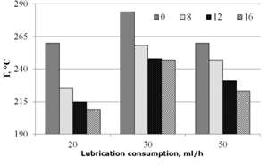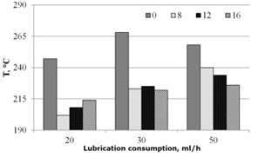

а) b)

**Fig. 2.** Estimation of the temperature of the treated surface when varying the dosage mode of the lubricant (ml/h), the amount of cooling air (m3/h), and the air flow rate for oil transportation: 2 m3/h (a) and 4 m3/h (b)

It can be noted that with a flow equal to 2 m3/h, at all levels of dosing of the lubricating medium, the tendency remains since as the flow rate of the cooled air supplied to the cutting zone increases, the temperature of the treated surface decreases (Fig. 2a). But with an increase in the flow, the mentioned dependence is valid only for the dosage level of the lubricating medium of 50 ml/h, and then it changes oppositely with the lubrication supply mode of 20 ml/h (Fig. 2b). The nature of these results, in our opinion, is explained by the better penetrating ability of the lubricating medium at a higher flow. This is especially noticeable when the amount of lubricant is insignificant. A similar mechanism of action is described in [11], where by changing the settings of the MQL system; favorable grinding conditions are created by reducing the size of lubricant droplets and increasing the efficiency of their delivery to the cutting zone.

Thus, in general, the results obtained are influenced by several factors at once. An increase in the amount of lubricant leads to an increase in the degree of contamination of the working surface of the wheel and to an increased formation of adhesion on abrasive grains, which in turn is reflected in the component of the cutting force *P*y. The use of CAMQL technology helps to clean the working surface of the wheel. There are much fewer traces of adhesion of the processed metal and sludge (Fig. 3). At the same time, the additionally cooled air supplied to the cutting zone, in addition to its direct cooling function, influences the grinding process by spraying a lubricating medium, especially at high flow rates. The value of the flow during oil transportation also makes its contribution through the influence on the size of the formed lubricant droplets and the penetrating ability into the cutting zone. As a result, the most favorable combination of the considered factors was formed with the following experimental parameters: lubricant dosage mode- 20 ml/h; air consumption for oil transportation - 4 m3/h; cooling air consumption - 8 m3/h.

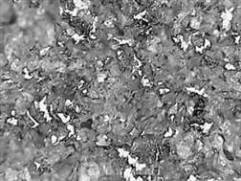

а) b)

**Fig. 3**. Photos of the working surface of the wheel after grinding: MQL (a) and CAMQL (b)

**Conclusions**

1. The effectiveness of the CAMQL technology in reducing the temperature of contact interaction relative to grinding with MQL has been proven.

2. The working surface of the abrasive tool when using CAMQL technology is less exposed to chip adhesion.

3. It was found that when the lubricant medium supply mode is 20 ml/h, the lowest values of the cutting force and temperature of the treated surface are observed.

4. The level of air consumption for oil transportation has a significant effect, according to the results of experiments it is more rational to use higher values.

5. The degree of influence of the cooling air flow supplied to the cutting zone during the implementation of CAMQL technology depends on a combination of factors, and the results obtained are determined by the specific prevailing processing conditions.

**References**

1. **Sen B., Mia M., Krolczyk G.M. et al.** Eco-Friendly Cutting Fluids in Minimum Quantity Lubrication Assisted Machining: A Review on the Perception of Sustainable Manufacturing. [International Journal of Precision Engineering and Manufacturing-Green Technology](https://link.springer.com/journal/40684). Vol. 8. Is.1. 2021. P. 249-280. DOI: 10.1007/s40684-019-00158-6

2. **Wickramasinghe K.C., Hiroyuki Sasahara, Erween Abd Rahim, Perera G.I.P.** Green Metalworking Fluids for sustainable machining applications: A review. Journal of Cleaner Production. Vol. 257. № 120552. 2020. DOI: 10.1016/j.jclepro.2020.120552

3. **M.S. Najiha, M.M. Rahman, A.R. Yusoff.** Environmental impacts and hazards associated with metal working fluids and recent advances in the sustainable systems: A review. Renewable and Sustainable Energy Reviews. Vol. 60. 2016. P. 1008-1031. DOI: 10.1016/j.rser.2016.01.065

4. **García E., Méresse D., Pombo I., Dubar M., Sánchez J.** Role of frozen lubricant film on tribological behavior and wear mechanisms in grinding. The International Journal of Advanced Manufacturing Technology. Vol. 82. 2016. P. 1017-1027. DOI: 10.1007/s00170-015-7397-3

5. **Reddy P.P., Ghosh A.** Some critical issues in cryo-grinding by a vitrified bonded alumina wheel using liquid nitrogen jet. Journal of Materials Processing Technology. Vol. 229. 2016. P. 329-337. DOI: [10.1016/j.jmatprotec.2015.09.040](http://dx.doi.org/10.1016/j.jmatprotec.2015.09.040" \t "_blank)

6. **Nguyen T.** An assessment of the applicability of cold air and oil mist in surface grinding. Journal of Materials Processing Technology. Vol. 140. 2003. P. 224-230. DOI: [10.1016/S0924-0136(03)00714-3](https://doi.org/10.1016/S0924-0136(03)00714-3" \t "_blank)

7*.* **Choi H.Z., Lee S.W., Jeong H.D.**The cooling effects of compressed cold air in cylindrical grinding with alumina and CBN wheels. Journal of Materials Processing Technology. Vol. 127. 2002. P. 155-158. DOI: [10.1016/S0924-0136(02)00117-6](https://doi.org/10.1016/S0924-0136(02)00117-6" \t "_blank)

8. **Saberi A., Parsa H., Ashrafijou M., Rabiei F.** Improvement of surface grinding process performance of CK45 soft steel by minimum quantity lubrication (MQL) technique using compressed cold air jet from vortex tube. Journal of Cleaner Production. Vol. 131. 2016. P. 728-738. DOI:10.1016/j.jclepro.2016.04.104.

9. **Zhang, J., Wu, W., Li, C. et al.** Convective Heat Transfer Coefficient Model Under Nanofluid Minimum Quantity Lubrication Coupled with Cryogenic Air Grinding Ti–6Al–4V.International Journal of Precision Engineering and Manufacturing-Green Technology. 2020.DOI:10.1007/s40684-020-00268-6

10. **Крутикова А.А., Митрофанов А.П., Паршева К.А.** Применение технологии подачи минимального количества смазки в охлажденном воздушном потоке при шлифовании жаропрочного сплава. Технология металлов. 2019. №1. С. 9-15. DOI:10.31044 / 1684-2499-2019-8-0-9-15

11. **A. S. S. Balan, L. Vijayaraghavan, R. Krishnamurthy**. Minimum Quantity Lubricated Grinding of Inconel 751 Alloy. Materials and Manufacturing Processes. Vol. 28. Is.4. 2013. P. 430-435. DOI: 10.1080/10426914.2013.763965

***Mitrofanov Artem Petrovich* –** candidate Sc. of Engineering, assistant professor, head of the sub-department of “Technology and Equipment of Machine-Building Production", Volzhsky Polytechnic Institute (branch) VolgSTU

*greenmap@yandex.ru*

***Malkov Sergey Nikolaevich*** - Master, VPI (branch) VolgSTU

*sergey96-0@mail.ru*

***Kozlachkov Andrey Pavlovich*** - Master, VPI (branch) VolgSTU

*kozlachkov1998@mail.ru*

***Zabrodin Alexander Vadimovich*** - Master, VPI (branch) VolgSTU

*zabrodin.alexsan@mail.ru*

УДК 621.9:004

Nekrasov R.Yu., Tempel O.A., Starikov A.I.

**Determination of the optimal thickness of hard-to-cut material to restore the product's working capacity**

*At the moment, improving the productivity and performance of products is an important aspect. During the operation of objects, high abrasive loads and impact types of wear are formed practically over the entire surface area. To increase the durability and service life of large-size products with a high cost, hard material (stellite) is fused onto the affected areas to minimize the cost of disposal and the purchase of a new element. Since this type of material is rather difficult to process due to its ultra-strong characteristics, it is proposed to begin with a choice of deposition thickness. The paper presents computer studies to identify the rational thickness of stellite surfacing on worn surfaces of the product and concludes.*

**Keywords**: hard-to-cut alloys, working capacity, quality, deformations, vibrations, modal load.

**Introduction**

Currently, with the acceleration of the development of the engineering industry, the requirements for the production of objects by more profitable and economically feasible methods are changing.

The development of this industry is supported by the development of various programs and strategies in the machine-building industry, the important tasks of which are to improve the models of the final assembly and stimulate the localization of production [1,2].

For example, the use of various methods of restoring the performance of products improves the quality of work performed.

One of these methods is the deposition of a layer of hard-to-cutmaterial on the worn parts of the product. The characteristics of hard-to-cutmaterials include hardness, strength, viscosity, corrosion resistance, heat resistance at low thermal conductivity, the parameters of which are very high.

Moreover, the cutting of these types of materials is carried out with great difficulties. The high temperature developing in the contact zone with the processed material causes softening of standard hard alloys and, as a result, a sharp decrease in tool durability and cutting speed [1,3].

In addition, by GOST 21449-75 [4], rods intended for surfacing a wear-resistant layer on parts of machinery and equipment operating under conditions of abrasive wear, shock loads, corrosion, erosion at elevated temperatures, or aggressive environments can increase the service life of products 4 times.

Therefore, an urgent task is to select the thickness of the deposited material to obtain the required technical characteristics of the product after restoration at the lowest cost.

**Material and research methods**

The study used methods of analysis, generalization, as well as the ANSYS software package to perform modal analysis of stresses, deformations and displacements, and finite element analysis.

**Research results and their discussion**

To determine the frequencies and forms (modes) of natural vibrations of structures, modal analysis is used. It can also be the first step for other types of dynamic analysis, such as transient analysis, harmonic and spectral analysis [5]. The possibility and feasibility of using this method are presented below.

The object of the study is the excavator bucket pin shown in Figure 1, as it is included in the category of parts that are subject to rapid wear.

Bucket pins of overall dimensions are disposed of after abrasion of the surfaces, but it is more expedient and more effective to apply surfacing of hard-to-cutmaterial to the affected area with further machining.

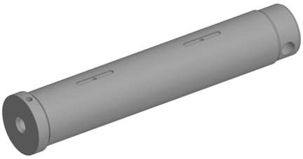

**Fig. 1.** Excavator bucket pin

In computer studies, stellite 6 was used as a surfaced material. It is a widely used wear-resistant alloy based on cobalt, which has good universal performance, good resistance to many types of mechanical and chemical degradation in a wide temperature range, good impact strength, and resistance to erosion [6].

The use of this material for surfacing on worn areas of the pin increases the reliability and durability as a result of the operation of the product.

This type of material during mechanical processing has its distinctive features from structural materials.

The processing of these alloys is complex. By the requirements for the quality and accuracy of the investigated part, a certain layer of material is removed from its surface. In this case, the remaining deposited layer after machining must have sufficient adhesion to the base material and satisfy the operational characteristics as a whole. Therefore, it is necessary to research the choice of the optimal thickness of the deposited stellite using computer technologies.

Based on the data obtained during the review of literature sources, the parameters of the depth of the deposited layer of the material (stellite 6) were determined, which made it possible to formulate boundary conditions for performing calculations.

The main initial data for the calculation in the ANSYS software package are presented in the form of characteristics of stellite 6 (surfaced layer) and steel 40X (product design) in Table 1.

*Table 1.* **Initial data for the calculation**

|  |  |  |
| --- | --- | --- |
| Characteristics | Stellite 6 | Steel 40X |
| Density | 8440 kg/m3 | 7820 kg/m3 |
| Young's modulus | 240 hPa | 205 hPa |
| Poisson's ratio | 0,3 | 0,29 |
| Tensile strength | 790 MPa | 980 MPa |
| Yield strength | 660 MPa | 785 МПа |
| Thermal conductivity | 35,6 W/(m\*K) | 15,2 W/(m\*K) |

Figure 2 shows the model in the program.

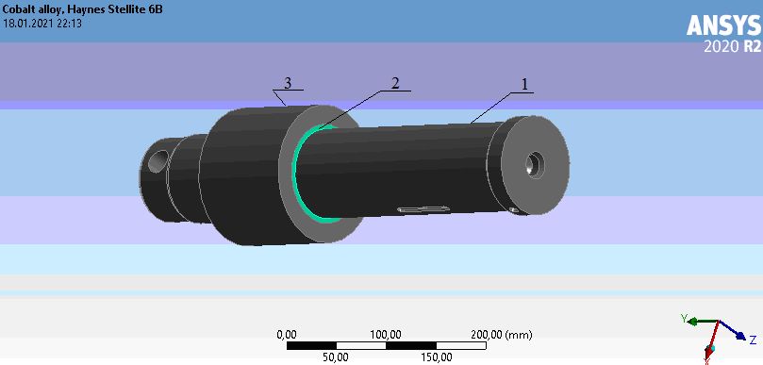

**Fig. 2**. Model in the ANSYS program: 1- pin, 2-deposited material, 3-bushing

The three-dimensional model of the "pin" part (Fig. 2) is transformed into a finite element model, to which boundary conditions are set (Fig.3): the characteristics of the used materials, the coefficient of friction (0.2) between the mating surfaces.

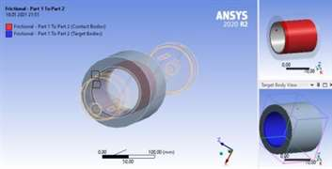

**Fig. 3.** Boundary conditions for performing calculations in ANSYS

*Table 2.* **Data processing**

|  |  |  |
| --- | --- | --- |
| Mode | Results without surfaced material | Results with surfaced material (3 mm) |
| 1 "Bending vibrations" | Stresses 43,52-6566,6 MPa | Stresses 32,34-11051 MPa |
| Deformations 0,89-8,06 mm | Deformations 0,89-8,02 mm |
| 3 "Torsion" | Stresses 62,7 – 8795 MPa | Stresses 21,81-21613 MPa |
| Deformations 0,73-6,63 mm | Deformations 0,78-7,04 mm |

As a result of the calculation, a diagram and a table with the calculated values of natural frequencies were obtained. 2 modes were taken for data processing (1 "bending vibrations", 3 "torsion"), which most characterize the process of deformation of the product (see Table 2).

Figure 4 shows a clear change in deformation deviations for the third mode "Torsion", where (a) denotes the results without stellite, (b) - with stellite.

а)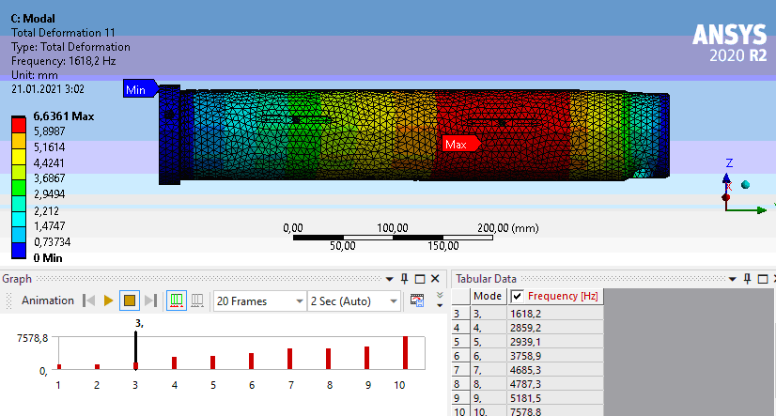

b)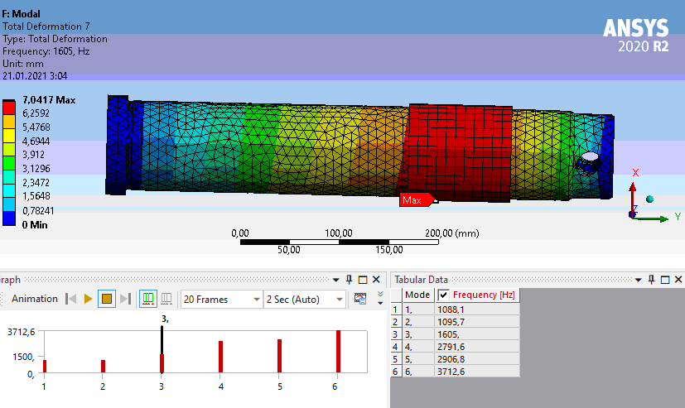

**Fig. 4**. Diagram and table with calculated values of natural frequencies

According to data visualization, it was found that it is advisable to use surfacing on worn parts of the "pin" part since the behavior of the model with maximum deformations is formed at large values. The natural oscillation frequencies of the part in the frequency range up to 3712 Hz with insignificant scattering are obtained. In addition, studies were conducted with a 5 mm stellite surfacing, deformations and stresses were approximated in values to the results obtained for 3 mm, so in the "bending vibrations" mode, the deformations were 0.90 – 8.12 mm.

It can be concluded that the provision of the required parameters of durability and operability of the product after restoration can be obtained with the lowest cost for the surfaced material since the results of the work revealed insignificant differences between the indicators of the surfacing depth.

**Conclusions**

According to the results of the modal analysis of the "pin" part, it was found that the depth of the deposited layer of the material (stellite 6) has a negligible effect on the operational characteristics of the product. Therefore, it is necessary to approach the determination of the optimal surfacing depth only by taking into account economic feasibility. The hypothesis put forward about ensuring the operability of the product after restoration using surfacing methods was also confirmed.

**References**

1. **Верещака А. С.** Обработка труднообрабатываемых материалов инструментом из твердого сплава с Re-Co-связкой повышенной теплостойкости и нано- структурированным износостойким покрытием [Электронный ресурс] / А. С. Верещака, и др. // Материалы МНТК ААИ «Автомобиле- и тракторостроение в России: приоритеты развития и подготовка кадров», посвященной 145-летию МГТУ «МАМИ». – Режим доступа: http://mospolytech.ru/science/mami145/scientific/article/s08/s08\_04.pdf.

2. Распоряжение Правительства РФ от 2011 г. №2227-р О Стратегии инновационного развития РФ на период до 2020г. [Электронный ресурс] – Режим доступа: https://www.garant.ru/products/ipo/prime/doc/70006124.

3. **Верещака А. С., Дачева А.В., Аникеев А.И.** Повышение работоспособности режущего инструмента при обработке труднообрабатываемых материалов путем комплексного применения наноструктурированного износостойкого покрытия и твердого сплава оптимального состава // Известия МГТУ «МАМИ». 2010. №.1(9). С. 99-105.

4. ГОСТ 21449-75 Прутки для наплавки. Технические условия : государственный стандарт : издание официальное : утв. и введ. в действие постановлением Государственного комитета совета министров СССР от 31.12.1975 г. № 4115 : дата введ. 1977-01-01 / разработан Министерством металлургии СССР. – Москва, 1977. – 11с. – Текст : электронный

5. **Леонтьев Н.В.** Применение системы ANSYS к решению задач модального и гармонического анализа. [Электронный ресурс] / Н.В. Леонтьев // Учебно-методический материал по программе повышения квалификации «Информационные системы в математике и механике». Нижний Новгород, 2006, 101 с.– Режим доступа: http://www.unn.ru/pages/e-library/aids/2006/2.pdf

6. Сварка. Материалы и оборудование. [Электронный ресурс] – Режим доступа: https://svares.ru/alloy-stellite-6

***Nekrasov Roman Yurievich*** – candidate of technical sciences, department chair, Department of Mechanical Engineering Technology, Tyumen industrial university.

*[Nekrasovrj@tyuiu.ru](mailto:Nekrasovrj@tyuiu.ru)*

***Tempel Olga Aleksandrovna*** –graduate student, Department of Mechanical Engineering Technology, Tyumen industrial university.

*[Tempeloa@tyuiu.ru](mailto:Tempeloa@tyuiu.ru)*

***Starikov Aleksandr Ivanovich*** – senior teacher, Department of Mechanical Engineering Technology, Tyumen industrial university.

*[Starikovai@tyuiu.ru](mailto:Starikovai@tyuiu.ru)*

УДК 004.896

Davydov E.V., Fomin E.V.

**Application of topological optimization for marine engineering products**

*The article aims to increase the productivity of manufacturing the mechanism of the "Shaft-turning device". For this purpose, the authors of the article perform topological optimization of the housing of the "Shaft-turning device" mechanism in the SolidEdge ST10 software package for further manufacturing it by the additive method.*

*As a result of the study, the authors found that the use of topological optimization in the design of the housing of the "Shaft-turning device" allows you to save material, reduce the number of assembly units and increase the production capacity of the "Shaft-turning device" as a whole, compared with the traditional manufacturing method.*

**Keywords:** topological optimization, marine engineering products, additive technologies, traditional manufacturing methods, productivity improvement, digitalization, digital enterprise.

**1. Preсonditions for the use of topological optimization technology for marine engineering products**

Topological optimization (one of the directions of Generative design technology) is fundamentally new design technology. It is based on the use of software that can independently, without the participation of a designer, generate three-dimensional models that meet the specified conditions. Topological optimization is what allows you to set the optimal balance of mass and strength for a specific part. With this design method, you can create the most optimal design or shape of the part, taking into account pre-set coefficients, for example, the safety factor. [3].

Parts and assemblies optimized using this technology have complex geometry, and their production by traditional production methods is not economically profitable, and in some housings, it is impossible at all. That is why it is more rational to produce such parts using the additive manufacturing method, which is an integral part of a modern digital enterprise and allows you to: reduce the duration of the "drawing – product" cycle, reduce labor intensity, material consumption, and energy consumption, as well as create an environmentally friendly production and increase productivity in the manufacture of parts as a whole.

The prerequisites for the use of topological optimization technology in the design process in mechanical engineering were: increasing the capabilities of 3D printing, increasing the quality of additive technologies in general, the appearance of the "Association for the Development of Additive Technologies" in the Russian Federation, which aimed to develop the additive technologies industry in the Russian Federation, as well as a global positive experience in such industries as aerospace, automotive and medicine.

**2. Topological optimization of the "Shaft-turning device" housing in Solid Edge ST10**

The general view of the shaft-turning device (STD), the parts of which are made by the traditional method (mechanical processing), is shown in Figure 1, and the housing of the "Shaft-turning device", which will be calculated by the method of topological optimization, is shown in Figure 2a.

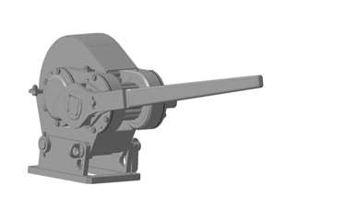

**Fig. 1.** General view of the STD, the model of which was created in the Compass 3D v17 software package

а)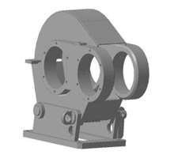 b)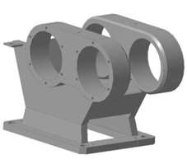

**Fig. 2**. The STD housing (a), the modified lower part of the STD housing

Before applying topological optimization in the Solid Edge ST10 software package, the lower part of the STD housing must be modified, eliminating all fasteners for the lower support. The modified lower part of the STD housing is shown in Figure 2b.

Before performing topological optimization, it is necessary to import the STD housing stored in the Compass 3Dv17 software package in STL format into Solid Edge ST10 and recognize the surfaces of its parts, as well as set all boundary conditions. The order of setting the boundary conditions of the lower part of the STD housing is as follows. First, we need to specify the material for the housing, the characteristics of which are shown in Figure 3.

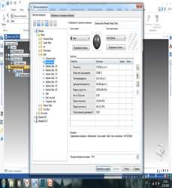

**Fig. 3.** Characteristics of the selected material for the lower part of the STD housing

Secondly, specify the unchangeable areas (in this housing, the unchangeable areas are the holes for fasteners with mating parts and places for installing bearings – Fig. 4a). It should be noted that immutable areas are those areas that are not subject to any changes during the topological optimization, i.e., the removal of unloaded elements and the change of geometry.

а) 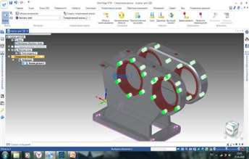 b) 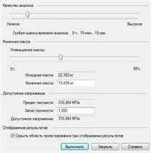

**Fig. 4.** Setting the unchangeable areas for the lower part of the housing of the STD( a), setting the calculation parameters

At the next stage, we indicate the loads to which the STD housing is subjected during its operation (in our housing, these are forces in the bearing area equal to 2000 N).

Further, as in all modern CAE systems, it is necessary to indicate the fixation of the model in space, corresponding to its real operating conditions (in our housing, this is the lower edge of the STD housing). The final stage in setting the boundary conditions is setting the calculation parameters (Figure 4b), namely, setting the calculation quality (in our housing, the calculation quality is low - to speed up the optimization process), indicating the percentage of the reduction in the mass of the final product (40%) and the minimum safety factor optimized design (1,3).

We perform similar actions to set the boundary conditions for calculating the topological optimization with the STD housing cover and the STD ratchet key housing.

The solutions obtained as a result of topological optimization have a faceted form, i.e. three-dimensional models of the lower part of the STD housing, the STD cover, and the ratchet key housing are presented in the form of a point cloud describing their appearance. However, with the help of Convergent Modeling technology, which is presented in the Solid Edge ST 10 software package, BREP (solid) and faceted representation are combined in one model, and it becomes possible to edit the models obtained as a result of topological optimization. The result of topological optimization for the STD housing is shown in Figure 5.

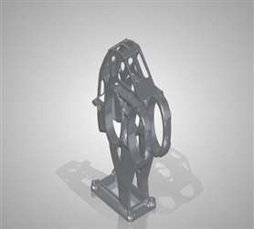 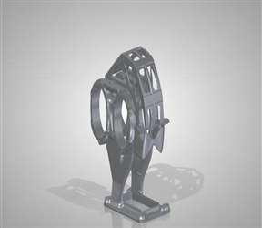

**Fig. 5.** The result of topological optimization in Solid Edge ST10 for the STD housing

The general view of the STD with an optimized housing and a ratchet key is shown in Figure 6.

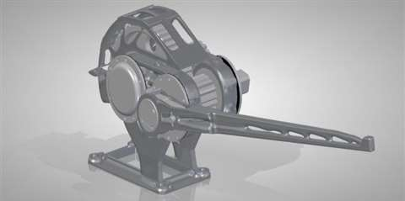

**Fig. 6.** General view of the STD with an optimized housing and a ratchet key

A comparative drawing of the STD housing "before" and "after" the application of topological optimization is shown in Figure 7.

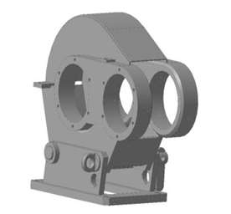 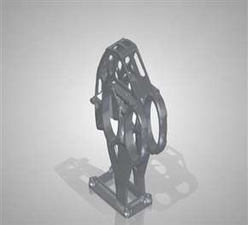

**Fig. 7.** The housing of the STD "before" and "after" the application of generative design in Solid Edge ST10

**3. Analysis of the results of topological optimization of the "Shaft-turning device" housing**

After the conducted research on the optimization of the STD housing in the Solid Edge ST10 software package, the following results were obtained:

3.1. Weight reduction:

a) The weight of the STD housing decreased by 48.7 % (from 28.53 kg to 14.635 kg);

b) The weight of the ratchet key housing decreased by 20.3 % (from 5.57 kg to 4.44 kg);

c) The total weight of the entire assembly of the STD decreased by 20.3 % (from 73.9 kg to 58.875 kg).

3.2. Reduction in the number of assembly components (standard products were not taken into account):

a) The number of components of the assembly of the STD housing decreased by 91 % (from 22 to 2 components);

b) The number of components of the ratchet key housing assembly decreased by 75 % (from 4 to 1 component);

c) The number of components of the general assembly of the STD decreased by 64 % (from 36 to 13 components).

Thus, with the help of the topological optimization technology carried out in this study for the STD housing and the STD ratchet key housing, we achieved a reduction in the mass of these products without deterioration of their strength characteristics, which will reduce material consumption and, accordingly, reduce the cost of optimized products as a whole. Reducing the number of assembly units of the STD mechanism will reduce the total time of all assembly operations.

The resulting geometry of optimized products allows us to use additive technologies as efficiently as possible in their manufacture, thanks to which it becomes possible: reducing the duration of the "drawing – product" cycle (no tooling and prototypes are required, and the production of the part is carried out immediately after the preparation of the digital model); reducing labor intensity, material consumption (layered creation of products allows you to reduce material consumption) and energy consumption (by reducing the number of technological operations). These positive results from the use of additive technologies can significantly increase the productivity of manufacturing the "Shaft-turning device" mechanism.

Additive technologies are an integral part of a modern digital enterprise and their introduction into production allows many enterprises to move to the stage of new industrial development – a digital enterprise. And the use of topological optimization in the design process allows you to achieve the maximum effect from the use of additive technologies since this technology provides the best solutions for the manufacture of parts that previously could not be implemented by traditional manufacturing methods. In such circumstances, the use of topological optimization in the design process and additive technologies in the manufacturing process gives an undeniable advantage to many enterprises in the highly competitive mechanical engineering market.

**References**

1. **Черепашков А.А, Носов Н.В.** Компьютерные технологии, моделирование и автоматизированные системы в машиностроении. – Издательский дом «Ин-Фолио», 2009. – 635 с.

2. **Липкин Е.** ИНДУСТРИЯ 4.0: Умные технологии – ключевой элемент в промышленной конкуренции». – М.: ООО «Остек-СМТ», 2017. – 224 с.

3. **Чад Джексон (Chad Jackson)** Новое поколение моделирования / Журнал в области САПР «CADMASTER». 2018. № 1 (87) – 114 с.

4. **Зиновьев Д.** Основы конструирования в Solid Edge ST10. Синхронная среда. – Студия «Vertex», 2018. – 206 с.

***Egor V. Davydov*** – assistant of department of metal technology and mechanical engineering Northern (Arctic) Federal University named after M.V. Lomonosov, NArFU branch in Severodvinsk.

Тел.: 8 (952)-259-84-68.

*[e.davydov@narfu.ru](mailto:e.davydov@narfu.ru)*

***Evgeny V. Fomin*** – Ph.D. (Engineering), Associate Professor, Head of the department of metal technology and mechanical engineering Northern (Arctic) Federal University named after M.V. Lomonosov, NArFU branch in Severodvinsk.

Tel.: 8 (902)-193-57-82.

*e.fomin@narfu.ru*

УДК 621.73.045

Gusev D.S., Sosenushkin E.N.

**Simulation of hot volumetric stamping of a wrench forging on an impactor**

*The choice of the shape and size of the initial workpiece in the processing of metals by pressure is largely determined by the parameters of the finished forging, the peculiarities of the metal flow in the stamp stream, and the desire to reduce technological waste in the form of flash. Computer modeling makes it possible, at the stage of pre-design studies, to analyze how much the quality of filling the stamp engraving depends on the original shape of the workpiece, to assess the effect of the initial temperature of the stamp on heat exchange processes in the “workpiece-stamp” system. The search for a rational shape of the workpiece was carried out using the DEFORM-3D software.*

**Keywords:** hot volumetric stamping, wrench, simulation, horizontal impactor hammer.

**Introduction**

The increase in the profitability of the technology of hot volumetric stamping is associated with a decrease in the rate of metal consumption in the production of forgings and the achievement of the highest performance indicators of the forming processes while minimizing subsequent machining. A large range of parts, elongated in plan and having elements in the form of thin sheets, can be combined into a separate class according to structural and technological features, which will ensure the unity of approaches to the technological preparation of blank production by pressure treatment methods. The accuracy and quality of the obtained forgings depend not only on the correct choice of the initial workpiece for a specific stamping operation but also on the accuracy of the equipment and tools used.

Technologies of hot volumetric stamping of wrenches are typical and are implemented on stamping anvil hammers of vertical layout or hammers with the counter motion of moving masses. However, the most productive is the technology using at least three hammer blows, which in turn can lead to a skewing of the workpiece, stamping of flash, and other manufacturing defects. The material utilization rate(MUR) when stamping round-section workpieces using such technologies is low, and there are some problems associated with the lack of filling of the stream cavity caused by some factors, including the shape and size of the workpiece, as well as the conditions of heat exchange of the workpiece with the stamp. The influence of these factors can be minimized by using horizontal hammers (impactors) with the oncoming movement of impact masses as part of automated complexes.

Mathematical and computer modeling of hot volumetric stamping of forging a wrench in open stamps, taking into account the named specifics, will allow us to identify the features of the kinematics of the metal flow when filling the stamp stream; to assess the stress-strain state of both the deformable metal and the stamp tool; to calculate the force parameters in the process of forming, as well as to evaluate the heat exchange processes in the "workpiece-stamp" system. The relevance of the listed and solved tasks is obvious.

**Statement and solution of the problem**

The wrench 7811-0001 by GOST 2839-80 [1] was chosen as a typical part. One of the first stages in the design of hot stamping technology involves the development of a forging drawing by GOST 7505-89 [2], which is shown in Fig. 1. The forging is a prototype for the preparatory stage of machine modeling - the creation of 3D models of the forging itself and stamp tooling. An important stage is the preparation and specification of the initial conditions of deformation and initial data on the rheology of the deformed metal, the kinematics of the tool movement, as well as the justification of the limitations for this model. In terms of the equipment used, the specificity of the operation of the horizontal hammer (impactor) ГШМ-4 with an electronic-hydraulic control system was taken into account.

Computer modeling was carried out using the DEFORM-3D V6.1 software [3], which implements one of the energy methods - the finite element method. For the formulation of numerical experiments, workpieces made of round rolled products GOST 2590-2006 [4] with dimensions Ø13, length 84 mm, and Ø9×70 mm were used. Induction heating of the workpiece is 1100 °C and 950 °C. The temperature range of the heating of stamps is from 150 °C to 300 °C. The material of the workpiece is DIN-41Cr4 (corresponds to steel 40X GOST 4543-2016 [5]). The material of the stamps is AISI-L6 (corresponds to the stamped steel 5ХНМ GOST 4543-2016). Equipment is a hammer with a collision energy of moving masses of 4.000.000 Ns2/m; the mass of the impact part is 0.245 t; the efficiency coefficient is 0.85.

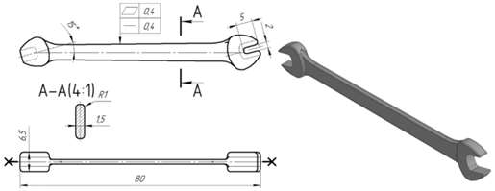

**Fig. 1.** 4×5 wrench: forging drawing and 3D model

The initial and obtained data are shown in Table. 1. Limitations of the problem: the maximum voltage in the workpiece is not more than 2200 MPa, the maximum temperature of the workpiece is not more than 1250 °C. Based on the restrictions, a mark of compliance is placed in the column of Table 1.

*Table 1.* **Initial and obtained compute simulation data**

|  |  |  |  |  |  |  |
| --- | --- | --- | --- | --- | --- | --- |
| Initial data | | | | Obtained data | | |
| Workpiece number | Workpiece dimensions, mm | Workpiece heating, ° С | Stamp heating, ° С | Maximum temperature of the workpiece, ° | Maximum stress in the workpiece, MPa | Compliance mark |
| 1 | Ø 13×84 (est.) | 1100 | 150 | 1250 | 917 | + |
|  | Ø 13×84 (est.) | 950 | 300 | 1066 | 1041 | + |
| 2 | Ø 9×70 | 1100 | 150 | 1400 | 1950 | - |
|  | Ø 9×70 | 950 | 300 | 1060 | 1230 | + |

Diagrams of cross-sections and diameters (Fig. 2) were constructed using the projected forging, the stamp streams were selected according to the reference data [6]. Based on these data, the geometry of the workpiece was selected as an average calculated workpiece with dimensions Ø13 × 84 mm. Modeling of the stamping process showed ineffective use of metal since most of it goes into the flash (Fig. 3).

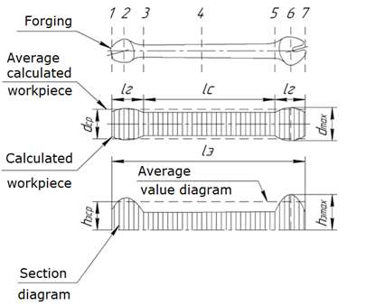

**Fig. 2**. Section diagram and calculated workpiece

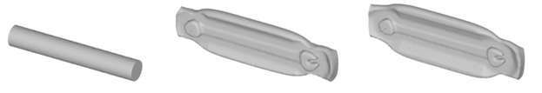

а) b) c)

**Fig. 3**. The geometry of the workpiece (a) and the results of modeling at Тз = 950 °C and Тз = 300 °C (b); at Тз = 1100 °C and Тз = 150 °C (c)

To obtain accurate results, the model must take into account the heat transfer between the workpiece, the stamps, and the environment. Also, the stamps are usually preheated for hot volumetric stamping processes. For stamps, as for the workpiece, a temperature change is expected due to heat transfer and heat released as a result of the thermal effect of deformation. The temperature fields of stamps and the workpiece were simulated. The results for the stamped material are shown in Table 2.

*Table 2.* **The results of modeling the stamping of the workpiece Ø13×84**

|  |  |
| --- | --- |
| heating of the workpiece 950°C, stamps 150°C | heating of the workpiece 1100°C, stamps 150°C |
|  |  |
| heating of the workpiece 950 °C, stamps 300 °C | heating of the workpiece 1100 °C, stamps 300 °C |
|  |  |

As can be seen from Table 2, the metal flow is better at the upper temperatures of the workpiece and stamps. However, the maximum temperature of the workpiece exceeds the critical temperature, which is unacceptable due to the danger of overheating. Therefore, the lower temperature value for the workpiece (950 °C) and the upper value for the stamp (300 °C) will be rational.

Modeling on workpiece 1 showed that the maximum temperature and maximum stresses of the stamped metal were within the normal range. However, in both cases, the modeling of the stamping of workpiece 1 revealed that the hammer energy is not enough to fill the stamp along the axis of movement of the stamps. The stamps were stopped at a distance of 3,618 mm in the first case and 2,097 mm in the second case. From this, we can conclude that the preheating of the stamp does not affect the stamping process as much as the preheating of the workpiece does. It was also revealed that when using the geometry of workpiece 1, a large amount of flash is formed, which will adversely affect the economic efficiency of the technology under study.

The workpiece according to option 2 was made with the dimensions of the diagrams with the choice of a rotating body with a variable section. The workpiece configuration and simulation results are shown in Fig. 4.

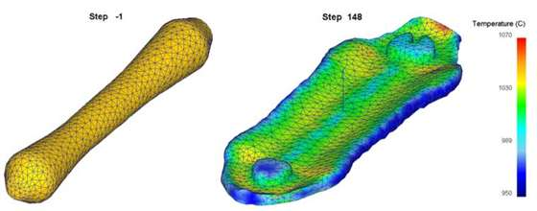

**Fig. 4.** The geometry of the workpiece according to the diagrams and forging after modeling at Тз = 950 °C and Тш = 300 °C

As can be seen from the simulation (Fig. 4), there is no under-stamping, i.e. the stamp engraving is filled, and forging of the desired thickness is obtained. However, the amount of flash can be reduced.

Based on the results obtained, the geometry of the workpiece was corrected (Fig. 5), which took into account all the previous shortcomings.

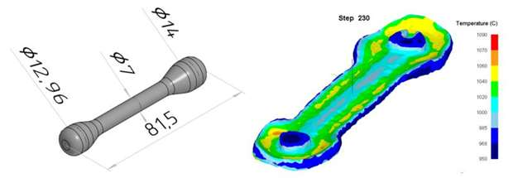

**Fig. 5.** The geometry of the workpiece and the results of modeling the stamp filling and temperature distribution

The simulation was carried out at a workpiece temperature of 950 °C, and a stamp temperature of 300 °C. Fig. 5 shows that with a given amount of flash corresponding to the filling coefficient of the flash groove of 0.4, a complete filling of the stamp stream is provided.

As a result of modeling, the dependences of the effective stresses and the temperature of the workpiece on time are obtained (Fig. 6). The stresses did not exceed 550 MPa, which is a satisfactory result. And the temperature of the workpiece remained no higher than 1250 °C, which will protect the stamped material from overheating.

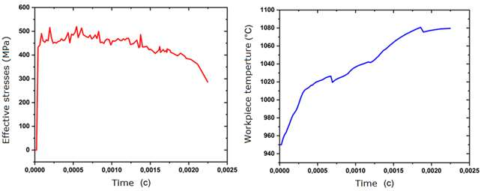

а) b)

**Fig. 6**. Change in time of effective stresses (a) and workpiece temperature (b)

Thus, computer simulation made it possible to achieve the desired shape and the required temperature parameters to ensure efficient punching of the wrench with the highest MUR.

**References**

1. **ГОСТ 2839-80** Глючи гаечные с открытым зевом двухсторонние. Конструкция и размеры. - М.: Госкомстандарт СССР, 1980. – 22 с.

2. **ГОСТ 7505-89** Поковки стальные штампованные. Допуски, припуски и кузнечные напуски. - М.: Госкомстандарт СССР, 1989. – 36с.

3. **Практическое руководство к программному комплексу DEFORM-3D** [Текст]: учебное пособие / В. С. Паршин [и др.]; науч. ред. Ю. Б. Чечулин; М-во образования и науки Российской Федерации, Уральский федеральный ун-т им. первого Президента России Б.Н. Ельцина. - Екатеринбург: УрФУ, 2010. - 265 с.

4. **ГОСТ 2590-2006** Прокат сортовой стальной горячекатаный круглый. Сортамент. – М.: Стандартинформ, 2006. – 8 с.

5. **ГОСТ 4543-2016** Металлопродукция из конструкционной легированной стали. Технические условия. –М.: Межгосударственный совет по стандартизации, метрологии и сертификации, 2016. – 47 с.

6. **Ковка и объемная штамповка.** Справочник в 4-х томах./Ред. совет: Е.И. Семенов (пред.) и др. – М.: Машиностроение, 1985. – Т.1, том 1. Материалы и нагрев. Оборудование. Ковка/ Под ред. Е.И. Семенова, 1985. – 568 с.

***Gusev Dmitry Sergeevich*** - post-graduate student of MSUT "STANKIN".

*[dagiet04@gmail.com](mailto:dagiet04@gmail.com)*

***Sosenushkin Evgeny Nikolaevich*** - Doctor of Technical Sciences, Prof., Head. Department of Composite Materials, MSUT "STANKIN".

*[sen@stankin.ru](mailto:sen@stankin.ru)*

УДК 539.374.4:539.214.9

S.V. Liubimskiy

**Simulation of the combined technological process of severe plastic deformation**

*Computer simulation of the combined technological process of severe plastic deformation (SPD) has been carried out. The obtained results make it possible to make a rational choice of the parameters of the designed technological process from several alternatives, taking into account the decrease in the force modes of deformation.*

**Keywords:** severe plastic deformation, computer simulation, deforming force, equal-channel angular pressing, screw extrusion.

The actual direction of the development of mechanical engineering is the production of structural materials with ultrafine-grained (UFG) and submicrocrystalline (SMC) structures, which have an increased level of mechanical and operational characteristics [1]. Research in this field is essential for the creation and development of new products in various areas of industrial production.

To obtain materials with a UFG structure, of great interest are methods of severe plastic deformation (SPD), the essence of which is deformation with large degrees of deformation at relatively low temperatures under conditions of high applied pressures. Equal-channel angular pressing (ECAP) [2] and its type - equal-channel angular pressing in parallel channels ECAP-PC [3] are in demand. The attractiveness of these methods is in the simplicity of implementation and high efficiency [4], which allows realizing large values of accumulated shear deformation without changing the shape and size of the cross-section of the workpiece, which contributes to significant grain refinement [2]. Of no less interest is a relatively new SPD method - screw extrusion, the essence of which is to repeatedly push the workpiece through the screw channel, which also leads to the accumulation of shear deformations in the workpiece with a simultaneous change in the deformation route [6].

This paper investigates the possibility of increasing productivity and improving the ECAP technological process by combining simple shear mechanical schemes and screw extrusion.

Several variants of die tooling designs with carrying out solid modeling in the DEFORM-3D environment based on the finite element method (FEM) are proposed. The results obtained make it possible to trace the rheology of the metal, to determine the intensity of the distribution of accumulated deformations, the necessary pressing forces, and to reveal the rational geometric parameters of the matrix channels.

The developed scheme of the combined SPD technological process connects the technological processes of equal channel angular pressing and screw extrusion (ECAP + SE) [7].

Since a large amount of equipment and tooling is required to experiment, it is advisable to first simulate the ECAP + TE process to identify possible technological problems even before they arise in a real physical experiment.

**The work aim**s to substantiate the choice of rational geometric parameters of die tooling that affect the features of the kinematics of the metal flow by modeling the combined ECAP + SE technological process.

To achieve this goal, it is necessary to solve the following tasks:

- to develop a scheme of a combined technological process;

- to create 3D models of die tooling;

- to carry out computer modeling of the combined ECAP + SE process;

- by varying the geometric parameters of the matrix, to determine their influence on the flow kinematics and the pressing force.

As the initial workpieces, we used square rods of 14 × 14 mm made of wrought aluminum alloy (rod АМg2,5. М КВ14П ОСТ 1 92093-83).

AMg2,5 is an aluminum alloy of the "Aluminum-Magnesium" (Al-Mg) system, which belongs to deformable alloys. In addition, this material stands out among others for its high corrosion resistance, ductility, and good weldability. In terms of strength, it surpasses АМц but is inferior to it in plasticity. The chemical composition of AMg2,5 can be called balanced. The magnesium content in it does not exceed 3%, which has a positive effect on the plasticity and corrosion resistance of the material, as well as its weldability. At the same time, the Mg content exceeds 2%, which has a positive effect on the strength of the alloy.

An alloy of the Al-Mg system according to ISO 209-1, the alloy of the AMg2,5 grade, having the designations AlMg2,5 and 5052, is well deformed in the cold and hot state. The alloy, having high overall corrosion resistance, is not prone to stress corrosion cracking and intergranular corrosion, especially in the annealed state.

It is used for the manufacture of forgings for aircraft parts.

The choice of this alloy is dictated by the presence of its specifications for various states in the DEFORM 3D software package due to its wide use in foreign industry, as well as the close chemical composition to the AMg2 alloy, which is widespread in the industry of the Russian Federation, and for this alloy, there are research results for the effect of SPD on it.

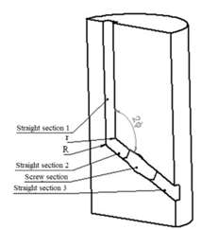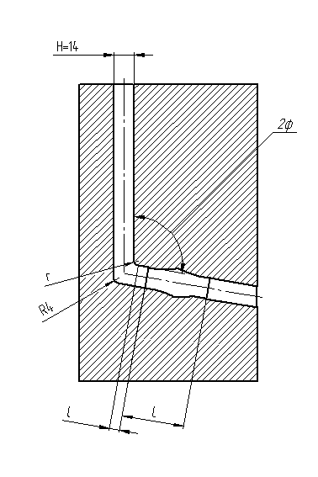

а) b)

**Fig. 1**. Semi-matrix: a - 3D model; b - channel diagram

**Simulation of the combined technological process of SPD**

The combined technological process of ECAP and SE is the operation of punching a workpiece through a die channel, which consists of input, intermediate, and outlet sections, and the intermediate channel is made of a screw (Fig. 1).

In the process of pressing, the workpiece perceives high pressures and, passing through the zones of the intersection of channels due to large shear deformations, accumulates deformations with a simultaneous grinding of the grain structure by fragmentation.

The simulation included a series of 9 experiments for a single-bend circuit. The channel conjugation angle (2φ) was set to 100, 110 and 120 degrees, and the length of the screw section 2H, 3H and 4H (H=14 mm – the size of the side of the square section of the workpiece) was also varied to find out the influence of geometric parameters on the deformation force.

The combinations of geometric parameters of the matrix channel that participated in the modeling are shown in Table 1.

*Table 1.* **Geometric parameters of the matrix channels**

|  |  |  |  |  |  |
| --- | --- | --- | --- | --- | --- |
| Experiment | *r*, mm | *R*, mm | *l*, mm | *L*, mm | 2*φ*, ° |
| 1 | 3 | 4 | 7 | 28 | 100 |
| 2 | 3 | 4 | 7 | 42 | 100 |
| 3 | 3 | 4 | 7 | 56 | 100 |
| 4 | 3 | 4 | 7 | 28 | 110 |
| 5 | 3 | 4 | 7 | 42 | 110 |
| 6 | 3 | 4 | 7 | 56 | 110 |
| 7 | 3 | 4 | 7 | 28 | 120 |
| 8 | 3 | 4 | 7 | 42 | 120 |
| 9 | 3 | 4 | 7 | 56 | 120 |

The following parameters were taken as modeling parameters: the material of the workpiece - aluminum alloy AA5052; the dimensions of the workpiece are 13.9×13.9×100 mm; the model of the workpiece material is rigid-plastic; the number of finite elements is 68470; the smallest element size is 0.5 mm; the scale factor is 3; the Siebel friction factor is 0.4; the speed of movement of the punch is 1 mm/s; the process temperature is 20°C; the step resolution is 0.1 mm/step; the maximum movement of the punch is 90 mm.

Figure 2 shows graphs of the dependence of the force on the punch on the displacement to track the influence of the length of the screw section on the power parameters of the process with the constant angle of intersection of the channels 2φ and the radii of rounding at the intersection of the channels.

а)

b)

c)

**Fig. 2**. Dependence of the load on the punch on its movement:

a – experiments 1-3; b-experiments 4-6; c-experiments 7-9 (see Table 1)

According to the obtained graphs, it is established that an increase in the length of the screw channel, in general, leads to a decrease in the load on the punch in the process of pushing the workpiece through the screw section of the matrix. This is caused by an increase in the arm of force, and, consequently, the moment of force, as well as a decrease in the angle of inclination of the helix. As a simple example, we can provide a cantilever-fixed beam, which is twisted from the side of the loose end, with a constant cross-section of the beam, for twisting at the same angle, with a longer length of the beam, a force less in magnitude will be required.

а)

b)

c)

**Fig. 3.** Dependence of the load on the punch on its movement:

a – experiments 1, 4, 7; b-experiments 2, 5, 8; c-experiments 3, 6, 9 (see Table 1)

Fig. 3 shows graphs for tracking the influence of the angle value 2φ on the power parameters of the process with constant radii of rounding at the intersection of the channels and the total length of the output channel. Computer modeling revealed the influence of the channel conjugation angle on the value of the deformation force, the results show that an increase in the angle value leads to a decrease in the force parameters.

*Table 2.* **Geometric parameters of the matrix channels**

|  |  |  |  |  |  |
| --- | --- | --- | --- | --- | --- |
| Experiment | *r*, mm | *R*, mm | *l*, mm | *L*, mm | 2*φ*, ° |
| 1 | 3 | 4 | 7 | 42 | 100 |
| 2 | 4 | 4 | 7 | 42 | 100 |
| 3 | 5 | 4 | 7 | 42 | 100 |

The next stage of modeling was the study of the influence of the inner radius of conjugation *r* and the length *l* of the straight section 2, according to the scheme shown in Fig. 2, on the force of deformation. Table 2 summarizes the geometric parameters for studying the influence of the radius r on the force parameters of deformation. Fig. 4 shows the obtained graphs of the dependence of the load on the punch on its movement.

**Fig. 4.** Dependence of the load on the punch on the movement when changing the radius *r*

The obtained dependences demonstrate that with an increase in the internal conjugation radius *r* the average load on the punch increases slightly, in general, the influence on the average load can be considered insignificant, in comparison with the influence of the length of the screw channel and the angle of conjugation of the channels.

Table 3 shows the geometric parameters for studying the effect of the length *l* of the straight section 2 on the load (see Figure 1). Figure 5 shows graphs of the dependence of the load on the punch on its movement.

*Table 3.* **Geometric parameters of the matrix channels**

|  |  |  |  |  |  |
| --- | --- | --- | --- | --- | --- |
| Experiment | *r*, mm | *R*, mm | *l*, mm | *L*, mm | 2*φ*, ° |
| 1 | 3 | 4 | 7 | 28 | 100 |
| 2 | 3 | 4 | 14 | 28 | 100 |
| 3 | 3 | 4 | 7 | 42 | 100 |
| 4 | 3 | 4 | 14 | 42 | 100 |
| 5 | 3 | 4 | 7 | 56 | 100 |
| 6 | 3 | 4 | 14 | 56 | 100 |

а)

b)

c)

**Fig. 5**. Dependence of the load on the punch on its movement:

a - experiments 1, 2; b - experiments 3, 4; c - experiments 5, 6 (see Table 3)

Analysis of the graphs shows that there is an increase in the load on the punch with the increasing length *l* of the straight section 2. This circumstance is explained by the fact that the total length of the output of the channel increases with the increasing length of the straight section 2, so the area of the contact friction becomes larger and to overcome friction over a larger area is required a big load.

Based on the obtained data, it was decided to produce a matrix with an internal radius of rounding *r*=3 mm of the channel intersection zone with a straight section length *l*=0.5×H=7 mm.

**Conclusion**

Computer simulation of the combined SPD processes makes it possible to make a rational choice of the parameters of the designed technological process from several alternatives, taking into account the reduction of the force modes of deformation.

**References**

1. **Валиев Р.З., Александров И.В.** Наноструктурные материалы, полученные интенсивной пластической деформацией. – Москва: Логос, 2000. – 272 с.
2. Сегал В.М., Резников В.И., Копылов В.И. Процессы пластического структурообразования металлов. – Минск: Наука и техника, 1994. – 232 с.
3. **Sosenushkin E.N., Yanovskaya E.A., Sosenushkin A.E.** Computer and Physical Simulation of angular Pressing// International virtual journal for science, technics, and innovations for the industry. Machines. Technologies. Materials. - Year VIII. Issue 9. 2014. – Pp. 52–54.
4. **Сосенушкин Е.Н., Овечкин Л.М., Сосенушкин А.Е.** Показатели эффективности процесса равноканального углового прессования// Заготовительные производства в машиностроении. – 2015. – №12. – С. 23–28.
5. **Бейгельзимер, Я.Е.** Винтовая экструзия – процесс накопления деформаций. – Донецк: Фирма ТЕАН, 2003. – 87 с.
6. Патент РФ № 2181314. Устройство для обработки металлов давлением/ Г.И. Рааб, Р.З. Валиев и др. Опубл. 20.04.2002.
7. Патент № 2440210 Штамп для равноканального углового прессования/ Сосенушкин Е.Н., Овечкин Л.М., Сосенушкин А.Е. МПК B21J 13/02 (2006.01); B21J 5/06 (2006.01); C22F 1/00 (2006.01). Опубл. 20.01.2012. Бюл. №2.

***Liubimskiy Semen Vasilyevich*** – postgraduate student of the sub-department «Plastic deformation systems», MSUT «STANKIN», design engineer 1 cat., PJSC «ALMAZ R&P Corp.» LEMZ Division, Moscow.

*widowmakeriii@yandex.ru*

УДК 621.735.016.2

Sivenkov M. I., Ivanov Y. V., Semenyaka A. G., Poduraev Y. V.

**Artificial neural networks architectures for human semantic segmentation investigation**

*Artificial neural networks are one of the key technologies that make it possible to successfully apply machine training methods. This article discusses the problem of human recognition using various ANN architectures. An overview and analysis of the effectiveness of using various ANN architectures for semantic segmentation of an object are presented, an experimental comparison of ANN architectures is carried out.*

**Keywords**: artificial neural networks, semantic segmentation, human recognition

**Introduction**

With the development of modern technologies, the problem of human recognition by technical vision systems becomes more and more urgent. Various algorithms capable of determining the location of a person in the image are used in various fields, such as autonomous driving systems, industrial safety systems, multimedia applications, etc. Significant progress in the development of ANN in recent years has allowed us to achieve a high quality of object recognition, exceeding similar indicators for classical machine training algorithms, which makes ANN one of the most effective approaches for this task

There are many methods for localizing objects in an image. One of the most informative for the human recognition problem is the semantic segmentation method, which realizes the classification of all image pixels, i.e. defines the belonging of pixels to the classes "background" or "person", thereby allowing you to localize the figure of a person with pixel precision. The purpose of this work is to analyze and compare various ANN architectures and identify the most suitable for the task of human recognition.

**Comparative analysis of ANN architectures for semantic segmentation**

Currently, many ANN architectures implement the semantic segmentation algorithm. Based on the study of the results of research on machine training algorithms, such as COCO Segmentation Challenge [1] and PASCAL Visual Object Classes Challenge [2], the architectures that show the best results for the semantic segmentation problem were selected and investigated.

**FCN.** The Fully Convolutional Networks (FCN) architecture has gained widespread popularity following a publication by Evan Shelhamer et al. in CVPR in 2015 [3]. The authors of the work proposed the idea of replacing the output fully connected layers with convolutional layers. As a result, the ANN output is a two-dimensional tensor, the values of the elements of which can be interpreted as the probability of belonging to one of the classes. Thus, FCN issues feature maps (heatmaps) for each of the classes, thereby solving the problem of semantic segmentation.

In the course of the experiments carried out on the Pascal VOC dataset, it was shown that the proposed architecture outperforms competing architectures such as R-CNN and SDS in terms of the quality of segmentation, determined using the mean Intersection over Union (mIoU) metric and speed of operation (Table 1).

*Table 1.* **Results of testing ANN on Pascal VOC 11/12 sets [3]**

|  |  |  |  |
| --- | --- | --- | --- |
| Architecture | VOC2011, mIoU | VOC2012, mIoU | Work time |
| R-CNN | 47.9 | - | - |
| SDS | 52.6 | 51.6 | ~50 с |
| FCN8s | **67.5** | **67.2** | **~100 мс** |

The disadvantages of the FCN architecture include the relatively low accuracy of the spatial definition of objects caused by the difference in the resolutions of the input image and the output tensor.

**DeconvNet**. One of the options for solving the problem of low accuracy of spatial definition of objects was proposed by Hong et al. [4], where the DeconvNet architecture was described. The structure of this ANN consists of two main components - an encoder that performs image convolution, and a decoder that converts the results of the encoder's operation into output class masks (Fig. 1).

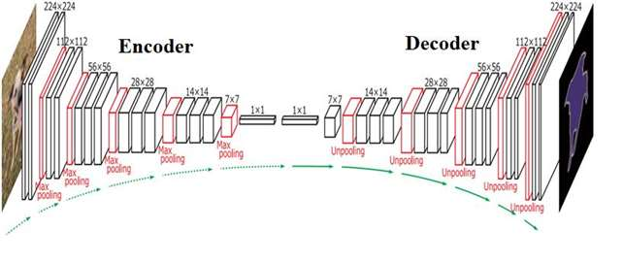

**Fig. 1.** DeconvNet architecture

It can be noted that the encoder and decoder are symmetric structures, the difference between which is the use of layers for lowering the dimensionality (max pooling) instead of layers for increasing the dimensionality (unpooling). The new approach, which consists in using layers to increase the dimensionality, allowed to improve the quality of semantic segmentation of objects and to overtake FCN-type architectures on the Pascal VOC dataset by more than 10% according to the mIoU metric.

**SegNet**. In 2016, in the work of Alex Kendal et al. [5] was presented a modification of DeconvNet - the SegNet architecture. The main innovation in SegNet is the decoder oversampling method. Each downscaling layer in the encoder is directly linked to a symmetric layer in the decoder. Thus, with an increase in the dimensionality of feature maps, information about the pooling indices that were selected at the stage of dimensionality reduction becomes available, which has a positive effect on the accuracy of the final segmentation (Fig. 2).

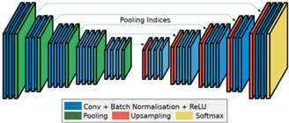

**Fig.2** SegNet architecture

The proposed architecture was tested on CamVid and SUNRGB-D sets and showed better results compared to other popular architectures, such as FCN, DeconvNet, and DeepLab.

*Table 2.* **Results of testing ANN architectures on the CamVid set**

|  |  |  |  |  |
| --- | --- | --- | --- | --- |
| Architecture | Dependence of mIoU on the number of training epochs | | | Maximum number of training epochs |
| 40 ths. | 80 ths. | More than 80 ths. |
| SegNet | 50.02 | **57.18** | **60.10** | 140 ths. |
| DeepLab-largeFOV | **50.18** | 53.34 | 53.88 | 140 ths. |
| FCN | 46.59 | 47.95 | 49.83 | 200 ths. |
| FCN (deconv) | 48.68 | 50.80 | 51.96 | 160 ths. |
| DeconvNet | 39.69 | 43.74 | 59.77 | 260 ths. |

**U-Net.** This ANN architecture was proposed by Olaf Ronnenberger et al. [6] in 2015 for biomedical image segmentation. The new architecture was based on a SegNet type architecture containing an encoder and a decoder. The authors of the work proposed to improve the quality of segmentation due to the direct concatenation of feature maps of symmetrically located encoder and decoder layers (Fig. 3).

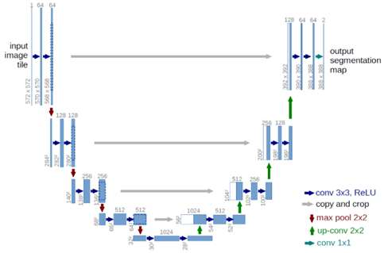

**Fig.3.** U-Net architecture

The U-Net architecture has shown the best results for biomedical image segmentation in competitions such as the ISBI Cell Tracking Challenge and Kaggle Ultrasound Nerve. Further works [7, 8] showed the high efficiency of using U-Net in other applied areas, which made this architecture one of the most popular for segmentation tasks at the moment.

**DeepLabv3+.** One of the newest architectures that have proven itself in solving the problem of semantic segmentation is DeepLabV3 +, published by developers from Google in 2018 [9]. This neural network also consists of an encoder and a decoder, but the main difference between DeepLab-type architectures is the use of atrous convolutions, which are filters parameterized by the rate value, which is responsible for the degree of convolution sparseness (Fig. 4).

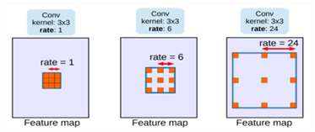

**Fig. 4.** Scheme for calculating sparse convolutions depending on the rate parameter

This approach allows us to achieve better segmentation by increasing the coverage area of each of the convolutions without increasing the number of ANN parameters and the number of calculations. The high quality of segmentation was experimentally confirmed on the Pascal VOC data set: DeepLabV3+ with the Xception-JFT architecture as an encoder showed a mIOU metric value of 89%, which exceeds similar indicators for such architectures as SegNet, DeconvNet, and FCN.

*Table 3.* **Results of testing architectures on the Pascal VOC 2012 set**

|  |  |  |  |
| --- | --- | --- | --- |
| Architecture | mIoU | Architecture | mIoU |
| Deep Layer Cascade | 82.7 | CASIS IVA SDN | 86.6 |
| TuSimple | 83.1 | DIS | 86.8 |
| Large Kernel Matters | 83.6 | DeepLabV3 | 85.7 |
| Multipath RefineNet | 84.2 | DeepLabV3-JFT | 86.9 |
| ResNet-38 MS COCO | 84.9 | DeepLabV3+ (Xception) | 87.8 |
| PSPNet | 85.4 | DeepLabV3+(Xception-JFT) | **89.0** |
| IDW-CNN | 86.3 |

**Analysis of ANN architectures**. The use of ANN for the task of human recognition assumes both high accuracy of the spatial localization of an object and a sufficiently high speed of the ANN to ensure real-time operation. Based on the analysis performed, in tasks close to human recognition, DeepLabV3 + shows the highest segmentation quality metrics, which is confirmed by other studies [9]. However, sufficient information was not found to compare the performance of the U-Net and DeepLabV3 + architectures on the same training and test suites. Also, an important issue is the performance of architecture. To solve these problems, it was decided to conduct experimental testing of the U-Net and DeepLabV3 + architectures to determine the most suitable for solving the problem of human recognition using the semantic segmentation method.

**Computational experiment**

During the experiment, the UNet and DeepLabV3 + architectures were trained on the COCO 2017 dataset. To obtain more reliable results, each architecture was considered with two different encoders: MobileNetV2 and ResNet50V2.

The sizes of the training and test samples are 10,000 and 200 annotated images, respectively. The Adam algorithm with a training step of 0.0007 was used as an optimizer. The loss function is a categorical cross-entropy. The total number of training epochs is 50, the number of images per training step is 16.

During testing, the quality of segmentation was evaluated using the mIoU metric, to assess the performance, the number of operations in gigaflops (gFLOPS) was calculated when processing images with a resolution of 320x320 pixels. The test results are shown in Table 5.

*Table 4.* **Testing results of U-Net and DeepLabV3+architectures**

|  |  |  |  |
| --- | --- | --- | --- |
| Architecture | Encoder | mIoU, % | gFLOPS |
| U-Net | MobilenetV2 | **0.786** | 21.053 |
| ResNet50V2 | 0.769 | 89.706 |
| DeepLabV3+ | MobilenetV2 | 0.770 | **9.383** |
| ResNet50V2 | 0.750 | 54.338 |

Based on the experimental data, it can be concluded that the U-Net architecture shows a higher quality of segmentation than DeepLabV3+, which is explained by the presence of intermediate concatenations of feature maps between the encoder and decoder. The difference is 0.016%, which is not a significant difference and allows us to say that these architectures have a similar quality of segmentation. At the same time, the performance evaluation shows that the UNet architecture requires more than twice as many calculations.

**Conclusion**

This paper presents an overview and analysis of various ANN architectures for the problem of object recognition by the method of semantic segmentation. As a result of the analysis, two ANN architectures were selected, with which a computational experiment was carried out. Based on the results of this experiment, it was found that the DeepLabV3 + architecture is the most suitable for human recognition using the semantic segmentation method.

**References**

1. **[Tsung-Yi Lin](https://arxiv.org/search/cs?searchtype=author&query=Lin%2C+T), [Michael Maire](https://arxiv.org/search/cs?searchtype=author&query=Maire%2C+M), [Serge Belongie](https://arxiv.org/search/cs?searchtype=author&query=Belongie%2C+S), [Lubomir Bourdev](https://arxiv.org/search/cs?searchtype=author&query=Bourdev%2C+L), [Ross Girshick](https://arxiv.org/search/cs?searchtype=author&query=Girshick%2C+R), [James Hays](https://arxiv.org/search/cs?searchtype=author&query=Hays%2C+J), [Pietro Perona](https://arxiv.org/search/cs?searchtype=author&query=Perona%2C+P), [Deva Ramanan](https://arxiv.org/search/cs?searchtype=author&query=Ramanan%2C+D), [C. Lawrence Zitnick](https://arxiv.org/search/cs?searchtype=author&query=Zitnick%2C+C+L), [Piotr Dollár](https://arxiv.org/search/cs?searchtype=author&query=Doll%C3%A1r%2C+P)** Microsoft COCO: Common Objects in Context, arXiv:1405.0312v3 [cs.CV] 21 Feb 2015

2. **Everingham, Mark & Van Gool, Luc & Williams, Christopher & Winn, John & Zisserman, Andrew** The Pascal Visual Object Classes (VOC) challenge. International Journal of Computer Vision 2010. 88. 303-338.

3. **E. Shelhamer, J. Long, T. Darrell**, "Fully Convolutional Networks for Semantic Segmentation," in IEEE Transactions on Pattern Analysis and Machine Intelligence, vol. 39, no. 4, pp. 640-651, 1 April 2017,

4. **H. Noh, S. Hong, B. Han** "Training Deconvolution Network for Semantic Segmentation," 2015 IEEE International Conference on Computer Vision (ICCV), 2015, pp. 1520-1528,

5. **V. Badrinarayanan, A. Kendall, R. Cipolla** "SegNet: A Deep Convolutional Encoder-Decoder Architecture for Image Segmentation," in IEEE Transactions on Pattern Analysis and Machine Intelligence, vol. 39, no. 12, pp. 2481-2495, 1 Dec. 2017

6. **Ronneberger, Olaf, Fischer, Philipp, Brox, Thomas** U-Net: Convolutional Networks for Biomedical Image Segmentation 2015 LNCS. 9351. 234-241.

7. **R. Dong, X. Pan, F. Li**, "DenseUNet-Based Semantic Segmentation of Small Objects in Urban Remote Sensing Images," in IEEE Access, vol. 7, pp. 65347-65356, 2019

8. **Z. Zhang, Q. Liu, Y. Wang**, "Road Extraction by Deep Residual U-Net," in IEEE Geoscience and Remote Sensing Letters, vol. 15, no. 5, pp. 749-753, May 2018.

9. **Hoeser, Thorsten & Kuenzer, Claudia**, Object Detection and Image Segmentation with Deep Training on Earth Observation Data: A Review-Part I: Evolution and Recent Trends, Remote Sensing, vol 12, May 2020

***Poduraev Yuri Viktorovich*** - doctor Sc. of Engineering, head of the sub-department of “robotics and mechatronics” of MSUT “STANKIN”.

*[poduraev@mail.ru](mailto:poduraev@mail.ru)*

***Ivanov Yuri Viktorovich*** - [Ph.D. student](https://context.reverso.net/%D0%BF%D0%B5%D1%80%D0%B5%D0%B2%D0%BE%D0%B4/%D0%B0%D0%BD%D0%B3%D0%BB%D0%B8%D0%B9%D1%81%D0%BA%D0%B8%D0%B9-%D1%80%D1%83%D1%81%D1%81%D0%BA%D0%B8%D0%B9/Ph.D.+student) of the sub-department of “robotics and mechatronics” of MSUT “STANKIN”.

*yuriivanov2012[@mail.ru](mailto:poduraev@mail.ru)*

***Semenyaka Alina Gennadievna*** - [Ph.D. student](https://context.reverso.net/%D0%BF%D0%B5%D1%80%D0%B5%D0%B2%D0%BE%D0%B4/%D0%B0%D0%BD%D0%B3%D0%BB%D0%B8%D0%B9%D1%81%D0%BA%D0%B8%D0%B9-%D1%80%D1%83%D1%81%D1%81%D0%BA%D0%B8%D0%B9/Ph.D.+student) of the sub-department of “robotics and mechatronics” of MSUT “STANKIN”.

*[semenyaka.ag@gmail.com](mailto:semenyaka.ag@gmail.com)*

***Sivenkov Maksim Igorevich*** - M.Sc. [student](https://context.reverso.net/%D0%BF%D0%B5%D1%80%D0%B5%D0%B2%D0%BE%D0%B4/%D0%B0%D0%BD%D0%B3%D0%BB%D0%B8%D0%B9%D1%81%D0%BA%D0%B8%D0%B9-%D1%80%D1%83%D1%81%D1%81%D0%BA%D0%B8%D0%B9/Ph.D.+student) of the sub-department of “robotics and mechatronics” of MSUT “STANKIN”.

*m.sivenckov@yandex.ru*

УДК 338.583:657.92

A.P. Kovalev

**Methodical issues of using the functional approach to the functional-value analysis of machines and equipment**

*The questions of the methodology of the functional approach, including the work on the description, classification, and evaluation of the functions of the analyzed object and its parts during the functional-value analysis of machines and equipment are considered. Recommendations for the creative search for new technical solutions based on the use of a functional approach are given.*

**Keywords**: functional-value analysis, functional approach, machinery, equipment

The functional approach is a special feature of functional-value analysis (FVA), the methodology of which provides for the work on identifying, describing, classifying, ranking, and evaluating the functions of both the object of analysis as a whole and its parts. A function for the FVA is understood as an action that the analyzed object can perform under typical conditions of its application. The concept of "action" in linguistics is interpreted as a manifestation of some kind of energy, activity. It has antonyms: inaction, impact, counteraction, assistance, interaction, as well as synonyms: execution, implementation, operation, work, procedure, process, the manifestation of something [2].

The general rules for the formulation of functions are reduced to three requirements: semantic accuracy, sufficient abstractness, conciseness, and quantitative certainty. Thus, a brief description of the functions helps to "get at the root", without being distracted by insignificant details and rationally use the available resources.

With the outward simplicity of the verbal description of functions, it causes difficulties and requires clarification. Since a function is an action, its formulation, at a minimum, must contain a verb or a verbal noun (the action itself) and a noun (the object of the action). The rule "verb plus noun" gives the most concise formulation. If a function cannot be described concisely, then either the analyst does not have comprehensive information, or is trying to consider it in an unjustifiably broad aspect. But laconicism does not exclude semantic precision. For example, the function of a switch: “*closes and opens an electrical circuit*”, i.e. its name should not be limited only to switching off.

In addition, you should use verbs with active meanings, reflecting the action taking place, and not its possibility. For example, the name “*delivers the load*” rather than “*provides the load delivery*”.

The formulation of the function is necessary to facilitate the search for analogs for the object of analysis to borrow technical solutions and data on prices and costs from analogs. However, according to the theory of valuation, in direct comparison, functional similarity alone is not enough. Analogs should also be classified, i.e. they are also similar in the principle of operation and design scheme. Hence it follows that the function formulation should not be too abstract and it should display the features of the function execution technology. For example, the function of a drilling machine can be described as "*drilling holes in parts*" or "*creating holes in parts*", the second formulation is too abstract and does not reflect the technology, so the first formulation is more suitable.

Lexical errors in the formulation of functions are often associated with the choice of a name from several variants that partially coincide in their meaning. For example, a certain vehicle is considered, for which the following names of its functions can be proposed: it *transports the load, carries the load, delivers the load, forwards the load, sends the load*. These names have a common component in their meanings. All of them indicate the movement of the load from one place to another place. However, each of these formulations has a specific meaning and use:

• transports the load - focuses on the movement by the method of transportation on a solid track (car, train, transporter, wheelchair);

• carries the load - focuses on the movement of the load by hanging and lifting from the ground (aircraft, hoist, lift, crane);

• delivers the load - focuses on the arrival of the load at a specific place and time using a particular type of vehicle;

• sends the load - used to indicate the corresponding transport service;

• forwards the load - focuses on changing the delivery address or on overcoming any part of the route.

Therefore, the use of the phrase “*transports the load*” concerning an aircraft or a ship will be regarded as a lexical error. In this case, the use of the words “*carries the load*” will be more accurate.

When formulating a function, the type of function must be taken into account. Functions are subdivided into *general-object*, related to the object of analysis as a whole, and *intra-object*, related to the components of the object (aggregates, blocks, nodes, parts). Functions are also classified according to the degree of necessity into *useful* (positive), *neutral,* and *useless* (unnecessary and harmful) [3].

When identifying and formulating functions, sometimes there is a substitution of the concepts of function and property, these concepts are close and somewhat interrelated, but they are different in meaning. A property is a quality, a feature that makes up a distinctive feature of something [2]. To expand the boundaries of the functional approach, some sources mention aesthetic functions [4], as well as value functions [5]. In the theory of commodity science, the concepts of aesthetic, ergonomic, and socially significant consumer properties are accepted. Consumer properties are a set of technical, economic, and aesthetic qualities of a product that provide the buyer with the greatest satisfaction of his needs for an optimal price [1]. Aesthetic or value properties cannot be described in the "language of functions". Functions assume that an object has physical properties (strength, tightness, thermal conductivity, electrical conductivity, etc.). For example, a tank performs the function of *storing liquid* and for this, it must have the property of tightness. Therefore, it is not necessary to attribute the function of *having tightness* to the tank.

Another difficulty is related to the need to distinguish functions from elementary operations. Both a function and an elementary operation represent an action, however, a function is characterized by generalization, and an elementary operation is a specific action. The function can cover several elementary operations.

Take a bench hammer as an example. The hammer consists of three parts: a steelhead, a wooden handle, and a spacer wedge. You can name about 15 elementary operations, but this does not mean that the hammer has 15 functions. All operations performed with a hammer are accompanied by blows, but the technology of their execution depends on which part of the hammerhead (striker or toe) it is performed with. Therefore, two functions of the hammer can be formulated: 1) *produces directional blows (strikes directed*) with a striker on a solid object and 2) *produces directed blows (strikes directed) with a toe on a solid object*. Most of the elementary operations relate to the first function, and the operations "beat off the scythe blade" and "punches a recess in the material" - to the second function. Thus, in the formulation of functions, technological features must be reflected.

The difficulty with describing the functions of a multifunctional object is not to miss and describe all its functions. When examining and observing the functioning process, it is necessary to find out which functions the object is capable of performing and which of these functions are useful, and which are unnecessary and even harmful. For example, we have formulated two useful functions of a hammer above. The question arises: does the hammer have unnecessary functions? When working with a hammer, blows are applied, and they are accompanied by increased noise. Creating noise is undesirable and can be considered harmful.

Unnecessary and harmful functions should not be confused with operational risks. For example, when working with a hammer, there may be damage to the surface of the object, bouncing of broken parts, injury to the worker's hands, etc. Such risks are caused by violations of technology and are not functions.

The requirements of semantic certainty, conciseness, and quantitative certainty are also imposed on the formulations of intra-object functions, but there are also some peculiarities. An intra-object function, as a rule, supports some general object functions. Therefore, there may be an error when the name of an intra-object function replaces a general object function. For example, the function of a light bulb – “*emits light*”, but the name “*illuminates a space*” is incorrect. The lighting function is performed by a lamp, the element of which is a light bulb. Many parts and nodes have names that themselves speak about their function. For example, from the names of such parts as a cover, a pusher, a slide, support, a switch, their functions are quite clear.

The sequence of operations for analyzing the functions of an object and its parts is as follows:

1) the analyzed object is presented in the form of a technical system, consisting of several structural elements or components (the degree of detail is determined by the given research conditions);

2) the components of the external environment in which the usually analyzed object functions are identified;

3) for each component of the object, functions are formulated as interactions with the components of the object and the components of the external environment, while the component from which the action proceeds is the carrier of the function, and the component to which the action is directed is the object of the function;

4) the functional-structural graphic model is built, which shows components and functions in the form of arrows from carriers of functions to objects of functions, and the same component can simultaneously be a carrier of one function and an object of another function;

5) the constructed functional-structural model is analyzed by obtaining answers to the following questions:

• Are there components in the system from which no function comes, and therefore unnecessary components that can be removed?

• Is it possible to assign some similar functions to one component as the carrier of these functions?

• Is it possible to replace some function carriers with more advanced and less costly objects?

• Are there any harmful functions in the system and, if so, how can they be neutralized or can their carriers be removed?

• Are all functions (actions) coming from the components of the external environment taken into account in the model?

• Are all functions (actions) of the system components aimed at the components of the external environment taken into account in the model?

6) based on the answers received, an improved functional and structural model of the object is built;

7) the determination of the costs of functions, i.e. the costs of manufacturing the corresponding carriers of these functions, among which the "critical" components with the highest costs are identified, which at high costs perform auxiliary, secondary functions;

8) the preparation of proposals for reducing the costs of "critical" components by introducing new technical solutions.

Thus, the inclusion of formulations of functions in the structural model of a real analyzed object helps to identify "weak" points in the structure and suggests ways to rationalize the structure of the object.

The creativity of the functional approach is explained by its closeness to the method of synectics from the theory of technical creativity when new ideas are mentally born in a person through the use of analogies and associations. But the functional approach has not only strengths but also weaknesses. Abstraction and immersion in the sphere of functional descriptions can be accompanied by the loss of important information, which will cause significant errors in calculations and conclusions. The costs of describing functions and preparing additional documentation are not always covered by the results obtained. Inaccuracies in the functional display of useful characteristics of objects cause common mistakes: 1) excessive abstractness and semantic inaccuracy of function formulations can lead to the wrong choice of analogs; 2) incomplete accounting of the composition of functions, especially useless and harmful, distorts the idea of the useful potential of the object of analysis, which gives an error in determining its value; 4) mismatch between the functional decomposition and the subject structure, hence the errors in the distribution of costs between functional components; 5) errors associated with duplication of some names of functions, elementary operations, and properties.

**References**

1. ***Калачев С.Л.*** Теоретические основы товароведения и экспертизы. Учебник. – М.: Юрайт, 2015. – 477 с.
2. ***Ожегов С.И., Шведова Н.Ю.*** Толковый словарь русского языка - М.: АЗЪ, 1996. – 928с.
3. Справочник по функционально-стоимостному анализу. Под ред. М.Г. Карпунина, Б.И. Майданчика. – М.: Финансы и статистика, 1988. – 431 с.
4. ***Miles L. D.*** Techniques of Value Analysis and Engineering. 3-rd Ed. - N.Y.: McGraw-Hill, 1989 - 366 p.
5. Wertanalyse: Idee–Methode–System. 5.uberarb. Aufl. Springer-Verlag Berlin,1997 – 589 S.

***Kovalev Anatoly Pavlovich*** – Doctor of Economic Science, Professor, Professor of the Department of Financial management MSUT “STANKIN”

*apkovalev@mail.ru*

УДК 65.016.2

Prosvirina M.E., Chervenkova S.G., Malina T.V., Andreev V.N., Kisel’ T.N.

**The selection of company key value drivers based on an A. Osterwalder business model**

*This article discusses the approach to the selection of value drivers based on the company's business model, proposed by A. Osterwalder and Y. Pigneur. The authors propose to identify the key value drivers in each block of the company's business model, influencing which the organization's management will be able to more effectively manage the business and increase the amount of cash flow.*

**Keywords**: value drivers, enterprise value, volume-based management, business model.

**Introduction**

Currently, the pandemic caused by the spread of the COVID-19 virus around the world, the increased volatility of the financial and stock markets, the fall in oil prices, have caused the economic deterioration of the country, which, in turn, has led to a decrease in the financial indicators of most economic entities and their competitiveness. Because of the current unstable economic situation, the management of companies in various industries is required to make managerial decisions aimed at overcoming the current crisis, and, often, at ensuring the survival of the business. Thus, issues related to ensuring the company's liquidity, as well as issues of maintaining cash flow and the cost of the business value at the same level (or minimizing the rate of decline in these indicators), are currently becoming the most important.

**Main part**

Value management, including any actions aimed at increasing the company's cash flow, is an integrating process, the main goal of which is to qualitatively improve strategic and operational decisions at all levels of management by concentrating common efforts on key value drivers [1]. In turn, the main areas of activity on which the company should focus its efforts in value management should be based on the principles of creation, development, and successful operation of the enterprise, determined by its business model. Thus, one of the possible directions for the development of tools for managing the value of the company is the allocation of value drivers, taking into account the developed business model of the enterprise [2].

Today, the classic approach to the formation of the company's business model is the model proposed by A. Osterwalder and Y. Pigneur, which allows to comprehensively consider all the processes of the company, focusing on the most important aspects of its activities, finding "bottlenecks" and identifying new points of growth and ensuring sustainable business development [3].

This business model includes modeling the situation and its analysis in key areas and is presented in the form of nine interconnected blocks: key resources, key activities, value propositions, key partners, customer relationships, customers, sales channels, expenses, and income. Thus, to create the model under consideration, the consumers of the products manufactured by the enterprise are identified and relationships are built with them. To this end, the company, with the help of its key partners and the resources used in production, carries out activities aimed at meeting the needs of customers, by creating such value propositions that define the exceptional characteristics of the enterprise, and the implementation of which is carried out through sales channels. As a result, a stream of income is formed that is directly related to value propositions and, which in turn must exceed the costs incurred by the company in the course of its activities.

Considering the listed blocks of the business model from the standpoint of the concept of value management, it is necessary to identify the key value drivers within each block, providing management influences on which it will be possible to achieve the greatest effect (Fig. 1).

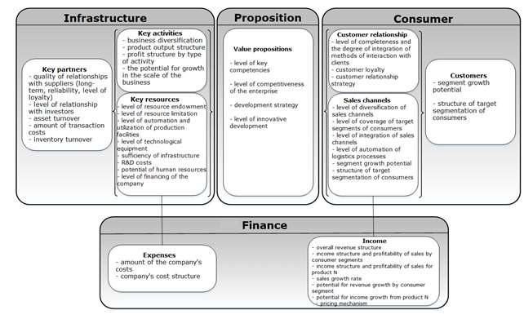

**Fig. 1**. Identification of key value drivers based on the company's business model

In this paper, the authors consider the key value driver as a characteristic of the enterprise's activities, on which the effectiveness of its functioning for each block of the business model depends [4].

The classification of value drivers presented in the figure demonstrates which methods of influencing a particular block of the business model must be applied to ensure effective management of the company's activities.

In the "Customers" block, one of the main value drivers is the structure of the target segments of consumers. Taking into account the constantly changing market situation, the company should periodically monitor the current structure of its customers and, if necessary, make adjustments to its activities aimed at changing the existing structure, including increasing the diversification of its clientage, to ensure the maximum possible profitability of the company.

The segment growth potential driver reflects the company's ability to increase its market share in the corresponding customer segment. Market share dynamics is an important indicator for any company. An increase in market share contributes to an increase in revenue and directly affects the company's growth rate, while a loss of market share means a decrease in the company's competitiveness and has an extremely negative effect on all performance indicators of its activities.

The most significant value drivers in the “Sales channels” block are the level of diversification of sales channels and the level of coverage of target consumer segments. The company should strive to use in its arsenal the widest range of available sales channels, both its own and partner ones. At the same time, it is important to what extent each of the sales channels covers a particular segment of consumers, the degree of availability of sales channels for each segment of consumers, the possibility of informing consumers about the company's value propositions at all stages of the sale, etc. At the same time, important aspects are the level of integration of sales channels and the level of automation of the company's logistics processes, since these drivers directly determine the company's ability to ensure the promotion and sale of products in the required time frame and are competitive.

The profitability and sustainability of the business will largely depend on what methods of relationship with customers the company chooses, how effective these methods will be, and are they integrated into the overall business model of the company. The choice of a combination of methods of interaction with clients will primarily be determined by the chosen strategic goal of relations with clients - acquiring customers, retaining customers, increasing sales, and one of the most important indicators of the effectiveness of the methods used will be the level of consumer loyalty.

In the “Value propositions” block, the main value driver is the level of key competencies, which is a combination of competitive advantages, features, knowledge, skills, abilities, and qualities of an enterprise that ensure its success and competitiveness in all markets. Therefore, along with this driver, the level of competitiveness of the enterprise is also considered. In this case, the assessment of the competitiveness of the enterprise should be based on the analysis of technological, production, financial, and sales opportunities in the context of the main competitors of the company.

The value drivers that determine the value propositions of consumers also include the enterprise development strategy, which is a set of methods aimed at achieving the goals, and the level of innovative development, which is determined by comparing the effect of innovation and the costs of its implementation.

The “Income” block in the business model defines the ways of generating the company's revenue streams in the context of each consumer segment and each type of product or service provided. Accordingly, the drivers of value in this block will be parameters that have a direct impact on the formation of income streams, such as the overall structure of the company's revenue, the structure of income and profitability of sales by consumer segments, the structure of income and profitability of sales by product, the growth rate of sales by segments of consumers, sales growth rates by-product [5]. Analysis of income in these sections will allow the company to promptly make changes not only in the selected methods of generating cash flows but also in strategic development plans [5]. Since each income stream has its pricing mechanism, the correct choice of the appropriate mechanism will have a significant impact on the formation of cash flows.

In the "Expenses" block, the main value drivers will be the size and structure of the enterprise's costs. Analyzing these drivers, an enterprise needs to understand that the total amount of production costs depends on the type of output, its structure, variable costs per unit of output, the total amount of fixed costs, and the price of consumed resources. The analysis of the total amount of costs should take into account as much as possible all technical and economic drivers, conditions and organization of production, changes in the quality of products, and the efficiency of using production resources due to other influencing reasons.

In the "Key resources" block, it is advisable to allocate human, material, intangible, and information resources, as well as to consider value drivers within each type of resource. The main task of the top management is to develop and implement such a personnel strategy that provides the company with long-term competitive advantages.

Material resource management is characterized by such indicators as the level of technological equipment of production and the utilization of production facilities. The level of technological equipment of production determines the effectiveness of the sale of products and the possibility of the rhythm of its sale with given consumer properties. The utilization of production capacities allows the enterprise to determine the maximum possible annual production output. To assess the company's strategy in the field of information technology, it is necessary first of all to analyze the sufficiency of the infrastructure, which can be determined by estimating the company's expenses on IT as a percentage of sales revenue, to assess how efficiently these resources are used, and also to track how efficiently works the communication network, allowing to maintain the company's databases, as a result of which the exchange of information within the company is significantly accelerated and facilitated. Also, the value drivers in this block are the level of security and the level of limited resources, which allow the company to identify the number of resources available in full at the enterprise, and the resources, the absence of which can hinder the production process.

In the "Key activities" block, the main value drivers should be the level of business diversification, the structure of output, and the structure of the company's profit by type of activity, which also allow determining the share of individual types of products in the total output and the share of profit that each product brings in the total profit structure.

The "Key partners" block, which implies interaction with the main suppliers and contractors, defines communication with them as the main task. The key indicator that characterizes the relationship with suppliers is the quality of such communications. Thus, a sign of reliable partnerships with suppliers is the acceleration of inventory turnover, which allows you to determine the presence or absence of excess inventory since an increase in this indicator indicates problems in the supply system of the enterprise, and the amount of transaction costs associated with the transfer of ownership rights. Do not forget about the main partners of the company – investors. Relationships with them are an integral part of the company's activities. This indicator is characterized by the number of offers that the company made to the market and how favorably they were accepted, which indicates a friendly attitude of investors to the company. The developed approach was tested within the framework of the project of the digital product design of aircraft engines. The following key activities were highlighted:

* production of products (engines) with long service life and high reliability based on a single product platform;
* production of main components and assembly units;
* fitting-up of finished products

The key resources of the enterprise were identified: the provision of the production process with intangible assets, such as knowledge bases, highly qualified and experienced personnel, as well as tangible assets (technological equipment).

Since the innovative activity of the enterprise was assessed as low by all indicators, it was decided to revise the business model of the enterprise to create digital products based on the allocation of key value drivers in each block of the business model.

First of all, to support key competencies, an innovative technological process was developed that ensures the target cost of aircraft engine production. For this process, the missing resources were determined by the required indicators capable of ensuring the functioning of a modern enterprise.

To ensure interaction with customers, a digital platform based on the SAP S/4 HANA CRM module was chosen, which will reduce the cost of the product lifecycle in the future and ensure high manageability of the supply chain.

It is also planned to increase customer satisfaction in the future through the use of a PLM system that will allow the continuous analysis of engine operation and wear, as well as their maintenance.

As an approach to managing the value of the company, a balanced system of indicators was chosen, the analysis of which is carried out continuously based on data collected by the i-ERP system in four directions:

- indicators of the target value of the product and the value of the business;

- customer satisfaction indicators (quality and after-sales service);

- indicators of the efficiency of business processes;

- indicators of the effectiveness of human resource management.

As a result of the project, a new business model for the production of aircraft engines was developed, which will allow the company to achieve a high level of competitiveness not only in Russia but also in the world market.

**Conclusion**

Thus, the identification and implementation of management influences on the set of value drivers within the framework of the developed business model will allow the management of the enterprise to analyze, evaluate and control the influence of drivers on the value of the enterprise, considering them as an integral system, which, in turn, will create the basis for making timely operational, tactical and strategic management decisions to increase the value of the business and, consequently, increase the efficiency of the enterprise and the competitiveness of the enterprise.

**References**

1. **Еленева Ю.Я., Червенкова С.Г., Андреев В.Н.** Оценка бизнеса и управление стоимостью предприятия. Рекомендовано кафедрой финансового менеджмента в качестве учебного пособия для студентов ВУЗов, обучающихся по экономическим специальностям / Москва, 2019.
2. **Просвирина М.Е., Тагирова А.М., Червенкова С.Г**., Подходы к выделению факторов стоимости на основе бизнес-модели компании. Наука сегодня: задачи и пути их решения [Текст]: материалы международной научно-практической конференции, г. Вологда, 27 мая 2020 г. – Вологда: ООО «Маркер», 2020. – 160 с.
3. **А. Остервальдер, Ив Пинье** Построение бизнес-моделей. Настольная книга стратега и новатора. М.: Альпина Паблишер, 2019
4. **Скотт М.** Факторы стоимости: руководство менеджеров по выявлению рычагов создания стоимости/ Пер. с англ. – М.: ЗАО «Олимп-Бизнес», 2005. – 432 с.
5. **Червенкова С.Г., Просвирина М.Е.** Применение методов математического моделирования при планировании денежных потоков предприятия // Вестник МГТУ Станкин. 2019. № 1 (48). С. 135-140.

***Chervenkova Svetlana Gennadjevna*** - Candidate of Economics Sciences, Associate professor of the sub-department «Financial management» of MSUT «STANKIN».

Tel.: +7(499) 972-95-05

*[gensveta@inbox.ru](mailto:gensveta@inbox.ru)*

***Prosvirirna Maria Evgenjevna*** - Candidate of Economics Sciences, Associate professor of the sub-department «Financial management» of MSUT «STANKIN».

Tel.: +(499) 972-95-05

*[mprosvirina@mail.ru](mailto:mprosvirina@mail.ru)*

***Malina Tatiana Vitaljevna*** - Candidate of Economics Sciences, Director of Economics and Finance JSC «AgroGard»

Тел.: 8(916)165-51-82

*TMalina@agrogard.ru*

***Andreev Vladimir Nikolaevich*** - Candidate of Economics Sciences, Associate professor of the sub-department «Financial management» of MSUT «STANKIN».

Tel.: +7(499) 972-95-05

*[andreevv85@mail.ru](mailto:andreevv85@mail.ru)*

***Kisel’ Tatiana Nikolaevna* -** Candidate of Economics Sciences, Associate professor of the sub-department « Management and innovation» NIU MGSU

Tel.: 8(495)651-81-82,

*doremi2@yandex.ru*

##### УДК 330.4

Ryzhkova T.V.

**The essential qualities of the production function model in a complex form**

*Economic and mathematical models of production functions are described in a complex form by the use of two functions of the real variables. The special properties of analytical complex functions are used in complex function modeling based on economic data given by tabular real indicators.*

**Keywords:** mathematical modeling in economics, production functions, analytical complex functions,restoration of complex function.

**Introduction**

The production function characterizes the relationship between resources and output or profit and, thus, can describe the conditions for effective production methods. Knowing its production function, the manufacturer can estimate on the model how, for example, the volume of output will change with variations in the resources used. The variety of forms of setting production functions is explained by the fact that each new production method is effectively described by its production function. Modern nonlinear models of optimal control in the economy, in turn, are associated with nonlinear models of production functions. Thus, at present, economic and mathematical models of production functions (PF) are used as a helpful tool that allows conducting quantitative optimization analysis and concluding the effective amount of production resources.

The complexity of the mathematical description of the production process determines the variety of such models. The question of the adequacy of a mathematical model of a complex economic structure contains all the features of the question of any kind of mathematical modeling. Thus, Table 1 shows how researchers are modifying and complicating the PF model: using complicating the parameters of processes for optimization, and also using multiplications with a well-tested Cobb-Douglas type power function. As a result, in generalized models, researchers, as a rule, make assumptions about non-compliance with such classical properties of PF as uniformity, constancy of elasticity of factors, rejection of the explicit form of the task. Such artificial techniques are necessary to take into account the mutual influence of factors in the PF model [1].

*Table 1.* **Known modern PF models**

|  |  |
| --- | --- |
| 1. | PF with fixed proportions of production resources  • Leontiev  • Leontiev-Harrod-Domar (LHD) |
| 2. | PF with a multiplicative effect   * Cobb-Douglas * CES - constant elasticity of substitution of factors |
| 3. | * Linear PF |
| 4. | * Allen * PF with linear elasticity of substitution of factors(LES) * Sollow, Hillhorst |

**Models of complex PF of a complex argument**

Mathematical modeling using complex functions of a complex variable has long been effectively used in physics and engineering. Mathematical modeling is implemented most successfully due to the correct use of mathematical theories and conditions for the repeatability of the experiment. In economics, the question of verifying the adequacy of the mathematical model of an economic process remains an unavoidable obstacle, since in economic processes, unlike physical and technical processes, it is impossible to repeat a practical experiment to refine or change the parameters of the model. Therefore, the basis of mathematical modeling in economics can serve as well-founded methods and mathematical theories tested on models of engineering and physics

In this regard, we note that similar techniques and special properties of functions of a complex variable have already been extended to objects of mathematical modeling in economics [6,7,8]. By collecting the factors into one complex number, we eliminate the imperfection of mathematical models that require mutual independence for the factors.

So, in economic and mathematical modeling, we can build models of complex production functions from a complex argument. Then the so-called factors of the economic model will be combined into one number. At the same time, there is no restriction on the mutual independence of factors and the normal distribution present in regression models for production functions [1,2,3]. Let two factors: K-capital and L-labor be reduced to one complex number, and  is a complex function that defines a model of the production function

,  (1)

.

Since the complex function is related to real functions describing the real and imaginary parts of the complex function, two real functions of two variables (K, L) are introduced into consideration. It is known that the theory of functions of a complex variable uses the basis of the methods of real analysis. Table 2 presents the simplest complex PF models, which in form repeat the known PF models in the representation of real factors [6,7,8].

*Table 2.* **Complex PF models**

|  |  |
| --- | --- |
| ***Z - space of complex numbers*** | ***R - space of real numbers*** |
| **1. Linear function** of the general form    Of a particular type, according to the contribution of factors    **2. Power-law function** of the general form | **1. Linear function**    **2. Power-law function** |
| **3. Function similar to the Cobb-Douglas function**  **Additive model.**  **Multiplicative model.** | **3. Cobb-Douglas function** |

In this paper, when modeling functions in a complex space, the author pays attention to a class of analytical functions of a complex variable that have effectively manifested their properties in optimization complex models in engineering. Analytical functions of a complex variable have special properties associated with derivatives that allow us to take into account the rate of change of processes in the model and correctly build the model in a complex form. It is known that the rates of change in the parameters of a mathematical model are set by the values of their derivatives, and the derivative of a complex function requires more "rigid" conditions of existence. The differentiability condition at a point in the complex plane is "rigid" since it requires the value of a finite limit at various increments on the plane or the fulfillment of the Cauchy - Riemann conditions associated with the differentiability of the real functions  that make up the function of a complex variable [4,5]. In addition, analytical functions also require their differentiability on open task sets. In this regard, it is important, according to the author, to note that when modeling complex functions 2 and 3 from Table 2, the conditions of differentiability of functions (in a simply connected open domain) for arbitrary parameters of the model, namely, the analyticity of these functions, will not be fulfilled.

So, to build a model of a complex production function, we will use an important assumption that this function belongs to the class of analytical functions of a complex variable in its domain of definition, i.e. . This condition allows us to link the actual source data for the parameters *K, L* as correctly as possible, without making a deliberately impossible assumption about the independence of the factors [6]. The differentiability criterion of complex functions sets the conditions for two real functions that make up a complex function in the form (1).

For the C-differentiability of a function at the inner point of the domain of definition, it is necessary and sufficient that the functions should be differentiable at the point and that their partial derivatives at this point are connected by Cauchy-Riemann relations

 (2)

The author draws attention to a special property of analytical functions of a complex variable - the property of "restoring" the real or imaginary part of a complex function [4,5] from a known part of a complex function. In this case, we will be able to build a correct mathematical model in a complex form using the known functional dependence of the parameters *K, L,* usually specified by tables of "working" economic indicators in the form of real numbers, by "restoring" the imaginary part.

As a result, we get the opportunity to "restore" an unknown function of the imaginary part by the formula

. (3)

Let's consider examples of "constructing" well-known models of production functions (PF) in a complex form.

1. ***Linear PF***

Let the factors (*K, L*), given in tables, have a linear trend  in the form of time series. We set the real part of the complex PF in the form, then according to the law of "restoration " described above, the imaginary part of the complex function can be easily obtained and has the following form

 . (4)

Here, without losing generality, we assume *C=0*.

Then, the modeled complex linear PF will be represented as follows by (1) by the formula

. (5)

Note that the linear complex function sets the similarity transformation of the complex plane (*K, L).* In this case, the module of the derivative sets the degree of local stretching of the original region *(K, L)* -, and the corresponding argument  is the angle of local rotation, in other words, a possible "reversal" of the trend (Fig.1). In this case, the derivative argument sets the angle indicated by an arrow between lines 1 and 2 and is associated with the control parameter *a* ( Fig.1).

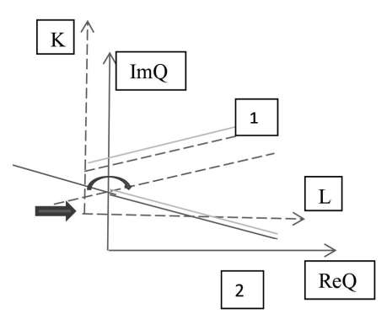

**Fig.1**

***2. Complex functions of the Cobb-Douglas type***

***Requirements for the model by the type of the Cobb-Douglas function***

First, when constructing a model of a complex function in form 3 for an additive model (Table 2), it should be noted that the approach consisting in modeling a complex PF based on known real data will lead to the fact that we get a non-analytical complex function. To do this, it is easy to check the harmony condition for the function of the real part

. (6)

Secondly, when constructing a model of a complex function in the form of a multiplicative model (Table 2), we also get a non-analytical complex function if the control parameters of the model do not satisfy a special condition, which is easy to obtain from the condition of harmony of the real part of a complex function of the form 

The functional relationship for the parameters of the Cobb-Douglas model can be determined based on the initial economic data presented in the reports of enterprises. A condition for the parameters to meet the requirement that the model function belongs to the class of analytical functions is obtained:

.

In the simplified case, choosing a complex model of the form , it is not difficult to check that the function representing it will be a harmonic function. The conditions (6) are fulfilled for it. Then the imaginary part of the complex function modeled by PF, up to an arbitrary constant, which, without losing generality, can be set equal to zero, will have the form

 (7)

As a result, it is shown that the complex function will be analytical, which can be correctly and effectively used in the following form

. (8)

***3. Power-law complex model***

If we construct a complex model in the form of a power-law function (form 2, Table 2), then the function representing it has the following general form

 (9)

In this case, it will be natural when analyzing the behavior of a complex PF to go to the complex logarithm

 (10)

Using the approach described in [4,5], it is possible to notice the alternation of maxima and minima in a power-law function due to the presence of complex logarithms (Fig.2). Such a method of visualizing the values of a function on the Riemann sphere is used in geophysical research and is described in [6], it allows you to visually highlight the anomalous zones and zones of stable behavior of the function.

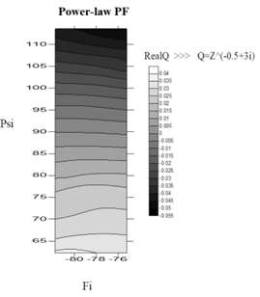

**Fig.2** 

Often, when constructing power-law real models of PFs, they are chosen in the form of polynomials, in this case, for the complex model, the condition is satisfied that the power parameter belongs to natural numbers,



In this case, according to the initial data on the known parameters of labor and capital, we can set the function of the real part of the PF in the form

. (11)

Then, according to the scheme described above, we perform the procedure of "restoring" the imaginary part according to formula (2), since a power-law complex function with a natural exponent is an analytical function. The property of analytic complex functions can also be useful in this case, that an arbitrary polynomial will be an analytical function of a complex argument and an analytical fractional-rational function of a complex argument in a domain that does not contain zeros of the denominator will also be analytical.

If you build a model with a real power exponent, you should pay attention to the fact that such a function will be multivalent, ambiguous. This difficulty can be overcome by setting the conditions for finding on one Riemann sheet allocated for analysis.

Let us consider the features of the behavior of a power complex function with a real exponent

 (12)

Based on the representation according to formula (12), it becomes clear that the control parameter *a* will be associated with a series of maxima and minima of the complex PF.

***Complex PF module for an optimization of control parameters of the model***

The author pays special attention to the property of the module of an analytical function associated with metric properties in the space of complex numbers [6]. So, it is known that if  is analytic in some open simply connected domain G and in this domain (for example, on the level line) , then the function itself will also be constant in this domain. So, Figure 3 shows the level lines for a power-law complex PF. The construction was also carried out using the geometric interpretation of the complex function using the Riemann sphere (Fig.3) [6].

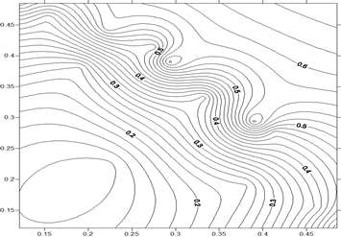

**Fig. 3** Isolines of the power function module

This position allows us to move the procedure for optimizing the control parameters of the complex PF model to the space of real numbers - R3, namely, (*K*, *L*, ). We define the sequence of finding the optimal control parameters of the production function as follows [2,3]:

1. We find a parametric class of analytical complex functions that most accurately approximates the quantitative relations between the selected characteristics of the production function in the real domain according to known economic indicators (the index *t* determines the nodal point in the source data)



2. We set the numerical parameters of the evaluation models . The set of values of the desired control parameters will be found taking into account these values



3. To define an optimal model of a complex function ****, similar to the most characteristic dependence in the real domain, it is necessary to evaluate the control parameters of the model  by minimizing the expression

.

**Conclusion**

So, in complex PF models, the economic factors of the model are collected into one complex number, while the control parameters of the model are also set in a complex form. A complex variable itself can be considered as a model that characterizes the properties of an object more comprehensively, since it consists of two real variables, and not of one variable, as is typical for models of real variables (i.e., taking into account the relationship of factors, unlike regression models). In economic models, the correct correlation of complex variables with economic indicators and functions is often a separate subject of research [10, 11].

The author draws attention to the special properties of analytical complex functions that can be used when modeling a complex PF based on the initial economic data given by tabular time real indicators. In this regard, the application of methods of applied mathematics to the construction of economic models of analogs is a step in complex-valued economic modeling, in particular, on the example of the production function. Such methods of applied mathematics are used in the study of flow potentials of various nature, in physics and engineering and allow us to correctly expand the mathematical instrumental economic modeling.

Illustrations are given on the main complex characteristics: the argument and the module for models of linear complex functions. For linear differentiable functions, a geometric interpretation of the argument of the derivative of a complex function is presented, which can serve as an indicator of trend changes, given economic indicators.

As a generalized quantitative characteristic of an analytical complex function, the value of the metric module in the space of complex numbers is proposed, which makes it possible to move the analysis of the control parameters of the PF model to the space of real numbers and, thus, determine the sequence of the procedure for optimizing the control parameters of the model.

**References**

1. **Клейнер Г.Б.** Системная экономика и системно-ориентированное моделирование // Экономика и математические методы. 2013. Т. 49. № 4. С. 71–93.
2. **Лотов А.В.** Введение в экономико-математическое моделирование. М.: Наука. Физматлит, 1982. 392 с.
3. **Ашманов С.А.** Введение в математическую экономику. М.: Наука, Физматлит, 1984. 292 с.
4. **Боярчук А.К.** Справочное пособие по высшей математике. Т. 4. М.: URSS, 1999. 349 с.
5. **Лаврентьев М.А., Шабат Б.В.** Методы теории функции комплексного переменного. М.: Наука, Физматлит, 1973. 736 с.
6. **Рыжкова Т.В.** Математическая модель производственной функции в комплексной форме// Вестник Станкин, 2016, №3(38), С.71-101.
7. **Светуньков И.С., Светуньков С.Г.** Степенные производственные функции комплексных переменных // Экономика и математические методы. 2012. Т. 48. № 1. C. 67–79.
8. **S.Svetunkov** Complex-value modeling in economics and finance. New York: Springer Science+Business, 2012. 318p.
9. **Sukhorukova I.V., Fomin G.P.** Hybrid Method for Multi-Criteria Risk Minimization //Espacios, 2019, Vol. 40, pp 14 -22.
10. **Merkulova T. V., Prikhodko F. I.**Dynamics of macroeconomic indicators modeling by functions of complex variables // Бiзнес-Iнформ. Бюлетень ВАК Украiни. 2010 (381). № 4 (5). С. 67–71.
11. **Lishchynska l. b.** Using of the complex variables in economic calculations//Вiсник Хмельницького нацiонального унiверситету. 2017.№2.Т.1. С210-214.

***Ryzhkova Tatiana Vasiljevna*** – Ph. D. Associate Professor, Department of Mathematics of the Plekhanov Russian University of Economics.

Tel.: 8 (499) 237-05-30, **8-916-473-01-36**.

*rtvhome@yandex.ru*

УДК 338.24.021.8, 338.28

Tsuverkalova O.F.

**The heat supply industry digitalization role in achieving sustainable development goals**

*The main aspects of the information technologies application in the heat supply industry are considered, their connection with the sustainable development goals is shown. Examples of existing solutions in this area are given, and promising areas of digitalization are identified.*

**Keywords**: sustainable development, digitalization of the economy, heat supply industry.

The modern development of economic sectors and individual enterprises is determined by global trends that have developed today on a Russian and global scale. Among them, first of all, it should be noted the course adopted by the UN for sustainable development. For the first time the term “sustainable development” was voiced in 1987 in the report “Our Common Future” [1] of the UN World Commission on Environment and Development. Sustainable development is generally understood as a balanced solution to the problems of socio-economic development, aimed at meeting the needs of the present and future generations of people and ensuring the preservation of the environment and natural resource potential. Over the past years, the concept of sustainable development has been supported by most of the countries of the world, and since 2015 it has been elevated to the rank of a global ideology shared by all UN member states.

The consistent implementation of the concept of sustainable development is ensured by the development of goals and objectives that are adjusted by the changing situation. Thus, in 2000, the UN General Assembly adopted the Millennium Development Goals (MDGs), which defined the main goals and objectives of socio-economic and environmental development for the period up to 2015. The report, prepared by the Inter-Agency Expert Group led by the Department of Economic and Social Affairs of the United Nations Secretariat, notes that “The MDGs that put people and their urgent needs at the fore have changed decision-making in both developed and developing countries” [2]. At the same time, most of the problems have not yet been resolved, which led to the need to adjust the set goals, and in 2015, in the resolution "Transforming our world: the 2030 Agenda for Sustainable Development" [3], new 17 Sustainable Development Goals (SDGs) that are relevant today. Achieving the set goals requires solving a large complex of interrelated tasks both at the macro-, meso- and micro-levels.

The focus on the SDGs is reflected in the program documents of almost all countries, including the Russian Federation [4]. Within the framework of the SDGs, the main directions of the strategic development of Russia were identified [5], of which a special role is assigned to digitalization. The National Program "Digital Economy of the Russian Federation" provides for "the creation of an ecosystem of the digital economy of the Russian Federation, in which digital data is a key factor of production in all spheres of socio-economic activity" [6]. The digitalization of the economy provides for the development and creation of integrated management systems on the information technology platform, which makes it possible to increase the efficiency and quality of functioning of industries and individual enterprises, move to a new level of development, increase labor productivity and efficiency of production processes, and ensure the quality of products (services).

Despite the presence of common approaches in the field of informatization and digitalization, the solution of the problems of digital transformation of enterprises and industries is largely determined by their specifics. One of the main sectors of the Russian economy, on the successful functioning of which the achievement of some sustainable development goals largely depends, is the heat supply sector, which is unique in its scale. At the same time, its current state can be characterized as problematic, which is confirmed by both official statistics and information published in the Russian media. The solution to many problems that exist today in the domestic heat supply can largely be achieved through the introduction of digital technologies. Let us consider the main directions of digitalization of the activities of heat supply organizations (HSO) and their relationship with the achievement of sustainable development goals (Figure 1).

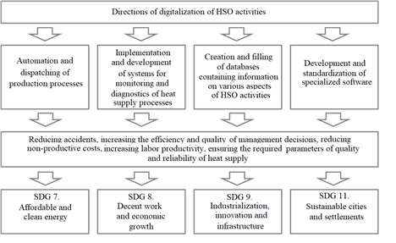

**Fig. 1**. Directions of digitization of HSO activities

1) Automation of heat supply systems means the use of a set of automatic devices for controlling technological processes, providing regulation (stabilization) of parameters, control of the operation of equipment and units, their protection and blocking, control and measurement of parameters, accounting for the consumption of supplied and consumed resources, remote control of measurements. Today, there is a sufficient number of software and hardware complexes for the automation of heating network facilities, the introduction of which will solve the problems associated with the optimization of hydraulic operating modes, high electricity costs during heat transportation, improper maintenance of technological modes of equipment, untimely detection of leaks and improperly organized accounting. energy resources, high costs of the payroll due to a large number of maintenance and operational personnel, and others. The effect of the introduction of an automated heating system control system can be up to 30% of all costs for production, transport, and energy consumption [7].

At the same time, to date, the use of various automation tools has not yet found full application in heat supply systems. For example, according to the «Regional Heat Supply Efficiency Rating» published in May 2020, the median value of the indicator "The share of apartment buildings equipped with automated individual heating points" was 0.7 points out of 10 possible, and the indicator "The share of modern pipes" (including pipes equipped with a remote operational control system (ROCS)) - 1.0 out of 5 points [8].

2) One of the main problems associated with the operation of heating networks is the high accident rate due to a significant degree of wear of pipelines and network equipment, as well as the low quality of construction and installation work during the building and repair of heating networks. The consequences of accidents on heating networks are interruptions in the supply of heat energy to consumers, an increase in costs, and a decrease in the profit of HSO, which significantly reduces the efficiency of the functioning of these organizations. The listed problems can be avoided by consistently introducing into the practice of HSO systems of operational diagnostics of the state of heating network elements by monitoring their technological parameters in real time. Timely identification of deviations in the course of technological processes will allow eliminating their causes without waiting for an emergency, which will significantly reduce losses associated with repair and restoration work and disruptions in the functioning of heating networks.

Speaking about the implementation of monitoring and diagnostics systems, it should be understood that they should provide not only a constant readout of information from sensors, which can be provided by various automation tools but also the prompt processing of incoming data. The variety of monitored parameters, large volume, and constant updating of information allow us to classify monitoring data as "big data", which determines the methods used for their processing. These methods include, first of all, statistical methods for analyzing time series, which make it possible to predict the behavior of technological parameters based on the construction of trends. At the same time, it should be taken into account that the dynamics of indicators, as a rule, are characterized by significant fluctuations caused by a combination of various technological and external factors, which makes it difficult to detect a trend.

The author considered some problems related to diagnostics of the equipment condition and predicting the behavior of its technological parameters. One of the approaches applied to solving such problems is the use of quality control charts that determine and visualize various statistical characteristics of the process under study. Quality control of technological processes can be carried out both “manually” using the simplest means (for example, Microsoft Excel), and using specialized software products. In [9], an analysis of pumping equipment was carried out using the Statistica package by Statsoft. One of the modules of this software product, focused on processing data on real industrial objects, is the Quality Control (QC) module, which allows you to build various types of quality control maps [10].

Today, other information technologies are becoming more and more common in the processing of monitoring data: predictive analytics, machine learning, cluster analysis, the use of artificial neural networks, and others.

3) Another direction of digitalization is the creation and filling of databases in various areas of HSO activities. An example is databases that allow accumulating data obtained in the course of monitoring. The accumulation of such information will make it possible to more accurately diagnose possible malfunctions, which will increase the quality and reliability of heat supply.

Another example is a database, the structure of which was developed by the author in [11], for storing information about sections of heating networks (Figure 2).

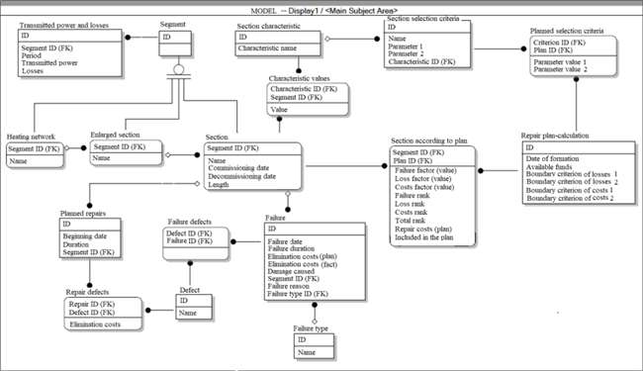

**Fig. 2.** Scheme of a database for storing information about sections of heating networks

Let's describe the individual entities used in the model and their purpose.

The “Section” entity is intended for storing information about individual sections of heating networks. Information about the date of its commissioning is stored for each section, which allows to automatically calculate the service life of the section for use in calculating the probability of its damage. To ensure the integrity of data for decommissioned sections of heating networks, a date is also put down for the decommissioning of the section. This will make it possible to exclude from the calculation of the repair plan areas that are not currently in operation, but at the same time preserve the historical data on their operation, including data on their repairs, failures, power transmitted through them, and transmission losses. This historical data can be used to calculate the likelihood of failure for similar sections of the network still in operation.

The entities "Section characteristic" and "Characteristic values" are intended to store information about various characteristics that describe individual sections. These characteristics include the length of the section, the diameter of the pipeline, the depth, the material from which the pipe is made, the presence and material of insulation, the presence and number of locking devices, etc.

The entity "Repair plan-calculation" is intended for storing information about the made repair plans. It stores information about the date of drawing up the plan, the estimated available amount of funds, as well as the boundaries selected for calculation according to the criteria of losses and costs (as noted earlier, the recommended initial thresholds for these factors are 20% for assigning the section to the first rank and 10% for assigning it to the second rank, but in the future, the HSO can set these boundaries based on existing conditions and established practice).

The entity "Section according to plan" is intended for storing information about the sections included in the plan calculation. For each section, information is saved about the calculated values of the factors of failures, losses, and costs, the assigned ranks, the final rank of the section, the planned repair costs and the final decision to include or not include the section in the repair plan. Since the data on each calculation is saved separately, this will allow you to analyze the change in the state of the section over time, building a history of changes in both the values of individual factors and the overall rank of the section.

The entities "Section selection criteria" and "Planned selection criteria" are intended to store information about which criteria were used to calculate the failure factor. As previously noted, when calculating the value of the probability of section failure, to simplify the calculation, not a theoretical distribution can be used, but empirical data on failures of sections with similar characteristics. Then, when building a repair plan, various criteria can be used, according to which a set of areas similar to it is determined for each section. Selection criteria can be simple (for example, sections whose length differs from the length of the considered section by no more than a given value can be selected) or complex, taking into account a large number of parameters. The data on all such possible criteria is stored in the “Section selection criteria” entity, and the data on the criteria used in a specific calculation plan, together with the selected parameter values, is in the "Planned selection criteria" entity.

The "Failure" entity is intended for storing historical information about failures in sections of heating networks. It is provided for storing data on the dates of failures (which will allow calculating the time elapsed since commissioning), their duration, the costs of their elimination and compensation for damage, the causes and types of failures.

The entity "Transmitted power and losses" is intended for storing historical information about the transferred heat power and heat losses at the sections. This information is used in the calculation to determine the value of the loss factor for each section. Because many HSOs currently do not keep records of losses for individual sections, but only for the entire heat network as a whole, the proposed model was supplemented with the entities "Enlarged section" and "Heating network", which form the "Segment" hierarchy. Due to this, it is possible to keep records of losses both on the scale of heating networks and on the scale of individual sections. At the same time, if the accounting of losses for individual sections has already been implemented on a part of the thermal networks of the HSO, a mixed accounting can be carried out, and the number of losses for sections for which no accounting of losses is conducted can be obtained by distributing losses in proportion to the length of the sections or the transmitted power (having previously excluded the losses of those sections where accounting is conducted from the total volume of losses).

The entity "Planned repairs" is intended for storing information about planned repairs of sections necessary for calculating the value of the cost factor. This object stores data about the dates of repairs and their duration.

The "Defect" entity is intended for storing information about various types of defects.

Information about defects eliminated during planned work and the costs of their elimination is stored in the "Repair defects" entity, and information about defects that caused a failure is stored in the "Failure defects" entity. This information is used to calculate the value of the failure factor: a set of similar sections is determined for each section, the specific share of defects that are the causes of failures and the costs of their elimination is determined based on historical information on failures, and the costs of planned repairs of such defects are determined based on historical information on repairs.

In the course of implementation, the proposed module can be further supplemented taking into account the needs and characteristics of specific HSO, for example, information about the organizations that carried out the laying or repair of the section, suppliers of materials, etc. If the HSO already maintains a database with information about the heating networks under their jurisdiction, such a database can be expanded by integrating the proposed entities into it.

4) Development and standardization of specialized software. Such support includes software products that allow simulating various heat supply processes, monitoring data processing programs, and others.

Today, one of the main elements of the territory heat supply scheme is an electronic model of the heat supply system, designed for simulation modeling of heat network processes to the topographic map of the settlement. The obligation to develop an electronic model and the requirements for it are regulated by the "Methodological guidelines for the development of heat supply schemes" approved by order of the Ministry of Energy of the Russian Federation dated March 5, 2019 No. 212 [12]. The most common environments for the development of such models are CityCom (LLC "Potok", Moscow) and Zulu (LLC “Polyterm”, St. Petersburg). In [13], a comparative analysis of these software products was carried out, which led to the conclusion that, in general, both products meet the requirements and allow implementing the necessary functions.

However, it should be noted that the development of electronic models of heat supply systems faces some problems, among which, first of all, the lack of complete and reliable information about the operating heating networks in most HSOs, as well as the lack of local specialists who can use the specified software products.

Concluding the conversation about the directions of digitalization of heat supply, we emphasize that all of the above areas are closely interconnected and, therefore, require comprehensive implementation. Cloud and blockchain technologies, the industrial Internet of things, the creation of digital twins, intelligent systems, etc. will find increasing application in this area as information technologies are used.

At the same time, it was previously noted that, despite the significant available groundwork in this area, in most HSOs (especially in small settlements) digital technologies are practically not used or are used only slightly. This state of affairs is primarily due to the unsatisfactory financial condition of the industry and the lack of proper investment. Other reasons include insufficient information literacy of the HSO management, lack of understanding of the benefits from the introduction of information technologies, lack of qualified specialists in the field, lack and low quality of available information, and others. Therefore, the following can be noted as the priority measures aimed at solving the problems of digitalization:

1) in the financial sector:

- development of targeted financing programs with the attraction of both budget funds and investors' funds

2) in the information sector:

-development of instructions and methods for collecting data characterizing the state of heat supply in the region;

-development of uniform requirements for presentation, structuring, coding, data processing, and information protection;

- ensuring the completeness and reliability of the data;

3) in the field of staffing:

-organization of advanced training and retraining of HSO employees in the field of information and communication technologies.

The development and implementation of integrated programs aimed at digitalization of heat supply will significantly improve the efficiency of the HSO, which, ultimately, will allow solving some tasks formulated within the framework of achieving the sustainable development goals.

**References**

1. Our common future. Report of the UN World Commission on Environment and Development. [Electronic resource]. - Available at: https://www.un.org/ru/ga/pdf/brundtland.pdf

2. Millennium Development Goals: Report for 2015 [Electronic resource]. - Available at: https://www.un.org/ru/millenniumgoals/mdgreport2015.pdf

3. Transformation of our world: Agenda in the field of sustainable development for the period up to 2030 [Electronic resource]. - Available at: https://undocs.org/ru/A/RES/70/1

4. The concept of the transition of the Russian Federation to sustainable development. Approved by the Decree of the President of the Russian Federation of April 1, 1996 No. 440 [Electronic resource]. - Available at: http://docs.cntd.ru/document/9017665

5. Decree of the President of the Russian Federation of May 7, 2018 No. 204 "On national goals and strategic objectives of the development of the Russian Federation for the period up to 2024" (with amendments and additions) [Electronic resource]. - Available at: https://base.garant.ru/71937200/

6. Digital economy of the Russian Federation. Approved by the order of the Government of the Russian Federation of July 28, 2017, No. 1632-r [Electronic resource]. - Available at: http://static.government.ru/media/files/9gFM4FHj4PsB79I5v7yLVuPgu4bvR7M0.pdf

7. Proshin A.I., Shekhtman M.B., Ladugin D.V. Integrated automation of heating networks as the most effective tool for increasing the efficiency of heat supply. [Electronic resource]. - Available at: https://www.krug2000.ru/pdf/kompleksnaya-avtomatizacija-teplovyh-setej-AVITE-4-2017.pdf

8. Rating of the efficiency of heat supply in Russian regions. Official section of the expert community [Electronic resource]. - Available at: https://expert.ru/ratings/rejting-effektivnosti-teplosnabzheniya-rossijskih-regionov/

9. **Tsuverkalova O.F., Galanova M.N., Kunyankin I.N., Merkulov D.A.** Statistical analysis of the state of technological systems of nuclear power plants // Reports of the Tomsk State University of Control Systems and Radioelectronics. - 2017. - T. 20. - No. 3. - P. 197-200.

10. Description of the tools of the STATISTICA Quality Control (QC) software module. - Quality control [Electronic resource]. - Available at: http://statistica.ru/local-portals/quality-control/

11. **Tsuverkalova O.F.** Organizational and economic mechanism for the development of heat supply organizations, taking into account the priorities of providing consumers with heat energy. Dissertation for the degree of candidate of economic sciences [Electronic resource]. - Available at: https://stankin.ru/uploads/files/file\_5ffd537b9241c.pdf.

12. On approval of Methodological guidelines for the development of heat supply schemes ”. Order of the Ministry of Energy of the Russian Federation of 03/05/2019 No. 212 [Electronic resource]. - Available at: https://base.garant.ru/72609692/

13. **Puzakov V.S., Sushchenko V.V., Vyalykh K.V., Petrov N.G., Antonov E.N.** Comparison of software products for creating electronic models of heat supply systems on the example of settlements in Chukotka AO [Electronic resource]. - Available at: <https://www.rosteplo.ru/Tech_stat/stat_shablon.php?id=4075>

***Tsuverkalova Olga Feliksovna*** - Associate Professor of the Department of Information and Control Systems, VITI NRNU MEPhI

Tel .: 8-903-40-49-852.

*OFTsuverkalova@mephi.ru*